Fundamentals of Music Theory
First Edition
First published in 2021 by the University of Edinburgh, Old College, South Bridge, Edinburgh, EH8 9YL.

© Michael Edwards, John Kitchen, Nikki Moran, Zack Moir, Richard Worth, University of Edinburgh. This book is published under a Creative Commons Attribution-ShareAlike 4.0 International licence (CC BY-SA 4.0) unless otherwise indicated. Cover adapted from a free to use image by Geralt on Pixabay.

ISBN: 978-1-912669-22-6
DOI: https://doi.org/10.2218/ED.9781912669226

For further information about the University of Edinburgh’s commitment to open educational resources (OER) please visit https://open.ed.ac.uk/

Preface
Fundamentals of Music Theory / Preface https://doi.org/10.2218/ED.9781912669226.x

Welcome to this resource! We are so pleased to share these open licensed educational materials, in which we deal with the building blocks of musical stave (sometimes known as staff) notation, a globally recognised language that is designed to communicate musical ideas. The particular ideas and concepts that we cover here include scale, and key, and harmonisation, and metre. The content has been devised to introduce the basic symbols and concepts the five-line stave, and to explain the ways that this notational system can be used to represent and also to analyse musical sounds. The materials cover topics such as pitches and scales, intervals, metre, proceeding to more sophisticated topics of key, time signature, harmonisation, cadence and modulation.
While the materials in this book begin from foundational principles of Western tonal music notation, what we teach here is really not all elementary. For decades and decades, these topics have been explained many times over in different media: In music lessons and lectures and conversations, in concert halls and classrooms and homes; in educational television programmes; in informal homemade teaching materials by instrumental teachers; in textbooks and workbooks that can be found in bookshops and libraries around the world, and – for the past 20 years – in a proliferation of digital content and technologies. Our contribution in this particular resource includes video lectures and their transcripts, supporting text explanations and illustrations. We expect that you have your own reasons for seeking out this resource, and that every individual’s own prior musical experiences and background will create a unique context in which to make sense out of these materials. On this assumption, we have begun from basic first principles, but we have sought to explain the concepts behind each topic in a critical and thoughtful way.
There are lots of reasons you might be interested in these resources. The open licensing means that both students and educators can make use of the audiovisual, text, and image sources that we share here. In terms of the content itself, the topics that we cover include practical skills and knowledge. Depending on your existing practice or interests, these skills could add an extra dimension or understanding to your musical life. Gaining fluency in both reading and using music notation might give you access to new repertoires or deepen your understanding or expression of familiar ones.
At The University of Edinburgh, the way in which we ask our students to approach these topics has changed significantly during the past few years. Like other institutions of higher education in the UK, and as an institution with an international student body and global outlook, we are aware that educational curricula both reflect and shape life and society. The matter of musical imagination has wide relevance not only in learning contexts, but also in our personal and social lives, and we certainly feel that this subject among all others deserves the most sensitive, critical approach. This is a fully open educational resource: we encourage you to make your own choices about your use and re-use of the contents.

Background to the project
The creation of this open textbook represents contributions from a significant number of people, over an extended period of time.
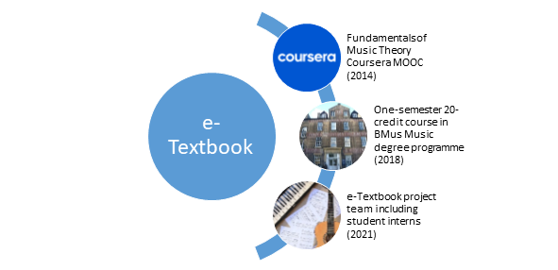
Much of the video lecture material that we share through this open textbook was originally conceived, designed and produced for The University of Edinburgh’s Coursera MOOC (Massive Open Online Course), Fundamentals of Music Theory, in 2013. MOOCs are accessible, freely available educational materials created by University academics who want to offer their expertise to a wider audience. The concept and direction of the original Fundamentals of Music Theory MOOC is attributed to Michael Edwards, at whose suggestion, Zack Moir, Richard Worth, John Kitchen and I offered to contribute. We each prepared scripts and teaching materials, which we revised together. This project was deeply rewarding. We learnt a great deal about how to reconsider the audience who might wish to access and engage with the knowledge that, as an academic team, we were accustomed to take for granted as fundamental to our discipline. It is no great surprise that this project was a precursor to considerable revision and re-assessment on our part on what these fundaments of music theory really represent, and how we should critically re-imagine them.
In 2018-19, an academic team in Music at Edinburgh devised an on-site course for entry-level University students. With support from the University’s Learning Design Service, content from the MOOC was repurposed to create a new blended learning (online and face-to-face) course for undergraduate students. The learning objectives for this course align with much of the material devised for the original MOOC, which our own students use alongside additional new lectures and contextual content which help learners to develop a critical perspective on stave notation, and to understand the topic in a contemporary, global light.
This current open textbook project is a collaboration between the University’s Open Educational Resources Service, and staff and student interns from the Reid School of Music. The project, funded by a University of Edinburgh Student Experience Grant, converted existing course content into convenient and reusable open formats suitable for use by staff and students both within and beyond the University.
Nikki Moran, 5 July 2021
Edinburgh, UK

Contributors

Open Textbooks for Access to Music Education Project (2021)
This first edition of the open textbook was created by a project funded by a University of Edinburgh Student Experience Grant in 2021. The project team were Dr Nikki Moran, Reid School of Music; Kari Ding, Ifeanyichukwu Ezinmadu, and Ana Reina García, Student Interns, Reid School of Music and Information Services Group; and Lorna M. Campbell and Charlie Farley, OER Service, Information Services Group.

Fundamentals of Music Theory MOOC (2014)
The Fundamentals of Music Theory MOOC has become one of The University of Edinburgh’s most successful Coursera ventures, enrolling 90,000 learners on its first run. Since August 2016, the MOOC has been offered on a rolling basis, reaching a further 165,000 active learners across the globe. In the years since we made the original MOOC in 2014, four of the academic team have moved on to new roles. Michael is now Professor of Electronic Composition at Folkwang University of the Arts, in Essen, Germany. Richard is Lecturer in Music and Popular Music at the University of Liverpool, and Zack is now Associate Professor in Music at Edinburgh Napier University. John Kitchen has now retired but remains The University of Edinburgh’s Organist, and Director of the Edinburgh University Singers.

Information Services Group contributors (2018 - 2021)
The original Coursera MOOC was produced in 2014 by The University of Edinburgh’s MOOC team, who recorded and produced video and quiz materials for the MOOC. The Learning Design Service supported the creation of the on-campus course for entry-level University students in 2018. The Media Production team from the University’s Online Course Production Service created new media for the course during 2020 – 2021.

On-site students, associated staff and postgraduate student tutors (2019-20, 2020-21)
Working with Edinburgh University students in small groups on a weekly basis, both online and face-to-face, we use a range of teaching and learning strategies which generate new content year-on-year, through the interaction of tutors and students.

How this textbook is structured
The student intern team devised topical sections, within which materials are presented in the following order: a video lecture link; explanatory content (text and figures); suggestions for further reading. You can find transcripts from the video lecture at the end of each section. In the following figure, you can see an example of how these materials are presented.
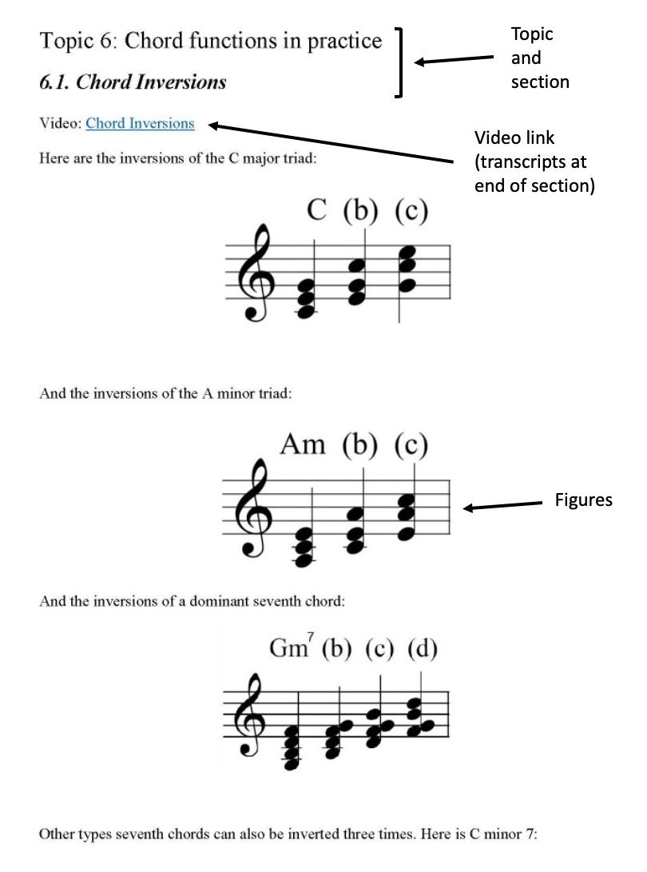
Given the origins of the videos shared openly in this resource, you will notice moments when the presenters may cross-refer lectures, topics, chapters or ‘weeks’ in the course. Where this happens, please simply return to the layout and organisation of this resource to navigate through the materials in the way that you wish to use them.

