Topic 6: Chord functions in practice
Fundamentals of Music Theory / Topic 6: Chord functions in practice https://doi.org/10.2218/ED.9781912669226.6. © Michael Edwards, John Kitchen, Nikki Moran, Zack Moir, Richard Worth, University of Edinburgh, CC BY SA 4.0, unless otherwise indicated.

6.1. Chord Inversions
Video: Chord Inversions
Here are the inversions of the C major triad:
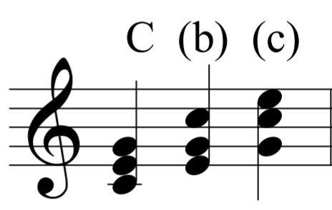

And the inversions of the A minor triad:
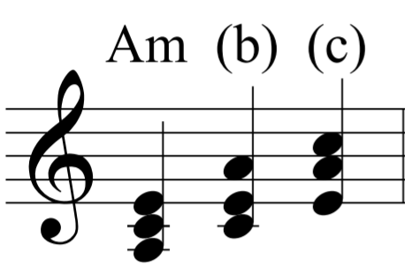
And the inversions of a dominant seventh chord:
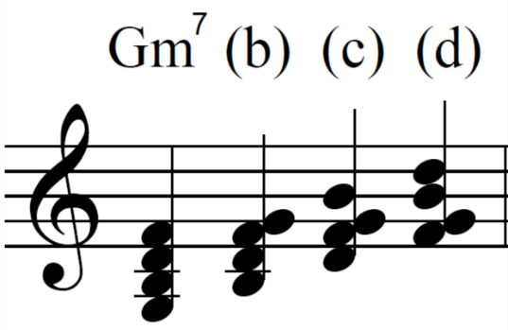

Other types seventh chords can also be inverted three times. Here is C minor 7:
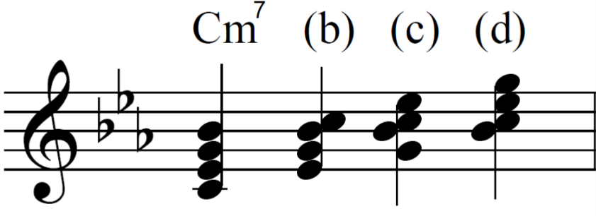
DO THIS:
Practice inverting triads and seventh chords on the keyboard. Practice writing them down.

Using the Root Position for a Final Chord
It’s common to end on a root position chord, for the sake of finality and stability that comes with this. Here is Twinkle Twinkle Little Star, ending on the root position tonic triad:
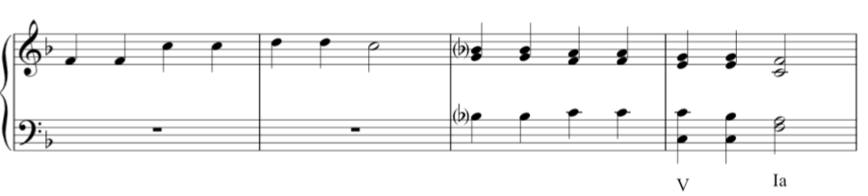
(Played at approximately 04:15 in the video)

Chord Progression Ic V7 I in F Major
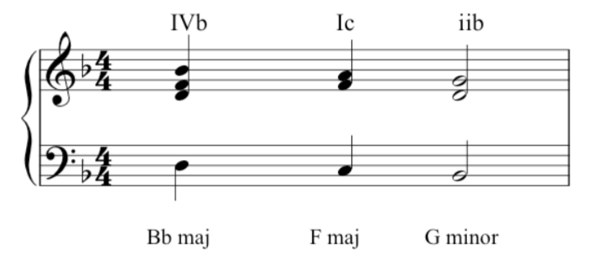

Passing Second Inversion
At 05:50 in the video, John played this example where the second inversion is again used. We are still in F major:
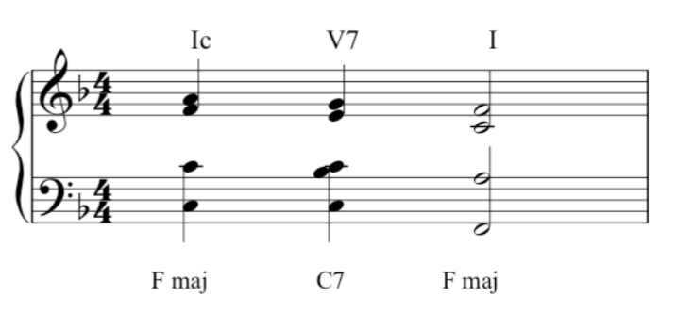

Transcript of the Video
00:05 | Hi there. We’ve already considered the most important chords, but so far we’ve used them only in root position. As you heard then, we use a single note name to identify chords, such as a triad of C-major. Here we are. And now’s the time to consider their inversions. If you take a triad of C-major, obviously it has three possible positions. What we call root position, first inversion, and second inversion. So we’re using the same three notes, but we’re stacking them up differently. We’re switching around the order of the, the same notes. And the, these chords have a slightly different feel to them. The root position feels firm and definite. The first inversion perhaps less so and needs to move on. And the second inversion demands to move on somewhere else. We’ll be considering second inversions in more detail later. But for the meantime, let’s consider a few more chords and their inversions. Let’s take A-minor, because of course this applies to minor triads as well as major. A minor, root position, A minor, first inversion, and A minor, second inversion. Let’s take G major root, first and second, and finally C minor root, first and second. You’ve also heard about some chords which have four notes one of the main ones being the dominant seventh, which has four notes. And obviously a chord with four notes will have three inversions, as well as the root position. So let’s consider a dominant seventh in the key of C major. Here’s C major. And it’s dominant seventh will sound like this in root position. And then in first inversion, second inversion, but also third inversion. Three inversions. And here is another one, key of E-flat. Dominant seventh in root, in first inversion, in second inversion, and in third inversion. Variety in music can be obtained by using the same chord in its various inversions, because each has its own feel.
03:16 | For example, the finality of a root position means that you nearly always find a root position at the end of a piece. And you feel the music has come to rest. Let’s have an example. If you take simple song like Twinkle Twinkle Little Star, and end it on a first inversion, it wouldn’t sound quite right. It’s the correct chord, but it’s the wrong inversion. If we ended the piece on the second inversion, it would sound even more peculiar. And we certainly feel we had not arrived home. If, however, you play it the correct way with root position at the end, it sounds like this. With a feeling of finality. So it’s important to get the right inversion, not just at the end of a piece as we’ve heard there, but throughout the music, throughout any piece of music. So that we call the progression of the harmony sounds pleasing and sounds smooth.
04:39 | There are many progressions we could consider, but one very common one that you find again towards the end of a piece, or the end of a section of a piece, is what we call Ic V I. Let’s stick to F major at the moment. Ic is the second inversion of the tonic, followed by the dominant, followed by root position of the tonic. So that’s Ic V I in F. Now here the second inversion really wants to move on. And this helps the harmony to progress strongly towards the final chord of the piece. Second inversion is a chord which has to be used very carefully. There are only really two main situations when you find it, one being the cadences just described, and the other is what we call a passing second inversion, where three chords move very smoothly with the base in conjunct motion. So the baseline was going to move by step, like this. So the middle of these three chords is a passing second inversion. I’ll play it again. So the chord is, as it were, protected by the ones on either side. So that is a correct way to use the second inversion, and the other one, to repeat, is the Ic V I cadence.

6.2. Cadences
Video: Cadences

Perfect and imperfect cadences
Here is the perfect/authentic cadence again in D major:
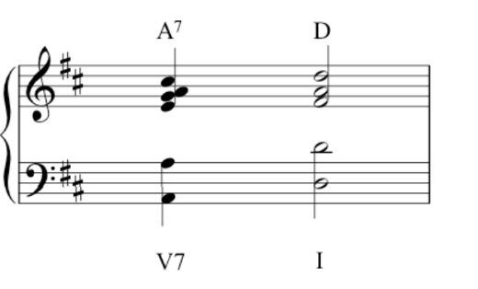
And here is the imperfect/half cadence example played by John:
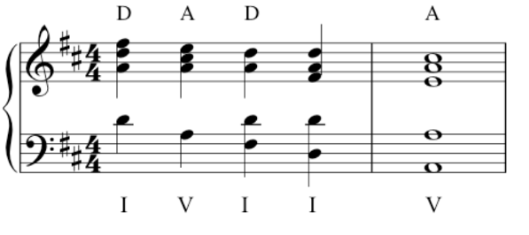
Note that the actual imperfect cadence, from D major to A major, features only in the final two chords.

Interrupted/deceptive cadences
Here we are in D major, with a phrase that finishes on chord vi, B minor.
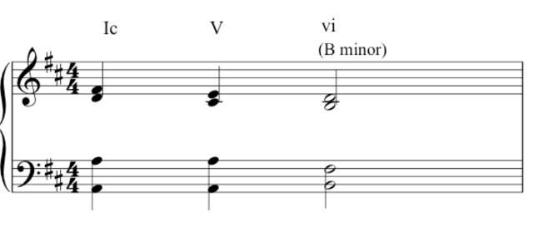
Compare this to the perfect/authentic cadence example:
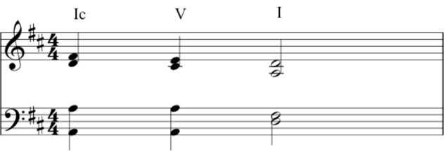
Note again that the first chord is played for context – the actual cadence is the movement from V – vi.
The minor key example in G minor:
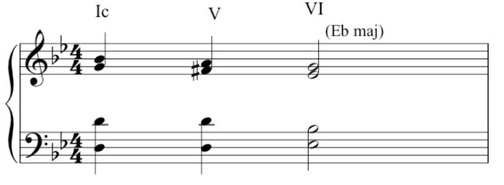
Compared to the minor key perfect/authentic cadence:
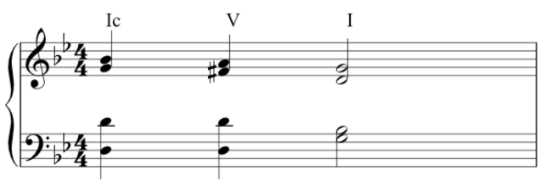

Plagal cadence / mixolydian mode
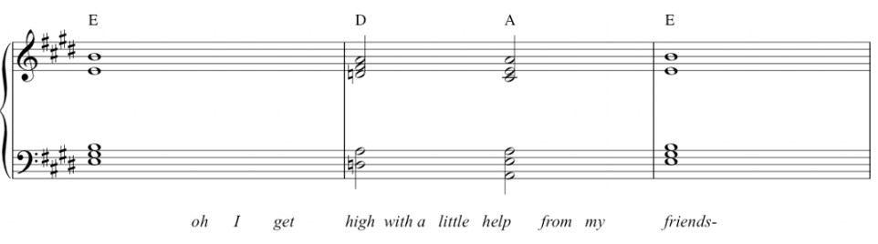
Here’s something to think about: this plagal chord progression could be called a mixolydian cadence. Why? Remember the discussion of modes from 1.4. More on Scales? Playing notes through the octave from G to G, using only the white notes of a keyboard, produces a particular set of tones and semitones which we can call the mixolydian mode. It’s characterized as sounding major in modality, but with a flattened seventh. As John showed, we can transpose modes (in the same way we have been transposing major and minor keys). The melody to the famous song shown in this example follows the mixolydian mode. For more on this progression, which is common in rock and funk, you might enjoy this YouTube link: Mixolydian Mini-Montage.

Transcript of the Video
00:05 | In week four we heard about certain cadences, we heard about perfect cadences, which occur at the end of a piece, and which sound very final. And we also heard about imperfect cadences, sometimes called half cadences which are a temporary stopping point for the music, before the music moves on somewhere else. For example, if we’re a key of D major, we might hear a passage something like this. Which obviously is not the end of a piece. Ending there with an imperfect cadence. But there are two other important cadences to be considered. First of all is the one we call interrupted or sometimes called deceptive.
00:55 | Now, if we recall our Ic-V-I cadence but change just one chord. If we change the final chord to chord six, which is the submediant, it sounds like this. Sounds very different. Let’s compare again. And I think you’ll agree that both the words ‘interrupted’ and ‘deceptive’ describe the effect here very well. The music obviously must continue.
01:36 | I’ll play you another example. That one was in D major, but let’s have one in G minor. Here’s a ic-V-i in G minor. And here’s an interruptive cadence in G minor. Moving to chord six, where the music demands it, that it continues.
02:05 | The other cadence we need to know about is called the plagal cadence, sometimes called a hymn or church cadence because it’s the one you often hear in a ‘Amen’ at the end of a hymn. And it’s chord four to chord one. The subdominant to the tonic, in F major here. This is a cadence that we used a great deal in church music in medieval and renaissance period but subsequently too and interestingly, we find it pops up quite often in newer music, in blues and rock and pop. And, a number of examples can be found in Beatles’ songs. For example, ‘With a Little Help from My Friends’, the last three chords of which are.... The last two of these making up the plagal cadence, IV - I.  And interestingly here, there’s an extra flavour added because of the influence of the third-to-last chord. Which is based on the flattened leading note. Here is a scale of E major. Leading note, this time with the flattened leading note, which gives us what we call the Mixolydian mode. And if you base a chord on that D, It gives you the third last chord of that song. And interestingly it’s also used in ‘Hey Jude’. Here’s the final chords of Hey Jude. With the plagal cadence says the last two, and the Mixolydian chord, the third last.

6.3. Chord Names
Video: Chord Names
We have already looked at all the diatonic triads but let’s be sure that we’ve identified (and learned) all the formal music theoretic names. These names can be used to describe both the scale degree (note) and the triad or extended chord built on that scale degree.
The diatonic triads in F major:
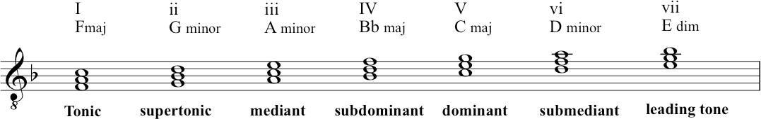
Also here in C major:
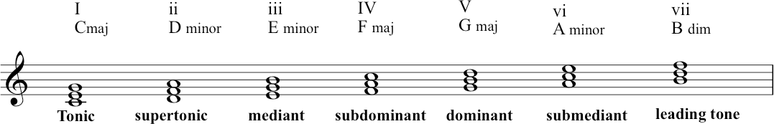

Of course all these triads can be extended to seventh chords, as you saw before. Here they are again in C:

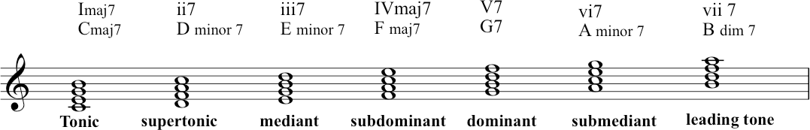

DO THIS:
Play through these triads and seventh chords on the keyboard.

Transcript of the Video
00:00 | You’ve already heard some of the chord names. That is what we call the triads, which are built up on different degrees of the scale. Let’s take the scale of F major. Where we’ve encountered the tonic, which is chord one. A dominant, which is chord five. And the sub-dominant, which is chord four. As we hear these are all major triads. And they’re the three most common, in fact, some music is harmonized entirely by these three chords.
00:58 | But as briefly mentioned before, the diatonic scale of course, contains seven notes. Back to the beginning, and a triad can be built on all of them. Not all the triads we find, will be major. But let’s go up and investigate them.
01:19 | First of all, sticking to the key of F, we’ve had the tonic, on the first degree of the scale. And then above the tonic. Chord two is called the supertonic, because it’s one step above the tonic. And as you’ll hear, the triad is minor, with the notes G, B-flat, and D. We have to remember that the triads have to be made up of notes, which are part of the scale. So it has to be one of those notes. So in this supertonic we have the G, B-flat, and D. Going up another step, the third degree of the scale is called the mediant, what we call chord iii, and its notes are A, C, and E. The sub-dominant we know. The dominant we know. And submediant, chord six is another minor triad. In this case consisting of D, F, and A. The submediant you remember is what we hear in the interrupted cadence that we talked about. And then finally, in the context of F we have, the final triad, which is built on seventh degree of the scale. And which is a diminished triad as you’ll hear, the notes are E, G and B-flat, and that’s chord seven. So to go up through all of these in F major, here we go chord one, two, three, four, five, six, seven, and back to one.
03:20 | Let’s just try them in another key, here’s C major. One, two, three, four, five, six, seven, and back to one.

6.4. Common Chord Progressions
Video link: Common Chord Progression

The Ic V7 I progression
Recapping again – here is Ic V7 I:
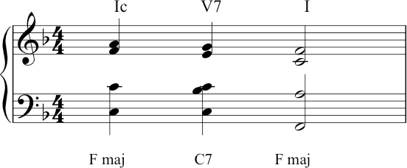

Here is that progression, still in F, in the context of the Christmas song ‘Hark the Herald Angels Sing’:
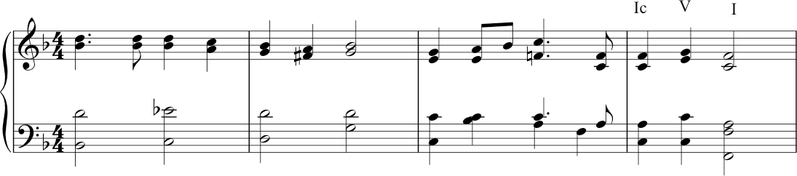

The iib V7 I progression
Firstly, John played A minor 7. In the key of G major, this is the supertonic- ii, but as a seventh chord it is ii7. John then puts it into first inversion:

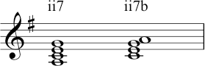

Here is that chord in context for the ii7b V I chord progression (very common in jazz also):

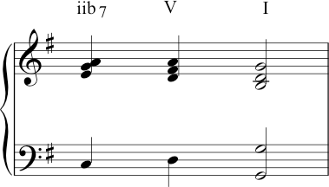

Circle of Fifths (in C major)
Here is the first example of the chord progression using the circle of fifths:
(Note this shows the chord names and the Roman Numerals: lower case Roman Numerals denote a minor chord except for viio, which denotes the diminished chord). Here is the example played in G major:
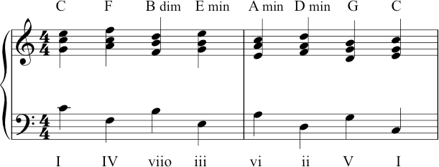

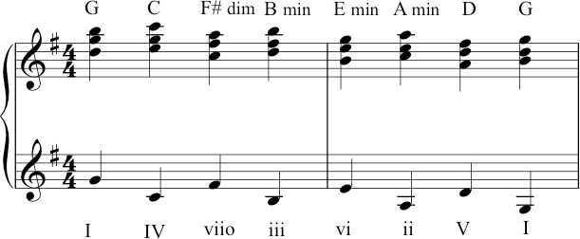

Two things to note here. Firstly, John played this in quite a high register, so please note the lower clef is also notated using the treble clef, rather than the usual bass clef. Secondly, this example (which was prepared originally by Richard) features all the chord names again. These are now in the key of G, but of course the Roman Numerals remain the same – which is of course the advantage of that system: it is not key specific, which makes it more flexible for analysis.

Vivaldi example (at 03:55 in the video)
This excerpt is in A minor and each bass notes is played twice (repeated an octave lower). The sequence of bass notes is: D, G, C, F, B, E, A.

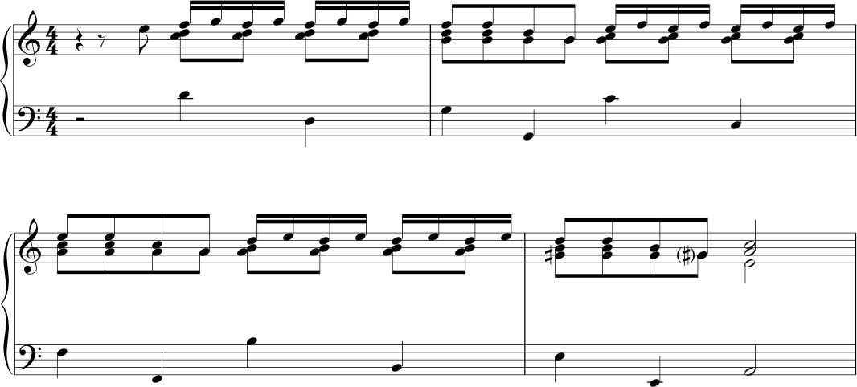

Autumn leaves (played at 04:33)
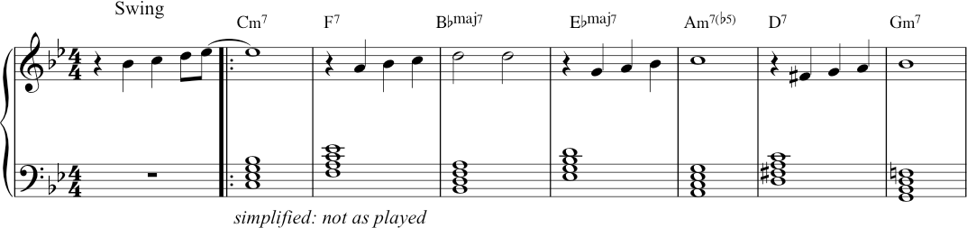

The chords are written out here as semibreves, stacked in thirds in order to make it easy to see them. But this is not how John performed (‘realised’) them in the video.
As you know, a lot of performance – especially that which is based on lead-sheet symbols rather than fully composed voicings – will require the performer to extemporise the rhythms and inversions as they go.

Circle of fifths with inversions
Here the second, fourth and sixth chords are in first inversion. Note how this makes the bass line smoother.
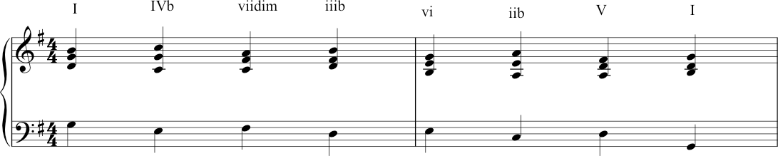

Using the circle of fifths to modulate to the relative minor (key of C major)
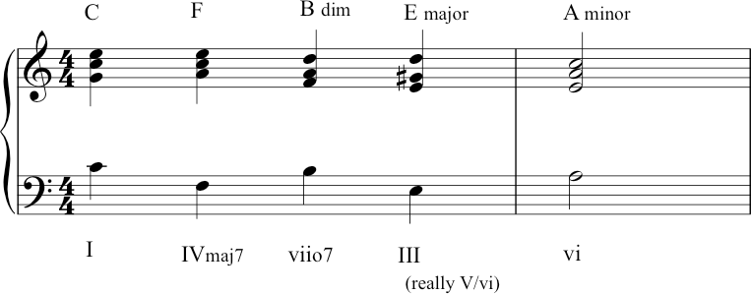
Here the circle of fifths stops at A on the relative minor. The difference from the earlier example is that instead of the fourth chord being iii (E minor), it’s been changed into III (E major), by moving the G natural to a G-sharp.

This E major is the dominant (chord V) of A minor – this helps to give a sense of modulation, rather than just carrying on through the circle back to C.

Using circle of fifths to modulate to another key
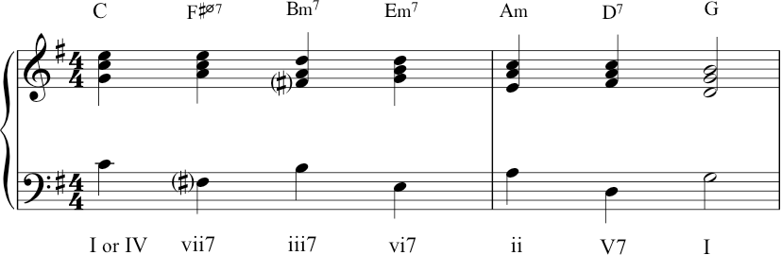
In this case John travelled from C major to G major. Imagine that the performance was (still) in C major – in that case, C was our tonic, our chord I. But now that we want to move to G, let’s re-imagine that C. Imagine we’re now thinking in G major. That makes the C major triad a chord IV in our new key of G major – it becomes the subdominant.

Pivot chord
This is sometimes called a pivot chord: C is the pivot chord, acting as a tonic in the old key and becoming the subdominant in our new key. The next chord is F-sharp half-diminished. (In a previous lecture, recall that Zack and Nikki demonstrated the difference between the (fully) diminished seventh and half- diminished seventh.) Importantly, that F-sharp chord is moving us into the tonality of G major. Why? Because the note of F-sharp is foreign to the key of C major, but it has a very strong identity in G major, as the leading note which leads our ear to a new tonic. From there, it’s just iii7 vi7 ii V7 I. (Another very popular sequence in jazz and Tin Pan Alley songs.)

Transcript of the Video
00:00 | In music, we find that certain patterns of chords, what we call chord progressions, recur frequently particularly at cadences. And we remind ourselves, of course, of the commonest cadence, Ic V I, which sometimes is enhanced by a dominant seventh on the second last chord. So we hear this. So a seventh is added to the dominant chord, which serves to pull the music strongly towards the tonic. So it’s a very strong progression and gives a pleasing finality to the cadence. You find it in lots of music, for example the well known carol, Hark the Herald Angel Sing goes like this. Or Happy Birthday To You, it goes like this. And that’s possibly the commonest of the chords progressions and cadences.  Another cadential progression which we often find in, involves a different chord in the third to last position instead of the one C, we find two B and often with a seventh added chord. Let’s stick to G major. There G major, chord two. The supertonic sounds like that. We add a seventh to it, and then we put that in first inversion. So, we rearrange the notes in this order, and that’s our third to last chord. I’ll just play that one once again. In addition to these and other cadential progressions, are recurrent patterns of chords. We find chord sequences.
02:22 | The most common of these sequences is called the Circle of Fifths, which I think has already been mentioned. And this is a very important particular pattern. And it’s found in 18th century music, by composers like Vivaldi, writing in early 18th century Venice, but also in later music of all sorts. The circle of fifths is so called because of the pattern of notes in the bass going like this from C to F, B to E, A to D, G to C, so you’re going down fifths. And if you put root position chords on top of that in the context of the key of C, it would sound like this. I’ll play that again. Here we are in, the same thing in G, circle of fifths in G, all root position chords. Now let’s hear it with some real music. I mentioned the composer Vivaldi. Well, here’s an example of a short piece by Vivaldi from his Concerto Grosso, Opus 3. And he uses a circle of fifths, and it sounds like this. And here’s the music again. You find exactly the same pattern of chords in the popular song, ‘Autumn Leaves’. Again, all the chords are in root position. This time, we’re in G minor. And it goes like this. Here’s the circle.
05:03 | So far the circle of fifths we’ve had have been with chords in the root position. But the circle of fifths also works with some of the cords in first inversion. Here’s G major. G major again. You don’t see the pattern of fifths in the bass because some of the chords are in the different inversion because the second fourth and sixth chords are all first inversion. But it’s the same chords so instead of, [MUSIC] We have [MUSIC]. And again, I’ll play the whole thing.  And finally, the circle of fifths is sometimes used to modulate to a different key. Depending on how you arrange things, you can actually use the circle of fifths to change key. So for example, if we’re in C major. And we want to go to A minor, we might do this. The all-important G-sharp, which is the leading note of A minor, pulls us towards A minor but we have the circle there in the bass, once again C major to A minor Or, we might want to go to G major. So, if we start again in C. The important thing there, is that the first fifth is not perfect. It doesn’t go F, it doesn’t go C, F. It goes C, F-sharp, and that pulls around to G. So, here we are, again. C major to G major.

6.5. Modulation
Video: Modulation
Here are two possibilities for modulation, in the hymn, ‘While shepherds watched their flocks by night’.
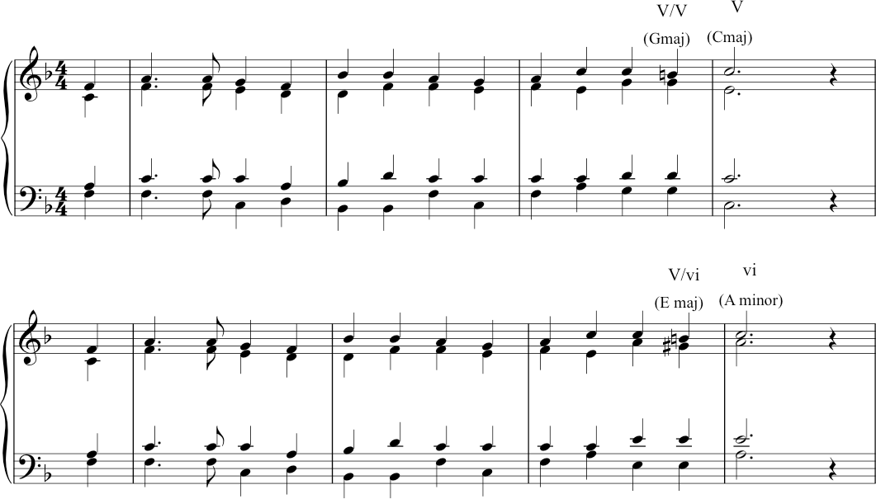

Secondary dominant chords
Both of these use ‘secondary dominant’ chords. This choice of harmonization creates an effect such that we can have something of the experience of a perfect cadence (chord movement from V to I) – and yet this happens in a new key. By introducing accidentals – chromatic notes – to harmonize a note, we can tilt the direction of harmonic travel towards a new key.
So, both of these options above take us towards a new key, away from the original F major. The first one hints at a modulation to C major from the original F major. The second one moves towards A minor instead. So, instead of:
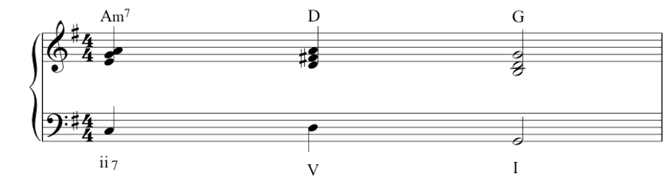
We can have:
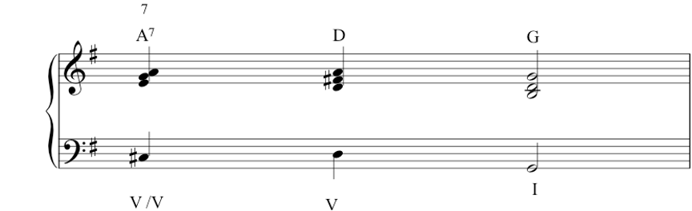

V/V Secondary dominant
The following example is as used by Bach in a cantata, ‘Wie schon leuchtet der Morgenstern’ (BWV 1). 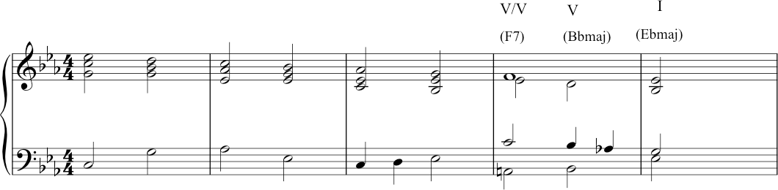

Transcript of the Video
00:00 | When talking about circles of fifths, we consider those that could help you to modulate, i.e. to move the music to another key, and I’d like to think a little but more about this, modulation is a very important concept in music, means going from one key to another. Music would be very boring, boring and dull. If pieces remained in the same key all the time. So we find that modulations occur a lot in music, and sometimes a great deal. And this keeps the music interesting, and gives us a feeling, that we’re moving on somewhere.
00:41 | The commonest modulation, that you often hear, quite near the beginning of a piece is to the dominant. So for example, a piece in F major might move to C major quite soon in the, its course. So for example, the well-known Christmas  Carol, While shepherds watch their flocks by night goes like this. And we’re now in the dominant of C major. If you really wanted, you could even modulate that to A minor, it would sound like this. Now it sounds slightly more forced, perhaps not quite so natural. But anyway, the, that illustrates the concept of modulation; going to a different key.
01:41 | These are quite definite modulations, where the new key is established quite firmly. But we also find many instances of. Keys simply being hinted at. Rather than a true modulation taking place. We find that a key is suggested. And again, this gives the music interest. And means that we feel we’re moving somewhere. And one of the commonest of these involves a chord, which we usually call the secondary dominant, which means a dominant 7th of dominant generally. And you find this towards the end of a piece, as I said gives greater colour, greater variety to the chord progression. And can again, make the cadence sound more final, and more satisfying.
02:31 | If, for example, we return to the progression already mentioned, iib7, V, I, that sounded like this. That’s iib7, V, I in G major. If we make one alteration in the bass. Rather than C natural, if we change that to a C-sharp, it sounds like this. What we’ve created there is actually the dominant 7th in the key of D major. But in this case, it doesn’t go to D major, it just suggests D major and goes-immediately to G. But you get that extra colour. And so it’s hinting at a new key but not actually modulating to it.
03:32 | Many composers have used this, Bach is an example. For example the choral Wie schon leuchter der morgenstern ends like this. He could have ended (this). And that would sound perfectly good, but this added secondly dominant, makes it just a bit more interesting. Where we’ve hinted at another key, without actually modulating. Another example of the secondary dominant, and can be found in the tune Blackbird which ends. There we’re in g major and the third last chord is the secondary dominant, which suggests, again, D major. But actually, immediately comes back to G. So here it is again.
04:55 | A move to the sub-dominant key often occurs later in the piece, because it helps emphasize the feeling of coming home. Sometimes composers actually modulate to the subdominant, other times they simply hint at it. If we’re in the key of C, the subdominant chord is F. The subdominant scale involves the note B-flat. And if we want to give the feeling of having moved to the sub-dominant that B-flat is an important note to introduce. So for example, if you were towards the end of a piece in C, you might hear this. By introducing that B-flat, which is one of the notes of the scale of F, the subdominant. And doesn’t enter into the scale of C. That B-flat helps you to think you’re, that B-flat gives you the flavour of the subdominant. So here’s the progression again. And you find this quite frequently towards the end of pieces. Either of a hint of the subdominant, or something slightly stronger. A famous example of it can be heard towards the end of the Prelude by Bach, the Prelude in C from Book one of the 48 Preludes and Fugues. And he introduces the B-flat just towards the end, to give the feeling of, hinting at F major, not actually going to F major; but hinting at it. And thus giving a ‘subdominant leaning’ as we sometimes call it. So the chords at the end of this piece sound like this, once again. And we’ll finish by hearing the complete Prelude in C, played on harpsichord, as it would have been in Bach’s own day.

