Topic 2: Tonal music language - concepts and theory
Fundamentals of Music Theory/ Topic 2: Tonal music language - concepts and theory https://doi.org/10.2218/ED.9781912669226.2. © Michael Edwards, John Kitchen, Nikki Moran, Zack Moir, Richard Worth, University of Edinburgh, CC BY SA 4.0, unless otherwise indicated.

2.1. Sharps and Flats
Video: Sharps and Flats
When thinking about sharps and flats and tones and semitones etc, it may be useful to visualise an instrument – particularly for those who already play. Below are images of piano keyboards and guitar fretboards. Look at them whenever you need them. In each case, there is a blank version, and one which has been annotated with pitch names, labelling all sharps and flats.
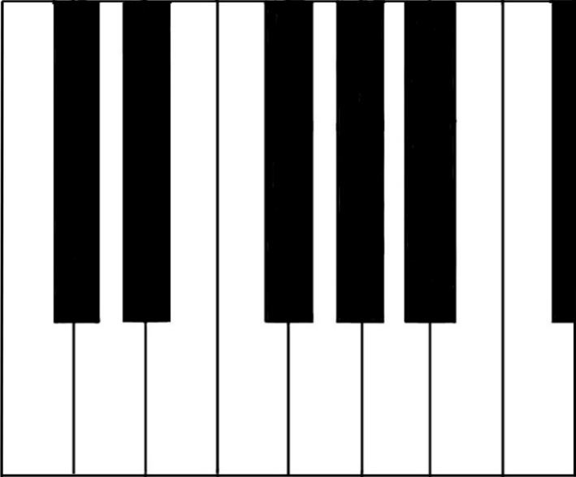
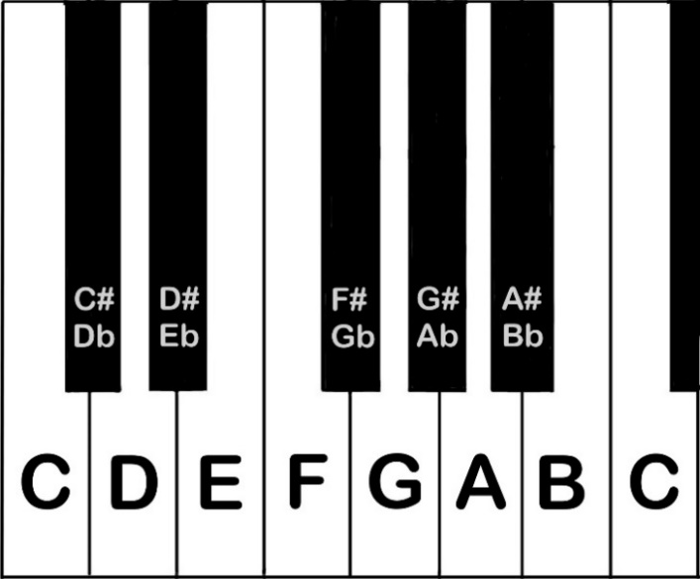
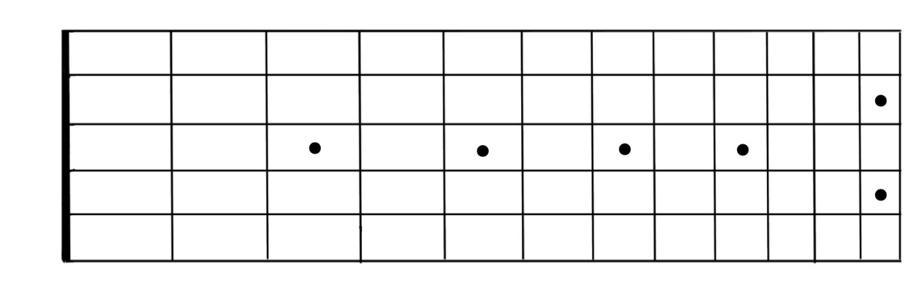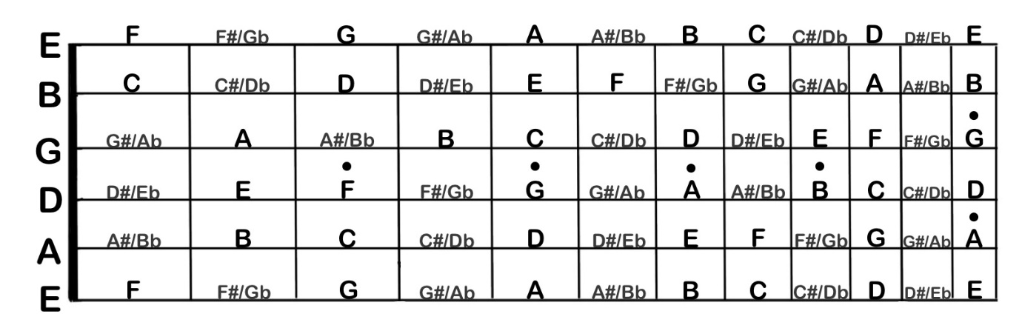
In the video, we ask you to try to build D major. So, what are the steps? First, we need to start on D and apply the pattern TTSTTTS. The image below illustrates this – and it reveals that this scale requires an F-sharp and a C-sharp: in order to make a whole Tones (rather than Semitones) between scale degrees 2 and 3, and between scale degrees 6 and 7, we have to make the interval wider than the one that we’d get if we just stuck to the white keys.
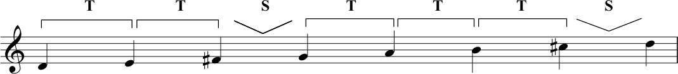D major scale example.

Transcript of the Video
0:00 | Hi. So this week, what we want to talk about follows on from what Richard and I illustrated last week, and that was the concept of tones and semitones. And what we did was we picked the note C and we applied the pattern of tone, tone, semitone, tone, tone, tone, semitone. And we called the result the major scale.
0:26 | So what we can do is we can pick any other note and apply the same pattern tone, tone, semitone, tone, tone, tone semitone, and the result is a major scale. So, what we’re going to do for the rest of this lecture is we’re going to refer to that pattern of tones and semitones as the major scale pattern. So, we’ll pick another note now I’m going to pick this note here - G. What I’m going to do is apply the major scale pattern to that so tone, tone, semitone, tone, tone, tone, semitone. Now you’ll notice actually when we played C, we only played the white notes on the piano, we didn’t touch any of the other ones, these black notes.
1:05 | When I started on G we need to play this note here. And this is called F-sharp in this context. So let’s take a closer look at it. It’s called F-sharp because it is one semitone sharper, or higher than F. But you might also notice that by the same rationale, we could say that it’s one semitone lower than G. We could then call it G-flat, which means one semitone lower than G. You’ll remember from last week that a semitone is a fixed interval. There are semitones between every note that I played just then. But you’ll also notice there are places on the piano keyboard where we have two white notes and no black notes in between them. It happens between B and C and it also happens between E and F.  Some of you that have come to this course as guitar players might already recognize this. So if you think about your E strings, for instance, if you play the first fret on your E strings, you’re more likely going to call this note F. And that’s the same if you play the first fret on the B string, you’re more likely going to call this C. And that really just serves to illustrate, just for a different instrument really, that the distance between B and C, the interval B and C is a semitone, and the interval between E and F is a semitone. And that’s why if you look back at the piano keyboard, there isn’t a black note in between these pairs of notes.  You might be thinking that it seems a bit arbitrary. That you have a black note between some pairs of white notes and there’s a semitone there, and yet, between other pairs of white notes, you get a semitone all by itself with no black notes in between.
2:53 | But actually, this unevenness, this asymmetry that we get in the spread of the note names as they repeat across the octaves. This is something that gives eyes and our ears - more importantly our ears kind of landmarks that we can latch on to.
3:11 | So, a minute ago we played G major. We started on the note G and we applied our major scale pattern. We found that we needed to use an F-sharp. Let’s pick another note this time. Let’s pick the note F, and apply this pattern. So we get tone, tone, semitone. Again we’ve touched another black note there. Tone, tone, tone, and a semitone between E and F as we’ve just discussed. Now let’s look back then at this. So we’ve got F, G. So, a tone apart. G, A, which is a tone apart. And then we’ve got this black note. As Nikki said, because this is a little bit sharper than A, it’s a semitone sharper than A. We could call this A-sharp.
3:55 | But it’s also a semitone lower than B. So we could call it B-flat. So which are we going to call it, in this case? Well, as we talked about last week, scales need one of each letter name. So, actually, when we go up from F, we’re going to go F to G, G to A, not to A-sharp, because that’s another type of A. We’re going to go to B-flat, which is a semitone above A, or a semitone below B. And then a tone onto C up to D, E, and we have another semitone to take us back to our tonic, F.
4:28 | So it’s one thing to understand it, looking at the piano keyboard. It is another thing to get it into your own practice. You can use a keyboard app, or you can use a piano if you’ve got one, or you can go into your own instrument, or you can sing. But this time, start for yourself, do it for yourself. Start on D. Figure it out. Go from D up to D, an octave higher, and then show yourself what the pattern of tones and semitones is if you’re just using the, the plain note names. And then, go back to that major scale pattern. Tone, tone semitone, tone, tone, tone, semitone. And then see for yourself what note names you have to alter in order to recreate that major scale pattern.  So we should make a little bit of an apology. Because what we’ve been doing is talking about white notes and black notes, and clearly that’s only really relevant if we’re looking at a piano keyboard. Guitar players don’t have white notes and black notes, for instance.
5:24 | The reason that we’re doing this, and the reason that for this particular lecture we’ve made it so piano-centric is just because the layer of the keyboard’s actually a really clear and really beautiful way to illustrate where semi-tones are. And from that, you can build patterns of tones and semitones. So, it is important for you understand that on your own instrument, but just be aware that you can always come back to this visual, and there there’s picture of a piano keyboard in this week’s supporting material on the website for you. And as Nikki said, you can go on the internet and find an app that will do this for you absolutely no problem as well.  So the way to learn this and to actually understand it is to get it into your eyes, into your head, and into your fingers and into your ears. So, you can practice in all these different ways. Practice hearing and playing whole tones. Practice hearing and playing semitones.

2.2. Keys and Key Signatures
Video: Keys and Key Signatures
In the video we talked about the fact that key signatures are very useful in helping with the appearance of written music. The following is the tune, Twinkle Twinkle Little Star, written in the key of B major without a key signature. Although this is a very simple melody, you can see that, since B major includes five sharps, writing these out on each occasion could make it difficult to follow, particularly if you were sight-reading this music.
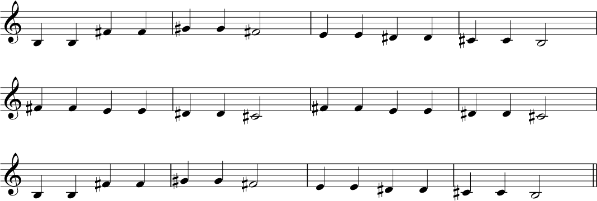

The next image shows notation for the same melody – but this time we’ve used the key signature for B major. In this case, the key signature tells us (right at the start of the line) that all Fs, Cs, Gs, Ds and As are sharpened. This makes the notation easier to read as it is not cluttered with accidentals.
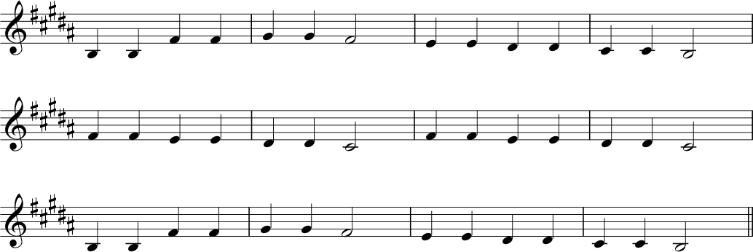

Circle of fifths
We talk about the circle of fifths in the video. It is helpful to have a more detailed look at it here. This diagram helps us to see the signatures of sharps or flats needed to construct each key and its relative minor.
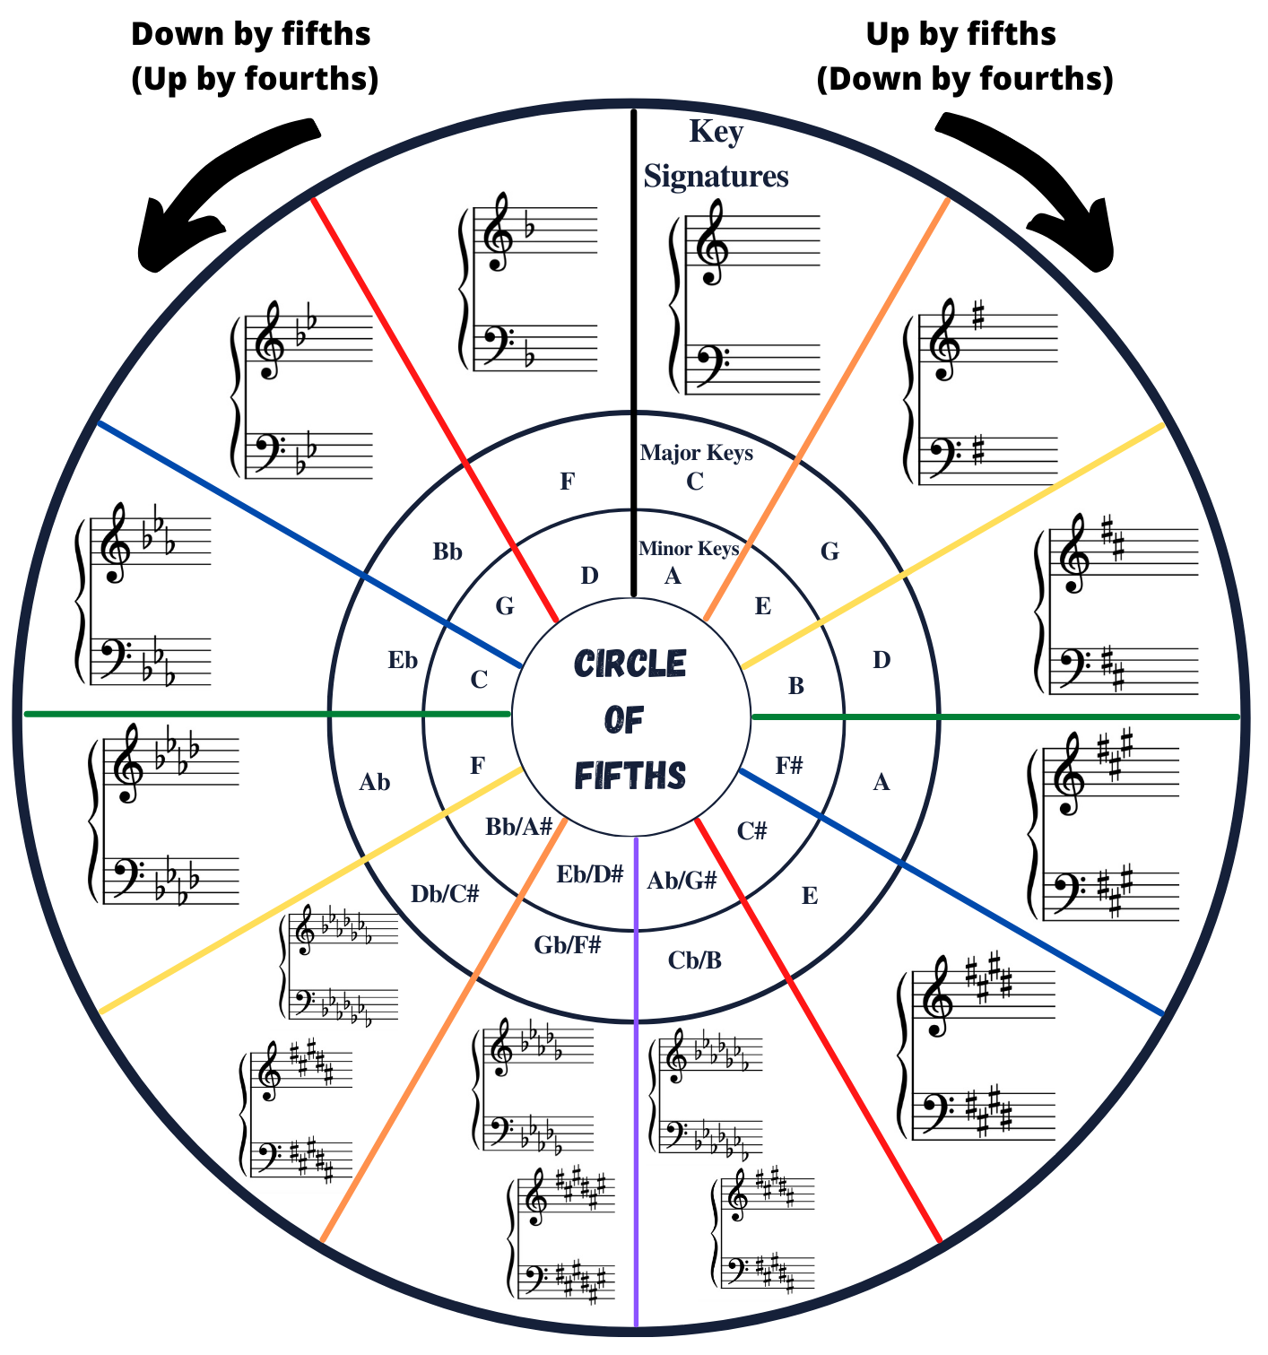
The circle of fifths is a really valuable tool and a handy way to visualise many of the things that we have been talking about in this lecture, and those that follow. Let’s highlight a few useful things at this point that will help you with key signatures, and which will also be useful for thinking about scales and harmonic progressions later in the course.

The order of sharps and flats
To reiterate the video lecture: when sharps and flats appear in a key signature, they always do so in a specific order. For sharps, the order is: F C G D A E B (clockwise round the circle of fifths). For flats, the order is: B E A D G C F (anticlockwise around the circle of fifths)

Reading Key Signatures
As we noted in the video, the circle of fifths can also be used to help us to read key signatures. It’s a matter of counting the points on the circle: count the number of sharps or flats in the signature. If it’s a signature that uses sharps, then we count clockwise from C (in the 12 o’clock position). If it uses flats, then we count anticlockwise...
So, imagine a key signature with three sharps. We know that the sharps will be F, C and G (always in that order), so we will count 3 steps from C.
1 = C → G
2 = G → D
3 = D → A.
Therefore, the key represented by three sharps is A major. Ta-daaaaahhh!
Let’s try one with flats. Imagine a key signature with six flats. Again, we are simply count steps round the circle. This time we’re going anticlockwise (because we’re dealing with flats) from C. And we need to move 6 steps. This time we get...
1 = C → F
2 = F → Bb
3 = Bb → Eb
4 = Eb → Ab
5 = Ab → Db
6 = Db → Gb
Ta –dahhhh! The key represented by six flats is G-flat major.
Try this yourself and see how you get on. Always count from C and to go clockwise for sharps and anticlockwise for flats. Remember, you will NEVER have a key signature containing a mix of sharps and flats.

Writing Key Signatures
We can use the circle of fifths to help us write key signatures too. Just reverse the process. So, if someone asks you to write the key signature for D major, then count the steps from C until you get to D:
C → G = 1
G → D = 2
Therefore, D requires two sharps.
We know the order of sharps to be F-sharp C-sharp G-sharp D-sharp A-sharp E-sharp B-sharp, so if the key signature needs two sharps, we use the first 2. So, D major needs F-sharp and C-sharp!

Appearance of Key Signatures
It is important that key signatures are written correctly. Why? Because we need to be able to glance quickly and recognise them. When we get used to looking at key signatures, we begin to see a complete visual symbol – a complete unit, like an entire word whose letters no longer need sounding out. WARNING! Key signatures do move around a bit, depending on the clef... We discuss clefs later this week. For your reference, here are all key signatures presented in four different clefs.

Key signatures with SHARPS
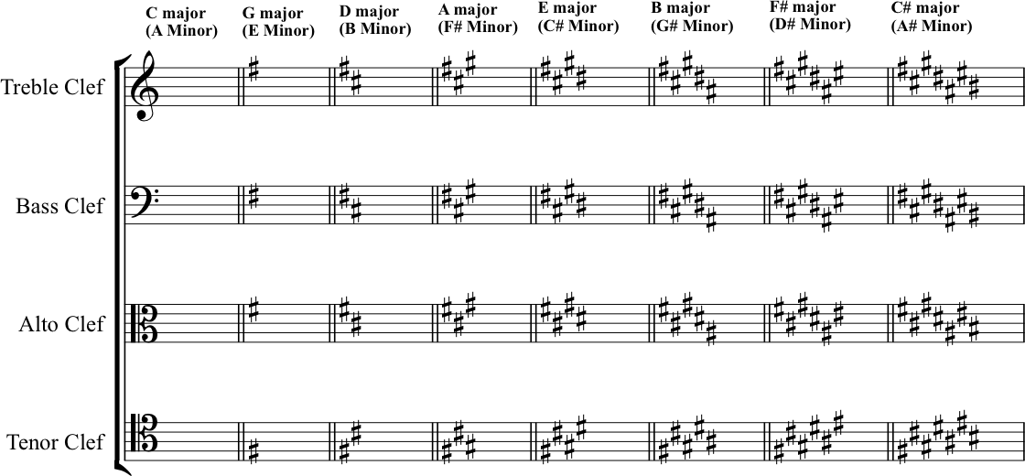

Key Signatures with FLATS
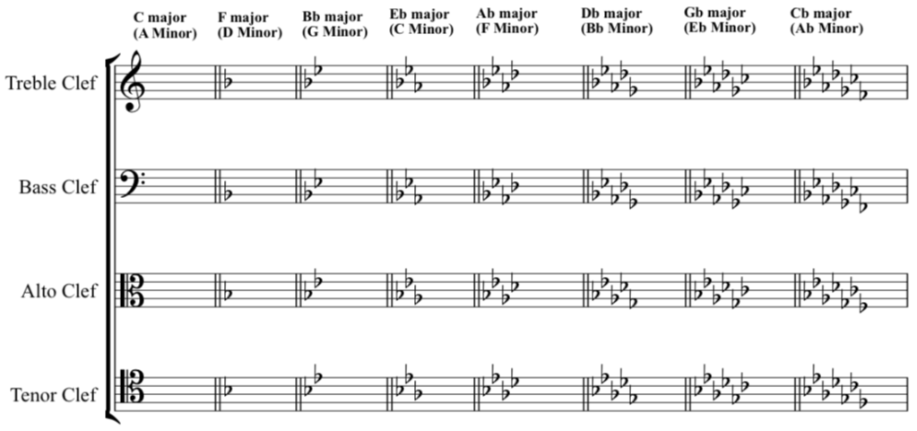

Transcript of the Video
0:05 | So in the last section we talked about scales and notes that we need to create these scales in quite an abstract theoretical way. Now it’s a good time to actually go back and relate this to music in more general terms. So if you had a piece of music that just used the notes of C major.
0:23 | That’s the notes of the C major scale. We could say that this music is in the key of C major. And if we had the notes of the G major scale; with that F-sharp, we can say that this is in the key of G major.
0:46 | So what do we actually mean by key? Well, it’s quite a complex term really, and it relates not only to the notes that are available to us, as drawn from the scale, but also to the way that we subconsciously hear the way that these notes work with each other and react with each other and the relationship that exists between each of these notes.  So, that feeling in G-major. We have a sense, that out of all these notes. G has got a kind of gravity for us. G pulls us home. G is our tonic. Yeah, we could say that when we are playing a piece of music that uses these notes; when we arrive back at G, there’s a feeling of completeness or that we’re at rest; it’s the home note if you like. So, when we are talking about scales and keys, they are sometimes confused as terms, and what we really mean when we are talking about scales is this sort of ordered. String of notes. When we’re talking about key, just to reiterate, it is this relationship and the feeling that pulls us back to the tonic when we feel at rest.  Okay, so, if you did the exercise that we used in the last section where we started on D, you’ll note that we got in D-major, we got an F-sharp and the C-sharp. So, if were looking at piece of music written down in a score, how would we know what key it’s in?
2:16 | What we might want to do is look to see whether any of the Fs are sharpened, and we say, yes, all the Fs have got a sharp next to them. And we see that, oh, also, all the Cs have got a sharp next to them. In the context of everything we’ve just said, so far in this lecture, it would make a lot of sense to say, oh, this piece of music’s probably in D major.  So given that we know in this case that we’re going to have every F-sharp and every C as a sharp, it might make sense for us to know this information up front, right at the start. And the convention that we’ve got for this, we call ‘key signatures’.
2:16 | What we might want to do is look to see whether any of the Fs are sharpened, and we say, yes, all the Fs have got a sharp next to them. And we see that, oh, also, all the Cs have got a sharp next to them. In the context of everything we’ve just said, so far in this lecture, it would make a lot of sense to say, oh, this piece of music’s probably in D major.  So given that we know in this case that we’re going to have every F and every C as a sharp, it might make sense for us to know this information up front, right at the start. And the convention that we’ve got for this, we call ‘key signatures’.
2:59 | So by announcing what we’re going to have in terms of sharps or flats right at the very start, it does a couple of things for us. So firstly from a musical point of view, what it does is it, it gives us an indication of where the tonic is, what’s going to be most important. And also the relationship that exists between the notes in this key.
3:17 | But also, just from a visual point of view, what it does is it really tidies things up. So that no longer do we have the need for every F and every C to have a sharp in front of it to say that these are going to be F- and C-sharp. Actually, we see this at the very start by means of the key signature, and we take it as read throughout unless we are signalled otherwise.  There’s additional on the website that’ll help you learn more about the conventions of notation because what we are talking about here, is the idea of graphically representing, for people to read and to write with, all of these concepts and terms that we’re, that we’re introducing to you for, for music theory.
3:57 | So key signatures are used to tell whoever’s looking at the music, what key the music’s in and to do so by signalling, which notes are going to be sharp and which notes are going to be flat; from the outset.
4:09 | There’s a really logical way for writing key signatures. And also, if we’re looking at key signature and determining what key it signifies.  We call this the circle, or sometimes the cycle of fifths. Let’s start with C. C, as we know, C major is signified by having no sharps and no flats. That’s the key signature. G, however, contains one sharp. F-sharp. F-sharp. G. And D, has got two sharps; it’s also got an F-sharp, and now it’s also got a C-sharp on top.
4:53 | So if we look at the cycle of fifths, we can see when we look at the key signature for C, there are no sharps or flats. And this makes sense because when we play C major and we’re looking at it on the piano, we only use the white notes. If we look at the next stage round clockwise, we see that we’re looking at G major, which is signified by having an F-sharp. If we look at the next stage again, clockwise. We see that we’ve got D major, and that this is an F-sharp and a C-sharp.
5:21 | So you’ll note, notice the cycle of fifth is proceeding literally stages of a fifth. C, D, E, F, G. And then we’ve got G, A, B, C, D. Each stage includes five note names forwards. And each stage includes one additional sharp as we go around the circle.
5:43 | Okay, so we’ve looked at our circle, the circle of fifths moving around clockwise where each stage takes on five notes for further forward. Okay, what happens if we look anticlockwise? The results of this is that we’re, in fact, going, moving in fourths instead of fifths. So, we’re starting at C again.
6:05 | So, let’s start with C and move around in fourths. So if we go from C, we go to the fourth note of C major. C, D, E, F. So we’re going to start on F. Now just to illustrate this really, let’s apply the major scale pattern to F. Okay, when we do that we get F, G, A, B-flat, C, D, E, F. So what we can say now is that the scale of F has a B-flat in it. One flat. One flat. One B-flat. Clockwise sharps, anti-clockwise, the first thing we notice is that we’re introducing one flat. Okay, so we might be able to guess where this is going. Starting from the F, let’s travel another fourth around the circle. So we’re going anticlockwise. F, G, A, B-flat. B-flat.
6:56 | So, we can take our B-flat as our tonic now, and we’re going to apply our major scale pattern. We’ve got B-flat, C, D, and a semitone takes us to E-flat, F, G, A and back to B- Flat. So what we’ve found now is we’ve got a B-flat and an E-flat, so we’ve added an extra flat. for an extra step, around the circle, just as we did for sharps. Therefore, B-flat has B-flat and E-flat. So it’s all fair and well, then, when we’re looking at the circle of fifths to say when we move around clockwise, we’re going to add one extra sharp. Or when we move anticlockwise, for each step, we’re going to add one extra flat. But it’s not really enough information. We need to know, which extra sharps and which extra flats we’re going to add for each step.
7:43 | So we could really go back to the keyboard and work it out from first principles, and for each new tonic, we build a major scale, and we work out which extra sharps we’ve got and which extra flats we’ve got. But that’s time consuming, it’s a bit of a pain; we need to remember lots of different information. Actually, having some sort of mnemonic device for the order that sharps and flats occur is probably going to be quite useful. And it’s really common for people to learn it in this way. So, and good pneumonic advice for the order that the sharps occur.
8:14 | Father Christmas gave Dad an Electric Blanket. So, that’s F, C, G, D, A, E, B.  You could also say, Father Charles Goes Down And Ends Battle. That’s a very common one to hear people talking about. Okay, so there’s two. You could make your own up. Now, this being the circle of fifths, with all the patterns inherent in that, when we go anticlockwise and start introducing flats, you might not be that surprised to find out that the order in which flats occur, is actually the same sequence as the sharps but in reverse. B, E, A, D, G, E, C, F. So two sentences that we could use to try and remember that sequence,.  Well, we’ve got Blanket Explodes And Dad Gets cold feet, which is the reverse of the Father Christmas one. Or Battle Ends and Down Goes Charles’ Father.
9:29 | So, we now know that if you see a key signature at the start of a piece of music, and it’s got four sharps in it; those four sharps have to be F, C, G and D. And we know that if you see a key signature with three flats in it, they’re going to have to be B, E and A.
9:51 | So we’ve been talking about sharps and flats within keys. So that’s to say that we’ve been talking about the sharps that belong to a particular key. Or the flats that belong to a particular key. But what happens if we want to use a note that’s out with the pool of not available to us in any given key? So say we were in G major. We wanted to use a B-flat for instance. We know this isn’t part of the key signature. But there’s absolutely nothing wrong with using a B-flat in the overall context of G major.
10:21 | If we do this, if we use a sharp or a flat in a place that we don’t expect that based on the key signature, we call these accidentals; let’s say it’s absolutely fine to use these. We just need to be aware of some conventions surrounding them, so we can actually use them, talk about them accurately. Have a look at the example:  We can see that in this example, the music got a key signature of one sharp, so we know it’s going to be an F-sharp, and we know that this signals G major; however, there are notes here that don’t belong to the key; there are some accidentals. As we work from left to right, looking along the example, we can see that there’s a sharp sign in front of the third note, meaning that this is a G-sharp.  And looking further along, we notice a flat in front of the B. Making it a B-flat. Now, just in front of the next B, we see a symbol that we haven’t seen before. This is another type of accidental, and we call it a natural. Its purpose is to cancel out the sharps or flats that have just previously been shown.
11:46 | One thing that we need to mention at this point is that when an accidental is used, it’s actually effective for the whole bar. We’ll discuss what bars mean more next week, but really what we mean is until we see the next vertical line across the stave. So the second bar, we see a B-flat. And this means that any other B in that bar is also a flat. The natural sign in front of the last note in this bar actually cancels out the flat, meaning that this particular note is to be played as a B-Natural. That is to say that it is no longer a B-flat. And again, although this is the last note in the bar, this instruction lasts right to the end of the bar.
12:31 | If we can look at the next bar, we see a natural in front of the F. Again, this cancels out the F-sharp in the key signature. And it means that this note is to be played as an F-Natural, not an F-sharp.
12:48 | Have a look at additional material on the website. We’ve included some practice questions to help you get to grips with this.

2.3. Minor Keys and Minor Scales
Video: Minor Keys and Minor Scales

Major/Minor Relationships
Right. Let’s get to grips with the relationship of major and minor scales.
Major and minor scales can be related in different ways. We can make a major scale starting on C, and we can also make a minor scale starting on C. Or on Bb. Or on G, etc. In music theory-speak, we would describe this major/minor relationship as a ‘parallel’, or ‘tonic’ relationship. In the video, we spoke about ‘relative majors’ and ‘relative minors’. This is a music theory shorthand, referring to major and minor scales which are related to one another because they share a KEY SIGNATURE. Let’s have a quick recap of this.
We’ll take the example of A major. Go back to the cycle of fifths diagram and find its relative minor. It is… F-sharp. The key signature of both A major and F-sharp minor feature three sharps (F-sharp, C-sharp, G-sharp).
Therefore, we say that F-sharp is the relative minor of A major. But, what does this mean...?
Well, if F-sharp minor has the same key signature as A major, it is built from the same set of notes. However, when we treat F-sharp as the tonic – the starting note – a different pattern emerges in this scale’s sequence of tones and semitones. If we play each note up and down the scale in turn, this pattern gives us a different perceptual effect than when we begin and end of the note A. Beginning and ending on A creates an overall quality of sound that we can describe as major tonality; beginning and ending on F-sharp creates a minor tonality.
While there are (at least) seven different named notes in every major or minor scale, they tend not all to occur with the same regularity. You can expect to hear plenty of the tonic note, and also the fifth, the fourth and the seventh notes of the scale. In real music, tonality emerges from the complete effect of this hierarchy (along with some other features of musical compositions and their performance).
As we noted in the video, there are several different types of minor scale. We are focussing on three different sorts of minor scale here: the natural minor, the harmonic minor and the melodic minor. Let’s have a closer look at them.

Natural Minor (AKA the Aeolian Mode)
This is the easiest of the minor scales to get to grips with. All the notes taken from the key signature, up and down, as you found from our A major – F-sharp minor example in the previous section.
Another way to discover natural minor scales is to find scale degree 6 from any major key… then begin and end from that note. In the case of our example of A major above we saw from circle of fifths that the relative minor was F-sharp minor. Alternatively, find the sixth scale degree: 1 = A 2 = B 3 = C-sharp 4 = D 5 = E 6 = F-sharp 7 = G-sharp...

Harmonic Minor
The harmonic minor is the next most straightforward of the minor scales. A harmonic minor scale refers to the same selection of notes as the natural minor, but with a raised (that’s another way of saying ‘sharpened’) 7. So, sticking with F-sharp minor at the moment, this gives us:
E is the seventh degree of the scale, so we have raised it by a semitone. This produces the harmonic minor scale.

Melodic Minor
The melodic minor is a bit more complex. That’s because its ascending form differs from its descending form – it goes up one way, and down another….
This is illustrated very clearly in the video but, just to recap, the ascending form of the melodic minor is based on the natural minor, but with both the 6 and 7 scale degrees raised up by a semitone. Then, in the descending form, these notes are lowered again back to the notes of the natural minor. So, the whole scale is:
You must play or sing these and get used to the sound of each of the scales. The differences between the minor scales only make proper sense when you consider how they sound, and how these different variations make different musical patterns to one another.

Finding the relative MAJOR
So far, we have talked about finding the relative minor of a major. If you began with a minor key, and needed to find the relative major? Well, you just need to reverse the process. Whichever note is the tonic (scale degree 1) of your minor key now needs to be thought of as scale degree 6 in a major key.
Or, yet another way to imagine major/minor key relationships is to look at the absolute pitch interval. (We deal with intervals in the next segment – so read this now, but come back to it and read it again after reading the next section.)
You can also find the relative major key by figuring out which note sits a minor 3rd above the tonic of the minor. The interval of a minor 3rd = 3 semitones = 1 ½ whole tones.
If your minor tonic is A, count up 3 semitones from A… 1 = A, 2 = B, 3 = C. C is a minor 3rd above A. Therefore, C is the relative major of A minor. Ta-dahhh!
Spend time working out for yourself the pairs of related majors and minors. Learn these associations! There’s no shortcut: just do it, through practice and repetition.

Transcript of the Video
0:00 | In the last section we were talking about key signatures, and whenever we did that, we were talking about major keys. We were saying things like, the two sharps, F-sharp, and C-sharp, so we must be in D major, or there’s three flats, B E, A flats. So we must be in E-flat major.
0:23 | Now a lot of you watching this video might have already realized, but we’ve only really given half the picture here because we’re only talking about major keys, and the thing that we’ve neglected to talk about up until now is minor keys.
0:35 | Now, when we’re looking at the circle of fifths, we noticed that there were 12 distinct tonics that we could build our major scales from. And actually for minor keys, there’s 12 distinct tonics that we can build these from as well. But, it’s the same key signature system that we’re using. So we don’t have to learn an entirely new system of building these key signatures. The key signatures that we already learnt, and the way they’re constructed from collections of sharps and collections of flats. This applies equally to the, to minor scale systems as it does to major scale systems. Every key signature actually represents not one, but two keys. It represents the major key and it represents the related, the relative minor key.  So this music we need to have a think about what we actually mean by minor keys. And how we work out what major keys they’re related to. One of the easiest ways to do that is to start thinking about minor scales, although this is slightly problematic, because when we talk about minor scales, we’re talking about something less concrete, the major scales. And this is because there’s more than one version of a minor scale. But we’ll start with the simplest.
1:46 | Now, every minor scale is related to a major scale and if we look at that major scale, it just so happens that the sixth degree, is the degree that the minor scale is built from. So if we take D major example with its F-sharp and its C-sharp, we’re going to start building up from D. D is number one. 1, 2, 3, 4, 5, 6. 6 takes us to B. B is the relative minor for D.
2:19 | So, from this degree that we’re going to build our relative minor scale. So if we take the sharps that belong to D major, F-sharp and C-sharp. We keep them, but we’re just going to start the whole sequence on B. We get B, C-sharp, D, E, F-sharp, G, A, B. What we got to produce that B minor, was all the notes of D major, but just rearranged with B as our new tonic. We call this the Natural Minor. It’s the most closely related to D. Now we mentioned that there’s a couple of different types of minor scale that are in use. The reasons that we’ve got a few different variations on that, is partly because of the transition we made from D to the relative Minor B, there in the natural form. Where, where we’re only using exactly the notes of D major but rearranged from B to B. And the results of that, is that although we can start and end on B if we want to, we could easily, just as easily, end on D and we’d be back feeling as though D was still our tonic.  So D really feels the point of which the music has come to rest that we feel comfortable with this as being the centre of the key and the whole note. And this goes back to what we talked about in the previous section, whereby it’s actually not just the notes that are available to us, but it’s the special relationship that they have, and the environment, the sonic environment that they create. And that’s inevitably going to pull us back to D. Listen to this though.  Now that minor scale had a really different feeling to the natural minor that we started with. We only changed one note, but the result of that one change was to give us a scale that showed us how B really is our new tonic. So the note that we changed was the 7th degree. So instead of an A natural, as we had when we derived the scale from D major, we have an A-sharp and actually, what we heard was that this. Really led our ears to B, being the new tonic. And actually the 7th degree of a scale is called the Leading Note. And we really had this, Raised 7th. Raised by a semitone, from an A to an A-sharp. Led our ears to B as our new tonic.  So, just to recap from previous lectures, we now know that the 1st degree of this scale is called the Tonic. The 5th degree of this scale is called the Dominant and the 7th degree of this scale is called the Leading Note. And this is one leads our ears to the Tonic. But don’t worry we’re going to cover all these note names and the others in week 4. This leads our ears back to the Tonic. So the scale that we just produced by raising that 7th degree, we call the Harmonic Minor Scale and it’s the one that has a really distinctive sound. In lecture 4, we’re going to talk about Harmony. We’re going to talk about the relationship of chords within a key and the way that the chords move and progress. And at that point, it’ll hopefully be a little clearer as to why we call this the Harmonic Minor Scale.
6:06 | So, up until now we’ve talked about the Natural Minor Scale, the Harmonic Minor Scale, and we’re going to go on to talk about the third main type, which is the Melodic Minor Scale. Now remember we were talking about the Harmonic Minor Scale. We noted how distinctive the sound was, and the reason for this distinctive sound is the big gap between the 6th degree and the 7th degree, created by raising our 6th degree, before leading back to our 7th degree.  It’s a whole tone and a half. It’s three semi tones in one leap. So, it takes us up, if we want to sing it, we have to sing. B, C-sharp, D, E, F-sharp, G, A-sharp, B. It’s a long way to travel. And it’s particularly awkward for people to sing. It’s a big, big interval to sing. So, although that distinctive sound, or the Harmonic Minor Scale is really useful in composition and it can create some really nice, interesting sounds. Actually in practice to get around the difficulty of that interval.
7:06 | The melodic shape of the scale is smoothed out. And actually when it’s smoothed out, the result is the Melodic Minor. So the Melodic Minor scale’s different.
7:19 | Actually to all the scales we’ve encountered so far, in that the ascending form when it’s going up, differs from the descending form, when it comes back down. So you can hear that we wanted to do something that would smooth out that great big tone and a half gap that, that was difficult to sing, a great big leap.
7:48 | So on the way up - that one. So on the way up, the way that the melodic minor is shaped, is it smooths out that gap. It keeps that sharp in 7th, the one that leads our ears up from the Leading note to the tonic, but to fill in that big old gap it raises the 6th degree as well. It’s easier to sing. B, C-sharp, D, E, F-sharp, G-sharp, A-sharp, B. Now when we come down our ears care less about that leading tone to tonic Interval. That when we’re going the other way, the leading note isn’t leading up to the tonic anymore. It’s kind of just the 7th. So, when we come down in the Melodic Minor Shape, both the sharpened 7th goes back, and the sharpened 6th reverts back. So we just come down in the Natural Minor Form. So, to make a nice smooth melodic musical shape coming down, we just take away that sharpened 7th and we take away that sharpened 6th and we just come back down in the same pattern as the Natural Minor, and that’s easy to sing to. B-A-G-F-sharp-E-D-C-sharp-B.  So what we can see, is that the ascendant form of the Harmonic Minor Scale, is just the Natural Minor with a raised 6th and 7th, whereas when we come back down, it’s exactly the same as a Natural Minor.

2.4. Intervals
Video: Intervals

Calculating Intervals
What do we mean when we talk about intervals? Well. By interval, we’re referring to a particular sounded (audible) quality that is generated between two tuneful notes. It’s worth being fussy about that definition. Because if you forget that we’re talking about heard experience, and start thinking about this in purely theoretic terms, you will wonder why it is that we describe intervals the way that we do.
As we said in the video, in order to calculate and fully describe the thing that mean when we say ‘interval’, we need two pieces of information:
- The numeric interval (e.g. a 3rd, or a 7th etc.)
- The quality (e.g. major, minor, diminished etc.)
The numeric interval is fairly easy to find as we simply count from the lowest note to the highest inclusive of the starting note.
So, have a look at the following interval:
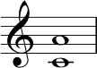
As we can see, the lower note is a C and the higher note is an A. So, in order to count this we start on C and count:
C = 1
D = 2
E = 3
F = 4
G = 5
A = 6
As such, we can say that the interval from C to A is a sixth. (NB: If you have a maths or science background, you might think of this as a bounded interval – as a set containing all points including the endpoints.)
Now, we need to find the quality... A nice way to do this is to imagine that we are in the major key of which the lower note is the tonic. So, in this case, the lowest note is C, so we imagine that we are in the key of C major. So, the question is: would we find an A natural in the key of C major...?
The answer is yes, so we can say that this is an interval of a major 6th. Let’s recap and then discuss some more complex examples.
Firstly, we imagined that the lower note of our interval is the tonic. Then we imagined that it’s the tonic of a major key. That allowed us to use our knowledge of the major scale pattern to test whether the top note of the interval belonged to the major key or not. If not, we know that it’s not a major interval.
The major scale pattern is a useful starting point because it’s constant, T T S T T T S, i.e. it doesn’t have variations or alterations, compared to minor scales.
As a consequence, we know that the scale’s internal intervals provide stable references points for us. Just to remind you, here are all the major scale interval qualities:

Quality of intervals from the tonic (1) in major scales/keys
Interval | Quality
Unison  Second  Third  Fourth  Fifth  Sixth  Seventh  Octave | Perfect  Major  Major  Perfect  Perfect  Major  Major  Perfect

How intervals change when we nudge notes up or down by a semitone
Here’s a graphic to illustrate how the quality (and corresponding description) of intervals change, when the size of the interval is increased or decreased by nudging it wider or narrower by a semitone.

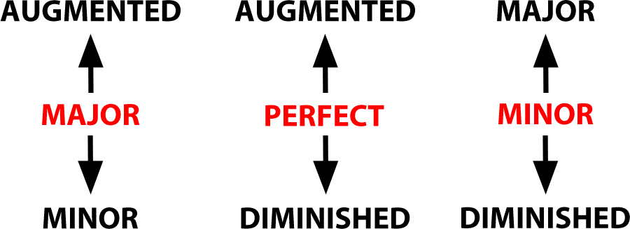

With that information in mind, let’s have a look at the following interval, which is very similar to the one that we just looked at:
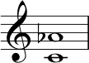
In the first example we worked out that C-to-A produces an interval of a major sixth, because A is scale degree 6 in C major. But in this example, the interval shows us C-to-Ab. We know that it must also be a sixth of some kind (C=1, D=2, E=3, F=4, G=5, A=6) – but this time, the interval is a semitone smaller than before because the upper note has been lowered/flattened by a semitone. Using this logic, we can say that a major interval made smaller by a semitone becomes a minor interval. So, this interval would be fully described as a minor 6th.
But for now, let’s keep working with the major scale as our basis. Now for a trickier example – again, using this method, for ease of calculation. Have a look at the following example:
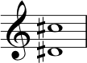
So far we have said ‘imagine you are in the key of which the lower note is the tonic...’. Whoa! D-sharp major!! When we look for it on the circle of fifths, we find ourselves off the charts... Don’t panic. Here is a method to help you identify that interval.
Cancel both accidentals. We can simply ignore both accidentals! This leaves us with the same interval, moved down by a semitone. If we ignore both sharps, we can pretend we’re looking at D to C. We can easily work out that D to C is an interval of a 7th.
Now, the key of D major = 2 sharps (F-sharp, C-sharp). Hmm. If this interval came from the major scale, it WOULD have a C-sharp in it. But we cancelled ours out. So our interval is a semitone smaller than the major seventh interval. It is thus a minor 7th.
The final step of logic: D to C is a minor 7th, therefore D-sharp to C-sharp is also a minor 7th.

Compound Intervals
How do we deal with something like the following interval?
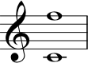
If we count from the bottom note to the top one, we see that it is more than an octave. It’s an 11th, in fact.
In jazz and popular music, musicians are happy conceptualising these big extended intervals. It’s common also, though, to re-imagine this interval as a compound interval. This is a way of describing an interval that extends beyond an octave. You can either re-imagine the top F down an octave, or take the middle C up an octave. Either way, you have a perfect 4th. So, we can describe this interval as a compound perfect 4th.

More Practice
Intervals can be tricky but the best way to get to grips with them is by doing as much practice as you can. The site musictheory.net is wonderful for this and you can use it to practice many elements of this course, including identifying intervals. You can set their interval exercise to be as challenging as you need it to be – customise it using the controls in the top right hand corner of the screen.

Transcript of the Video
0:04 | So last week we talked about intervals, and we said that this was the space between notes, but really to fully describe an interval, we need two pieces of information. We firstly need the number of the interval, but we also need the quality. So last week we looked to the distance between C and E. Everyone will tell you that this was a third, C to D to E, one, two, three.
0:28 | But, that’s only half the picture We say it is a third, but we need to know the quality, we need to know what type of a 3rd is it? Okay so Nikki what interval is this?
0:35 | One, two, three. That, that’d be a 3rd, Zack. Okay and this one? One, two, three. That, that’s also a 3rd, Zack. Okay, so these are two different intervals that we’re describing as 3rds and this is what we mean by quality.
1:01 | Take a look at this example. We’re going to use our major scale again as the reference point. We’re going to be figuring out and naming all our intervals with reference to the major scale. And this will give you a set of interval descriptions that match music theory convention.
1:18 | So we’re working from left to right. If we’ve got two notes that are exactly the same pitch, we say that they’re in perfect unison.  The distance between the 1st and 2nd, the 1st and 3rd, the 1st and 6th, and the 1st and 7th are all described as major. 2nd, 3rd, 6th, and 7ths, respectively.  The distance between the 1st and 4th, the 1st and 5th, and the 1st and the 8th are called perfect 4ths, and 5ths, and octaves, respectively.
2:00 | These intervals would all be the same in a major or a minor key. Hence, perfect. So as you can see, in each case we’ve got a description of the quality of the interval and in this case it was either major or perfect and we also have the number 1, 2, 3, 4, 5, 6, 7, or 8, but as we’ve also said, this is all based on the major scale. So, what happens if we want to work at intervals that don’t belong to the major scale? Well, firstly, we need to be aware that there are other qualities of intervals. So, we’ve already talked about major and perfect. We also have minor intervals, augmented intervals, and diminished intervals. So let’s use an example to take this forward.
2:47 | On your screen you’ve got a treble clef and a D up to a C. The lower note is D. The upper note is C. So let’s count up from D. D, E, F. G, A, B, C. One, two, three, four, five, six, seven. Seven steps. So we know we’ve got some sort of a 7th.
3:16 | Okay, so that’s only half of what we need to talk about. We’ve got the number now, we know it’s a 7th. Now we need to think about the quality. Well, a really good way to do this is to take the lowest note and imagine that you are in the major key. Imagine that’s the tonic of the major key. So in this case we’re going to imagine we’re in the case of D major, because the lowest note is a D.
3:37 | Okay, so, we know that in the key of D major we’ve got an F-sharp and a C-sharp. Therefore the 7th degree of D major, would be C-sharp. This would be a major 7th, we’ve already talked about this. Actually this is a C Natural, which is a semitone lower than the C-sharp that we would expect in this major key.  When a major interval is, it’s smaller, or lowered, we say that this is a minor interval.
4:08 | So we’ve now seen examples of major intervals, perfect intervals and, and now we’ve had our minor 7th as well. But we’ve also mentioned there’s such things as augmented intervals and diminished intervals. So, how would we get to any of those?
4:23 | Well, we’ve seen that the unison the 4th, and the 5th, and the octave, are described by the word perfect. This is because of the constancy between different types of scales. So they’re called perfect. But if we have a perfect interval and we raise it, we make that interval bigger. We call that augmented. And if we make that interval smaller, we call it diminished.  So, from a perfect interval, if you step up one semitone, you’ve made that interval augmented. From a perfect interval that you make smaller by one semitone, you’ve made that interval diminished. Now music theory convention given us, gives us even more options if what we’re starting with is, is a major interval. So if you remember the 2nd, the 3rd, the 6th, and the 7th, intervals, what all, originally started from our reference point as major. major 2nd, major 3rd, major 6th, major 7th.
5:26 | For any of those, if you were to add one semitone to the interval, so make the top note higher, sharpen it by one semitone, you would immediately get to an augmented interval so for major you’d setup one semitone to augmented. From that same major if you were to step down one semitone. So if you were to flatten the top note by one semitone, you would get to minor as we’d already seen. Now Zack, what would happen if you were to take that minor interval and flatten it by one semitone again? Well you’re making it smaller, so again we can see that, that interval has been diminished.

