Topic 1: Musical notes, scales, and the rudiments of notation
Fundamentals of Music Theory / Topic 1: Musical notes, scales, and the rudiments of notation https://doi.org/10.2218/ED.9781912669226.1. © Michael Edwards, John Kitchen, Nikki Moran, Zack Moir, Richard Worth, University of Edinburgh, CC BY SA 4.0, unless otherwise indicated.

1.1. Musical Notes
Video: Musical Notes
Here is an example of some early music notation, written before the standardized five-line stave came into use:
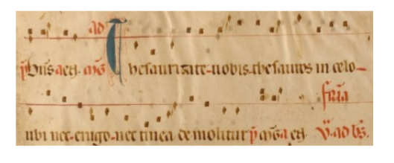
This type of early notation – known as neumes – gives some indication about how to perform this fourteenth-century chant. There are the words, there’s a reference line and there are some marks which indicate some approximate pitches (‘OK lads here’s the tune. It goes up a bit… down a bit…. Down a bit more… this bit jumps up and then it goes down again…’)

Rudiments: Naming the notes
Here are the seven alphabetical note names in ascending order. Note the ledger line for the last A, to temporarily extend the stave:
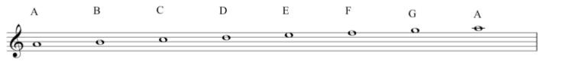
Here they are descending from A (with more ledger lines, extending the stave downwards):
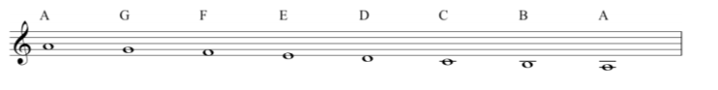
With a mnemonic for learning the position of the notes in the treble clef:
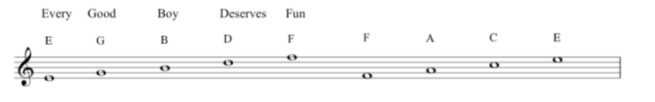
Which sounds as tired and archaic as music theory ever gets. So, please do invent your own new ones (Eating Green Beans Delivers Flatulence?).
Here are the notes on a piano keyboard:

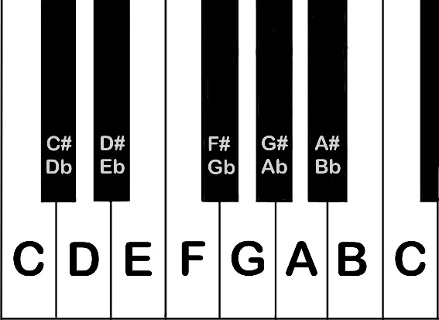

Finally, we introduced the octave. Here are the seven note names shown in adjacent octaves on the stave.
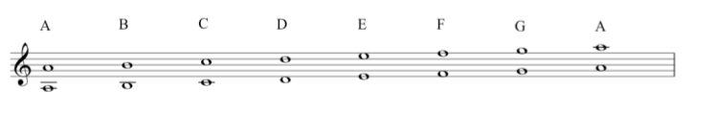
Note that when the lower note is on the line, its octave above is on a space. This lower C with one ledger line can be referred to as middle C:
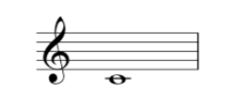
You can find it right in the middle of the keyboard. The note names are sometimes written on electronic keyboards. On an acoustic instrument, you would find it near the lock of the piano lid.

Transcript of the Video
0:00 | Before we get started, a word about pianos and keyboards. We are going to use the piano quite a lot for this music theory course. And we’re hoping that you can get access to any kind of keyboard, including one that you might download as an app. You don’t need to be a piano player; you simply need to be able to put your fingers on the keys and play along with some of the stuff as we do it. The only reason that we’re doing this is because it’s a really nice visual illustration of some of the things that we’re going to be talking about. So let’s get started. Here’s a sound. And here is another sound. You’d probably say that this one is high. Whereas this one is low. And that is the case in nearly every language in the planet. The thing is with this sound, while I can say it’s high, I can’t seem to sing it. I can’t find the note. And that’s just exactly the same as this one.
0:57 | We know it’s low, but again bom, bom, bom. There’s no, there’s no note to, to latch on to and recognize there. But compare with this, which is high, but is a note. La- sings same note. And then we’ve got a low note. That’s, again, something that we can sing, we can recognize. So those two examples have what we call Pitch. Okay? A singable musical quality to the sound, all right?  Now, we’re going to be looking at how to represent this stuff graphically. This is the written part of music. So, I could say obviously my note was high, so I’ll stick it up here. Zack’s note came afterwards with low down here, shall we, shall we say. That would imply that this axis is giving us time. My note first, Zack’s second. And this axis, this axis is giving us Pitch. High and low, okay? And that’s fine. But actually, it’s really quite difficult to know just how high that note is, or how low this note is. It’s not very good for us to able to give this to someone else, to be able to replicate what we did. You know? It’s, it’s, it’s purely a, a kind of graph of where our notes were. I can try and make a tune, like, la, la, la, la. But we don’t really know. Yeah, this is just a, a, Scatter Graph. It’s just plotting where things happened, and roughly how high or low they were.  In the seventh century, Archbishop Isidore of Seville, said, that unless sounds could be held in the memory of man, they are lost because they cannot be written down. You’ve got to imagine you’re a ninth century monk and you’ve come up with a really great piece of music for the church liturgy, okay?
02:37 | You can use this kind of system here, as a memory jogger for you and for the people you’re immediately working with. But you have no musical instrument and you have no recording devices. So if you wanted to send this to another monastery, if you wanted to submit it to the Pope for authentication, you couldn’t. There’s no way that anyone else would be able to interpret these dots. They struggled with this right through, until in the sixteenth century, they came up with this. Five lines called a stave, or if you’re American, a staff. Okay? These five lines are like a grid system that can be overlaid onto those dots. Now we have some relativity that we can work with. Right. So we got this stave, and I’m going to put a symbol here, which you’ll probably recognize.
03:31 | Now, these monks started naming the notes. Things like Do Re Mi, which we still use. But, also, particularly in English speaking countries, letters from the alphabet, and we’ll start with A. Which on the piano, sounds like. A, and I’ll put that right here, on this space. So that’s, A. Okay, so we said it was alphabetical. So the next thing obviously is B, and that sits on the line, just above that space. B. You guessed it. The next one is C, and that’s in the space above. C. And then we’ve got D on the next line. D. E on the next space. E. F on the next line. F. G compares just on top of the stave. G. And then it looks like we’ve run out of stave actually, but we can, we can write notes that are higher than this and there’s a trick for getting around that. Richard’s going to show you. It’s called a ledger line, and that gets us that note. Okay, so on that note if we were following that up alphabetically, A, B, C, D, E, F, G. Not H, what we get is another A. Okay, so we can say that our musical alphabet runs A, B, C, D, E, F, G and then the sequence starts repeating itself.
04:51 | Going down, I’m just going to come down to this stave and A goes down, of course, to G. And then if you keep going down we’ve got an F and the space, E on the line, D perched just below the stave. And again, we’ve got the same problem. But as Richard says, we can use a short line, which is temporary and it’s called a Ledger Line that represents our C. We can draw them, the line again, and write the next note in the space below, that gives us a B and we can keep going with this. So, so the next thing is two ledger lines. And all we’re doing is temporarily extending the stave when we do this and this takes us back down to our E, again.
05:31 | Now one other thing I’ll just mention. So we started on A and we came down to a G. This G is on the line and this line is where this symbol circles itself around. So this symbol can be called a G-Clef, or more commonly nowadays, a treble clef. But the really important thing we’ve got to deal with is the existence of more than one A. And in fact now we’ve seen this being a C, more than one C. What does that mean? That’s what we’re going to look at next.  Following on from this idea of having more than one of any given note represented at different points on the stave. Let’s use the guitar as an illustration.
06:08 | So on the guitar, if we play this string, we get an A. Now this instrument makes sound by having a string that vibrates. If I was to put my finger halfway along the length of that string, it now vibrates at double the frequency. This is what we call an Octave. This A is an octave higher than this A. But we can hear, although there are different notes on there’re different points on the instrument, they do sound equivalent in some way. And this is something that we’ll recognize intuitively, and we’ll be able to illustrate that with our voices. Okay, so imagine you’re at a party. Sing: Happy birthday to you, happy birthday to you. That’s quite enough of that!  But, I sang high, the part that often children or, some women would sing, and Zack sang low. We were singing the same melody. You always do this in your everyday life. We were singing in octaves. Okay? It sounded equivalent. It didn’t sound weird. It didn’t clash. This is what we mean by an octave.  So again looking at our stave, let’s see what this octaves mean. Right here’s A, and if we count these notes, A being 1, B 2, C 3, D 4, E 5, F6, G7, number 8 is when we come back to A. That’s not going to be much of a surprise to us given that we’ve called it an Octave. The 8.  So we’ve looked at these notes on the stave, but let’s just go back to the keyboard so we can look at where they are on an instrument. So the A that we’ve started with was here. We never got that A. An octave above up here. So we had A, B, C, D, E, F, G, and A. And you’ll notice that that’s just used every line and space on the stave, but we’ve only used the white notes on a piano and that’s going to become important. We’ll talk about that more in a minute. We can go down to A. A, G, F, E, B, C, B, and right down to A. So again, just to highlight this idea of the octaves. We’ve got an A here. We’ve got an A here. We’ve got an A here. We’ve even got an A up here, and this carries on both ways up and down the piano.
08:42 | Great. So we’ve seen the notes on the keyboard. We’ve been writing them down. You need a way to remember where they are on the stave, if you don’t already read music. So as Richard said, this is called the G-Clef, the treble clef and if we wanted, we could always go back to first principles and count everything from this G on the second line. G, A, B, C, D, E.  That’s going to take a long time though. So, we’ve got some nice ways to remember it. So, if I start on the bottom line, it’s an E. Then the next line is a G. The next line is a B. The next one a D. And then the line at the top is an F. E G B D F could spell Every Good Boy Deserves Fruit, football, fun, food. And, if we go to the spaces, the bottom space is F, the next space is an A, a C, then an E: F-A-C-E. So, that’s a way to remember the lines and the spaces separately, but of course we’ve always got to remember that it’s part of a spectrum. So at the bottom we’ve got E line, F on the space, G line, A on the space and so on alphabetically. These two things come together.

Rudiments: Ledger lines and clefs
Video: Ledger lines and clefs
So far in this course, we have spoken mostly about the treble clef. As we note in this video there are some other common clefs, and we’d like to just take a minute to discuss these here. The point of having different clefs is that different voices and instruments produce different ranges of pitches.

Treble clef
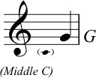
The treble clef is also known as the G clef. Why? The fat loop of the clef’s symbol encircles the second of the five lines of the stave (counting up from the bottom). This assigns the pitch G to this line. The graphic also shows the position of middle C. If you need to recap musical notes, please go and read point 1.1. on this same topic.

The bass clef
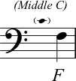
The bass clef is also known as the F clef: the two dots on the left of this symbol (see the image above) are positioned either side of the fourth line of the stave. This assigns the pitch name F to this line. Again, the position of middle C is shown in this graphic.

The alto clef
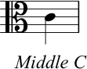
The alto clef is commonly used for music played by the viola or alto trombone, for example. The alto clef is known as a C clef; the line in the middle of the two curved loops (third line of the stave) is MIDDLE C.

The tenor clef
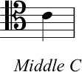
Confusingly, the tenor clef is another type of C clef. Again, the line in the middle of the two curved loops of the clef is MIDDLE C (see the graphic above).
Ledger Lines
As we are going to mention in the next section 1.1, we can extend the normal range of the stave by adding ledger lines, both above and below the stave. The following images show ledger lines being used above and below staves using each of the clefs that we have discussed so far.
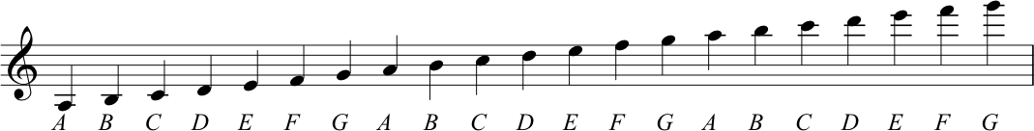
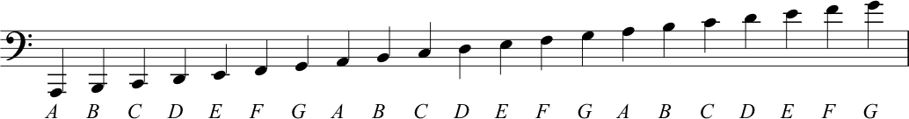
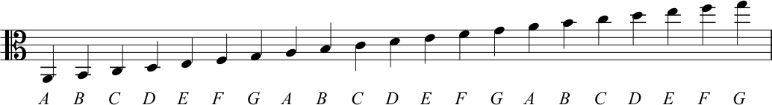
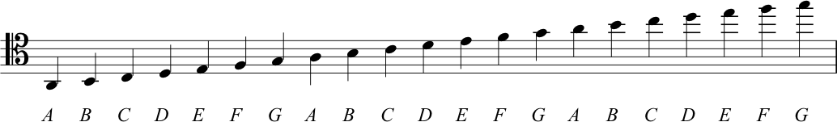

Transcript of the Video
00:00 | So up until this point, we’ve been reading and writing notes, in relation to the treble clef. And in lecture one, Richard showed us that, although this stave has five lines and four spaces, actually we can temporarily extend this. If needs be, by use of ledger lines. Now what this does, is allows us to go, a bit higher for a period of time, or a bit below the stave, a bit lower for a period of time, if we need to represent and show notes that are out width this main range. There’s a couple of problems with that. If we go on for any duration using only letter lines, that’s really quite hard to read. A musician trying to read that music, kind of loses that orientation if you stay a long way from those five lines and you’re just floating above the stave on those ledgers, or below the stave on those ledgers. You can see an example here. It gets a little disorienting to look at.
01:04 | And secondly, even using ledger lines, reasonable amounts of ledger lines above and below the stave, we still not getting, at all of the ranges of pitches that, that real instruments and real voices actually use. When they’re performing music if you think about a bass guitar and you compare it to a flute. We’ve got really low sound and we’ve got really high sounds. We need ways of covering both of those ranges of pitches. If you think about choirs and the four voice types that we might commonly have in a choir. We might have a bass voice. A tenor voice, an alto voice, a soprano voice. And kind of the point is, that in those different voice ranges, we cover different ranges of pitches. So you remember from week one, we described a clef, a cleft as really just a way to identify notes. And really to assign letter names to the series of four spaces and five lines.
02:04 | The treble clef is the one that we’ve used so far, and it’s just a system. sorry, the treble clef we’ve used is just a symbol, that we use to indicate which range of pitches we want these particular lines and spaces to represent. So, there’s actually a few different types of clefs. And all of which do exactly the same thing. They indicate the different selection of pitches that should be read from the lines, and the spaces on the stave, but we’re going to focus on the next most commonly used clef and that is the bass clef and as the name suggests this one is used to represent low-pitched notes. Now an interesting thing about this clef, is that it, quite often, forms part of a system with the treble clef. Anyone who’s ever looked at a piece of piano music, will be really familiar with the look of this.
02:53 | Now, you can see that we’ve got two staves. Each of them has got the normal five lines. And they’re connected by what we call, a brace. That’s the bracket here on the far left. So these two staves together, give us, a grand stave. So we’ve got five lines, on the top stave and we’ve got five lines on the bottom stave. Now what one is to do is imagine, an eleventh line, that runs right through the middle of these two. It’s right in between the two staves. We could say that this line gives us a meeting point between the ranges of pitches, and between the two clefs.
03:33 | So the middle line, if we think about it then, would appear as the first ledger line, below. The treble clef stave would go down, and if we are thinking about the bass stave, is the first ledger line above this stave. Now, this line whether you are thinking about it in the treble clef, or in the bass clef, actually, represents the same note, is the note that we, is the, is the line that we would draw, C on. And because it’s right in between the two, staves, with the two clefts, we actually call this, Middle C. So we can see that this note Middle C joins or it connects the two staves, and that as such, we can see that the treble and the bass staves aren’t completely separate entities but actually there are two constructs that serve to form a spectrum, of pitches from low to high. The treble and the bass clef are the two most common clefs. But there are others, as we’ve mentioned, and the additional material for this section goes into this further.

1.2. Octaves and scales
Video: Octaves

Musical intervals
Here is the interval of a second as shown in the video:
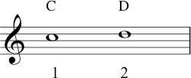
At approximately 3 minutes 20 seconds in the segment, Zack gives several examples of more intervals, and here they are in the order he played them:
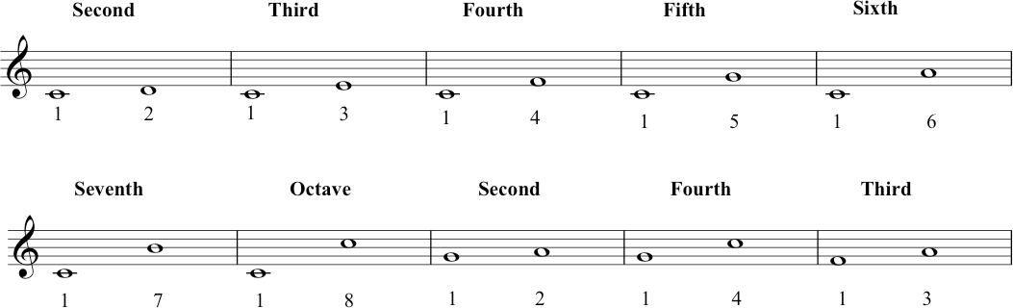

Tones and semitones
Note that – while only using white notes – we have identified two pairs of semitones. The first pair occurs between B and C:
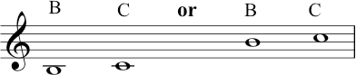
The other pair sits between the notes E and F:
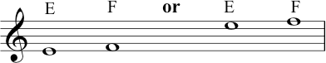
These intervals are clearly illustrated in the layout of a keyboard instrument, because there is no black key between them. If you look back at the keyboard graphic, you will see this.

The C major scale
Knowing the difference between these tones (T) and semitones (S), allows us to derive the C major scale:
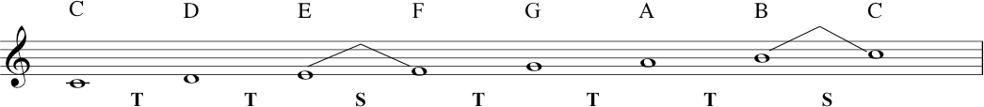
The note C is the tonic note of the C major scale. This scale is an example of a diatonic scale one that has a pattern of 2 semitones and 5 tones between the notes that take you from the tonic note in one octave, to the same (tonic) note in the next octave.
In the video we identified the octave on the guitar by halving the string. This brings up a phenomenon formally known as the harmonic series. If you keep halving a string and playing it, you don’t JUST keep getting the next octave; it becomes more interesting than that there is a mathematical relationship, which Pythagoras is often cited as the discoverer of (although others had probably figured it out before). If you are interested: Harmonic Series.
On top of semitones, smaller intervals do of course exist. The semitone as we’re talking about it today (as a fixed size of interval) comes from the technology of equal temperament – a type of tuning system – that has been dominant since the twentieth century. There are other tuning systems – e.g. just intonation, well temperament, etc. – in which some ‘semitones’ are deliberately smaller than others! If you are so inclined, you can read more about all this here… Just Intonation.
We can describe intervals smaller than a semitone as microtones.
A well-known example would be singers or guitarists ‘bending’ a note up or down in Blues, Rock and Jazz. Classical music from the mid twentieth century often used microtones as part of the compositional process, finding new ways to develop stave notation to accommodate this. And much music from other cultures around the world uses microtonal tuning as an essential element, in both imagination (theory) and performance.

Transcript of the Video
0:00 | In this section, we’re going to look more at the vertical distances between notes.  If you remember back to the graph, we originally drew and we said the vertical axis represented high pitches or low pitches. We’re now going to start quantifying those. Now, we did say that we had an octave which is a real phenomenon, a phenomenon of nature. And we said that was eight notes. Of course, it’s actually seven note names, A, B, C, D, E, F, G, back to A.
0:31 | But, of course, if you look, for instance, at Zack’s guitar here, you’ll see that there aren’t seven notes. There’s a lot more. So, we did an example where we said that the open A string is here and then if you half that string. It’s an octave above. But if we look at the, the discreet pitches available to us in between. We’ve actually got, 1, 2, 3, 4, 5, 6, 7, 8, 9, 10, 11, 12, and then things start to repeat again, actually. So what we’re saying is the octave on many musical instruments nowadays isn’t divided into eight, as you’d expect based on the prefix oct-. Actually, we have 12 distinct pitch classes. Yeah. Now, if we were to look at the piano, we will see the same thing again. So looking at what Zack did on guitar. If we look at it on the piano, instead of having frets, of course we’ve got all of these white notes. We’ve also got these black notes, which we’re now going to introduce. So, starting on A, where Zack was, 1,2, 3, 4, 5, 6, 7, 8, 9, 10, 11, 12, and then we’re back to A. And there’s the octave. Now, going back to this A, this distance here is called a semitone, where ‘semi-’ means half. If that distance is called a semitone this distance is called a Tone. Semitone, half, double it, tone. That’s the same on all instrument.
2:23 | Okay, keep that thought in mind. We’re now going to have a look at that represented back on our stave. Now, this semitone is the smallest distance that we’re going to work with at the moment. Now, if you want to find out more about that, we have additional material on it. But let’s just say for the moment, the semitone is the smallest working distance we can have between two notes. Also, at this point we’re going to stop using A and start orientating ourselves around C.
2:51 | And so, here is C on our stave. The next note up on the line is D. We can count from C to D, one, two. It’s a tone. But if we’re going to name it in a different way, we can say it’s an interval of a second. One, two, a second. There are lots more intervals for us to look at, and to do that we’re actually going to go back to the keyboard. So Richard’s just talked to you about this interval, the second, from C to D. But as he said, there’s much more than that. So let’s have another look through that, and we’ll do that within the octave. So, we’ve got C to D. There’s a second, one, two. We’ve got C to E, 1 2 3. That’s a third. C to F, a fourth. C to G, a fifth. C to A, a sixth. C to B, a seventh. And from C to C, we’re not going to call that an eighth, we’re going to use the word that we’ve already used, which is octave.
4:03 | But what we don’t want you to think is that intervals are only ever counted from C. You know, we could go from G to A, is a second. G to C is a fourth. F to A is a third. It’s all about counting the space. One, two, three. F to A is a third. Now, if we were to play B to C, for example. We can see that this is a second. One, two. But actually what we see here is that the B to C Is a second, but the C is only a semitone above B. Whereas, for instance, F to G, 1, 2, is a second. But G is actually a tone, that’s to say, two semitones above F. Now, they are both seconds, and it’s perfectly correct to describe them that way. But they do have a different quality. We’re going to talk about that more next week, so hold that thought, but at the moment let’s use that information and turn to think about scales.
5:24 | So now I’m going to turn our attention to scales. There’s one. Scales are a pathway through an octave, okay? It’s like they’re a pool of notes, a set of notes which melodies can be drawn from. And if we can have that on the piano as well. I could say if I was doing Julie Andrews. Which is that is a Do, Re, Mi, Fa, Sol, La, Ti, Do. But I can also say it is, C, D, E, F, G, A, B, C. That is why we have orientated ourselves to C, because we’ve now found the scale of C major, which I’m sure you’ve heard of. Which is very common throughout the world. Similarities exist in many cultures, and it’s what lots of music is built on, C major. And an important thing for you, looking at this, is when you’re looking at your piano, it’s all the white notes from C to C. So, Richard just said that this is an example of a major scale.
6:29 | And actually, what’s important here, is the relationship between the notes.  The relationship between all of these notes that are available to us within this pool of notes. And actually what we have to remember here is the difference between tones and semitones.
6:48 | So let’s look at them again on the last stave. C to D. That’s a tone, so I’m going to write T underneath here for tone. D to E another tone. So here is a T. E to F there is no black note in between so this is a semi tone. Which I will show with an S. F to G a tone. G to A a tone. A to B, a tone. And again, B to C, a semitone. There’s no blank note in between. So, that gives us a pattern of Tone, Tone, Semitone, Tone, Tone, Tone, Semitone.  So, this pattern of two tones and then a semi-tone and three more tones and a final semi-tone is what makes this scale sound the way it does. Now we could say that each note on its own doesn’t actually mean that much, what’s important is how they sound next to each other in the context. How they stand next to each other and build up relationships between one another. What this does is it gives us the flavour, gives us the overall sound. And if we’re going to talk about that formally in music theoretic terms, it gives us the quality of the scale.
8:06 | An important piece of terminology to remember, then, is that the letter name that the scale is named after is called the tonic. So, in the case of C major, C is the tonic. In the case of F major, F is the tonic.
8:28 | This major scale is also an example what is called a Diatonic Scale. ‘Dia-’ between two tonics. Diatonic scales are ones where we always have seven notes with some pattern of five tones and two semitones.
8:45 | Now, let’s just have a little bit of the scale again on the stave. And, remember we said C to D was a second. Zack had pointed out that B to C was also a second but one of the smaller ones: a semitone. So, I’m going to put this little dart sign here, to show that between B and C is the semitone. Now, the other place we have a semitone is between E and F. So, I’m also going to put the dart sign there. That will just help us to see, on the stave, or major scale, where the semitones are. So, there you have it, we found C major. Through our pattern of tones and semitones, we’ve found our first major scale. But of course, a scale isn’t just a scale. A scale helps to make music. C major can give us this. Well, we are in Scotland. C major can also give us this. And don’t think I’m being patronizing playing Twinkle Twinkle Little Star. It’s a good exemplifier of the major scale. It’s also a good enough tune for Mozart to write a whole set of variations on. While I’m on Mozart, that brings me to a little disclaimer. In this course, we’re dealing with musical techniques that are known as the ‘Common Practice’. And the ‘Common Practice’ era is basically Western Europe from 1600 to 1900. So, it’s very much the music of Bach, Haydn, Mozart, Beethoven, etc.
10:15 | But there are other forms of music around the world. That might use different techniques. Where possible, we will reference them, but it has to be said that the common practice is a good system to work from. It applies to quite a lot of pop and rock, a lot of jazz, quite a lot of folk music, and so that’s our main focus in this course.

1.3. Rudiments: Musical duration
Video: Rudiments of rhythm notation
The following graphics set out the forms of note-heads, stems, flags and beams which conventionally indicate musical duration. With each level (working from top to bottom), the duration of the note is halved, i.e., 4 beats, 2 beats, 1 beat, half beat...and so on. The first figure shows the symbolic forms used for musical notes. The second shows the equivalent symbols used to indicate measured rests (silences) in the music.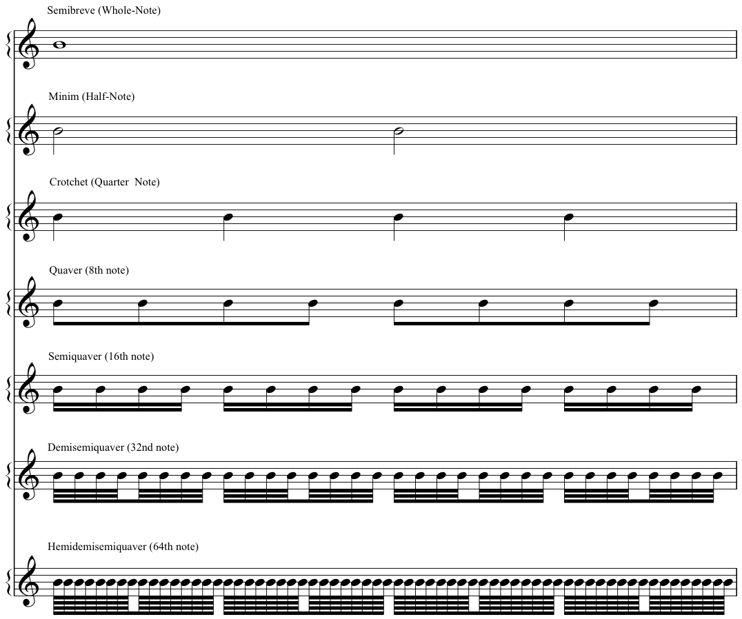
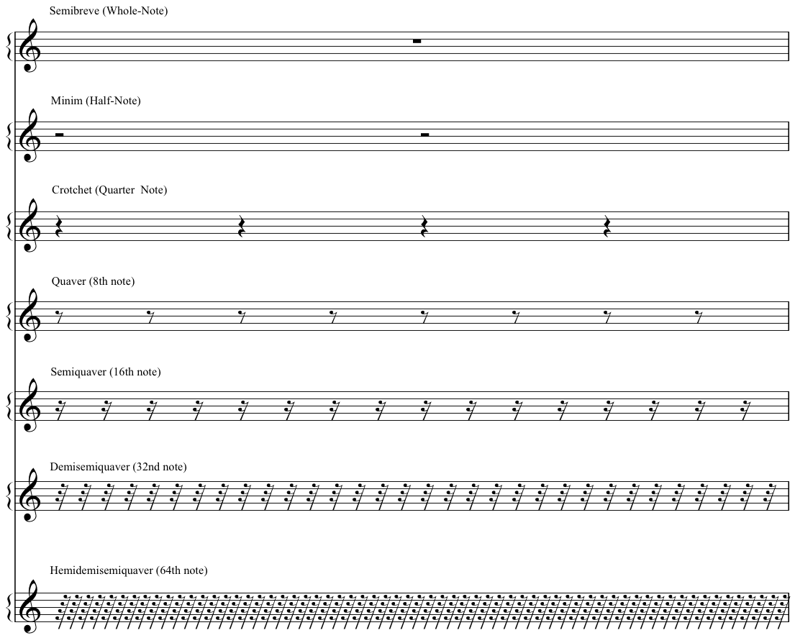

Musical example – quavers with flags, quavers with beams!
During the video, Nikki refers to an excerpt of a musical score which is freely available in the public domain. You can find it here at the sheet music repository, https://imslp.org. Nikki indicates the portion of the score in the upper half of page 33, and she highlights the stave of music marked ‘Corno Principale’. This musical example features the opening four seconds of the third movement (Rondo) of Mozart, Horn Concerto in E-flat, K.495, composed in 1786. Nikki suggests listening to the corresponding portion of a recording freely shared by the BBC Scottish Symphony Orchestra, recorded in Glasgow City Halls on 1 February 2018, available at https://www.youtube.com/watch?v=KogtLJpgHXg.

Transcript of the Video
0:00 | While we’re introducing some of the rudiments – some of the first principles - of notation, let’s talk about duration. About how long any particular note or sound should last - because not all musical notes last the same length of time. Some are long, and some short short short! And there’s everything in between.
0:23 | To communicate about this type of information, we can change the appearance of a note. We can do things like changing the appearance of the note-head, by having it filled or appearing empty. We can add stems, we can add flags and beams to those stems. So what matters here isn’t whether a note sits up high or low on the stave (whether it’s high up or low down). We’re looking at the shape of the symbol.
0:49 | And, we’ve got some names for these, of course! I’m using UK English naming conventions. So we’ve got - from top to bottom here - semibreve, minim, crotchet, quaver, semiquaver. And what do all these mean? Well this is a system. These symbols work in relation to one other. The middle level here, the crotchet, each one lasts for one count.
1:18 | So here are four crotchets. [Click - click - click - click.]  In the same time span of those four counts, we could have two minims. Or eight quavers. Or sixteen semiquavers. Or one semibreve. So each row, each level in this pyramid represents the same amount of musical time. They each represent four counts.
1:50 | And there are also symbols to indicate short versus long rests. By rests, we’re talking about gaps or silences, where there are no notes. Where there is no sound to be made. So these correspond to the same names and relative durations as the note symbols. And again, these have the same simple relationships as their counterpart notes. So in this pyramid, again, in this pyramid shape, the semibreve sits at the top - the semibreve rest is worth four counts. Two minims. Four crotchets. Eight quavers or sixteen semiquaver rests. So again, each level has a 2:1 relationship with the rows above and below it.
2:38 | Now you might notice that I’ve handwritten these graphics. And they might look a bit uneven places! This is not (totally!) an accident. I really want to keep away from the idea that there is one perfect form of musical notation. Remember that musical notation is about expressing and communicating about musical ideas. Which are human ideas! And so, for many reasons, you’ll notice a lot of variation in how notation symbols are formed across different musical scores and contexts.
3:10 | And when we’ve got them laid out like this, notation can perhaps seem like a simple code to map out musical sounds, unit by unit. But these rudiments of notation are not just about representing individual sounds. Language is more subtle than that, isn’t it?
3:28 | So even just looking at written English language, for example: notice how my ‘Q’ here is different to my ‘q’ here! They’re both Qs but they look different. And musical notation can work in similar ways to communicate about how the musical composition works, about how it hangs together.
3:51 | For example, you have seen already two different ways of writing out a quaver duration, using a flag or a beam. So we have two individual quavers here, with flags. We could also write them joined together with a beam. But the decision to do this - with a flag or a beam - it’s not only about how many quavers we’ve got together. It’s a notational convention that’s also communicating something about the bigger picture of a composition. About the way that the particular piece of music is expressing time and rhythm.
4:28 | So here’s one quick example, which will also help you to get familiar with the varied visual appearance of these rudiments of notation. You can take a look at this excerpt that I’m showing here. In the line of the score that I’ve highlighted here – the main melody line – you can see that both types of quaver notation appear. If you’d like to listen to a recording, scan the QR link – the first 4 seconds of this recording correspond to the score.
4:59 | So in this music the very first quaver, what it’s doing is it’s expressing a pick-up. Another name for this is an anacrusis. And what it means, is that the very first note that we see happening comes in just before a strong downbeat in the music. So the notation can communicate about this effect by showing that very first quaver all on its own. It’s not beamed together with the other notes that follow - even though they are all of the same duration.
5:32 | So the next time you are enjoying listening to some music, you might like to listen out for pick-ups! Now the well-known example that I gave on the previous slide is the Rondo from Mozart’s Horn Concerto in E-flat, K.495. Which was composed in 1786. But for an alternative example of an equally effective anacrusis, you could think about Dolly Parton’s hit song, Jolene, which was first released in 1974. Or you could listen out for melodies and songs that begin squarely with the downbeat and do not start with a pick-up. Two examples for you here include the 2020 global hit, Levitating by Dua Lipa. Or, the opening of ‘Morning Mood’, the first movement of Norwegian composer, Edvard Grieg’s Peer Gynt suite, which was composed in 1875.
6:24 | That is all for this segment about theory and notation of musical rhythm. We will of course come back to this significant topic in more detail elsewhere in the course.

1.4. More on Scales
Video: More on Scales
When we change the order in which the five whole-tones and two semitones occur, the scale sounds different. We could say it has a different quality.
We can change the order of tones and semitones just by choosing a different tonic note, then – starting with that new tonic – playing every white note on the keyboard for a whole octave, until our tonic note repeats.

The A natural minor scale/Aeolian mode
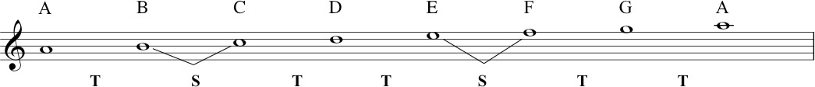
If we start on A (instead of on C), we get a different pattern. The pattern keeps five tones and two semitones, but the order in which they arise is: T S T T S T T.
This particular scale pattern and quality that we get by starting on A and using all/only the white keys on a piano keyboard is described as the ‘natural minor’ scale. It can ALSO be described as the Aeolian mode.
Here is an example of that different quality. This is God Rest Ye Merry Gentlemen, the Christmas Carol that Richard played on flute (written by an unknown composer, but probably dating back to the seventeenth century):
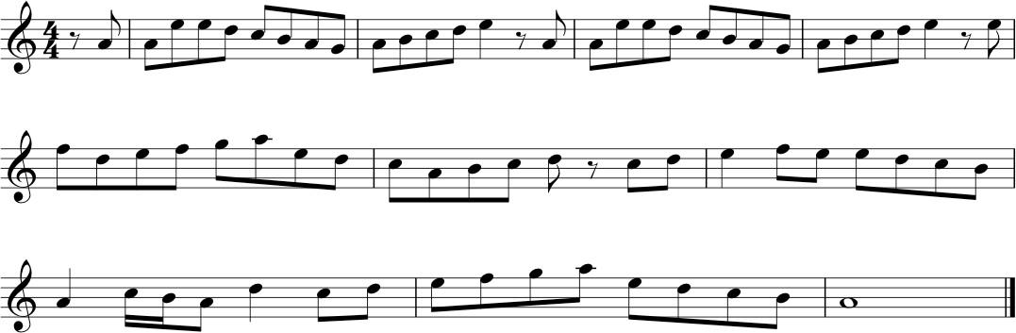
If you are new to reading notation don’t worry, you can still follow the notes of this tune as if you’re following neumes, looking at the general pattern of note-heads going up and down. Study the example, and circle all the As. Then while you’re listening to the example from the video, try to notice how the melody keeps coming back to the A.
We also named the A natural minor the Aeolian mode, we will now move on to the modes. Different modes can be discovered simply by sticking to the white keys on a keyboard and playing a scale through an octave until your starting note repeats. Each note (A, B, C, D, E, F or G) that you begin on – (by doing this, you’re designating it as the tonic) – will generate a different pattern of those five tones and two semitones.
Each of these patterns is identified as a particular mode, with a specific name.

The Seven Diatonic Modes
Today, we can refer to the seven diatonic modes as Ionian, Dorian, Phrygian, Lydian, Mixolydian, Aeolian, and Locrian.

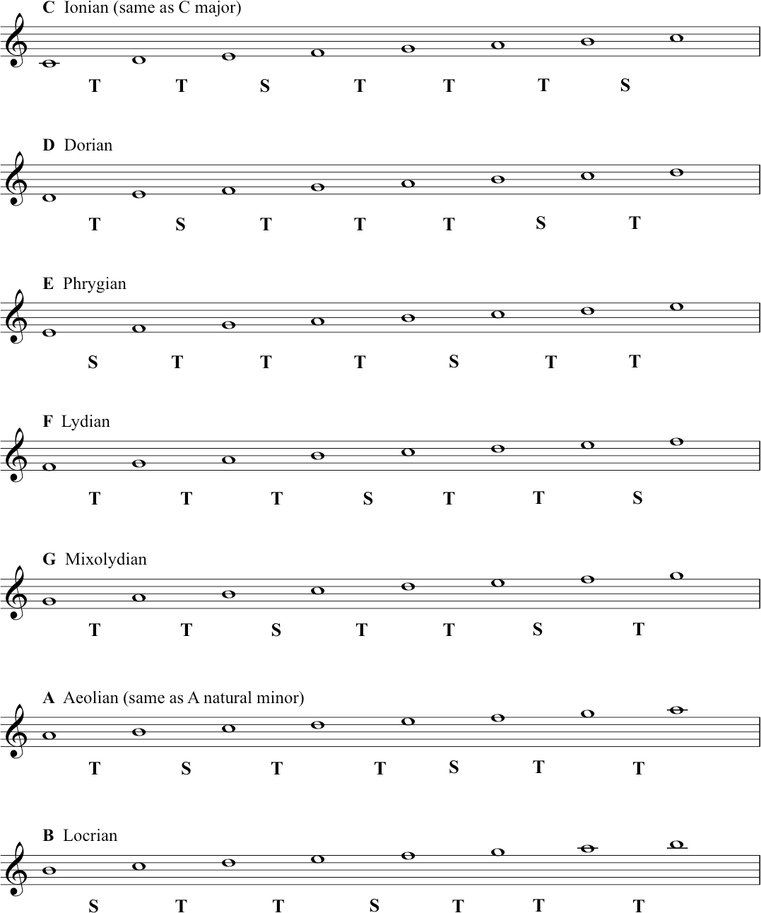

Do this:
Memorise which mode name is associated with which starting note. One mnemonic for remembering the modes is ‘I Don’t Punch Like Muhammad A-Li’.
To get a feel for the special qualities of each different mode, try playing them yourself. Notice the different sequence of tones and semitones. Also try this exercise. If you know the song Scarborough Fair, find the note D; play two Ds and then an A (the beginning of the song); keep trying to play it ‘by ear’. You will only need to use the white notes on the piano keyboard. If you manage to get through the tune, pay attention to the way that D feels like ‘home’. D is your tonic. Play all the notes through from D to D (this is the pattern known as the Dorian mode) – sing that scale back, now, while the song is in your memory.
Playing around like this will help you to experience tonality – it will give you real knowledge about the concepts and terminology that you’re learning on this course. And it will help you to develop your general musicianship. Try to play properly – by which we mean for fun! Mess around at the piano keyboard for your own discovery and satisfaction.
Another song in the Dorian mode is What Shall We do With a Drunken Sailor. To play this song with white notes you have to start on A and go down to a D - ‘What shall we do with the drun - ken ’(that’s the D on ‘ken’). Music doesn’t always start on its tonic, but it often finishes on it, and this song finishes on D – which again should feel like home. You could play along with our version of She Moved Through the Fair, and see if you can ‘feel’ the G as the tonic note. Just keep playing the note G and see how it ’fits’. Anyway, try it - improvise on a keyboard or your own instrument!
There is much more to say about modes and other kinds of scales - for instance, we haven’t even touched on pentatonic scales, which are very common in all kinds of music. For a very detailed article on the modes and their history, use Wikipedia again to start you off on that particular voyage of discovery: Modes. And for pentatonic scales here: Pentatonic Scales

Transcript of the Video
00:00 | So from this pool of notes we’re now going to look at more scales beyond just the scale of C major. So let’s take a different tonic this time. Let’s take A as our tonic instead of C. If we start now and play all the notes that we know and all the notes that we now know belong to C-major, we get A-B-C-D-E-F-G-A. So by taking A, as our new tonic what we see is that we actually still use all the same notes, but now we’ve got a different pattern of tones and semitones.
00:37 | We get A to B is a tone. B to C is a semitone. C to D is a tone. D to E is a tone. E to F is a semitone. F to G is a tone. G to A is a tone. Now this is called the Natural minor scale and we’ll talk more about this next week. Or also the Aeolian mode. It’s still a diatonic scale because it still has seven notes with five tones and two semitones, but they have a different sequence of tones and semitones now as opposed to the major scale.
01:15 | Now, many of you may have heard of modes, especially if you visit a lot of rock guitar websites. So we’ll briefly look at those now. See, one of the amazing things about music is that, simply by re-orientating ourselves around these notes in C-major, we can create different patterns and different kinds of melodies, for instance.
01:32 | This may be the wrong time of year for you, but....  So, that’s God Rest Ye Merry Gentlemen and Merry Christmas, if it is Christmas. I think you can hear that, that is different from the Auld Lang Syne, or Twinkle Twinkle Little Star, or God Save the Queen, or something else like that. That is because I was orientating that melody around the A, around that Aeolian mode that we just saw up on the stave. So the relationship of the tones and the semi-tones between the tonics changed and this is how we get a different flavour, we get a different quality.
02:27 | Well, we already know that starting on C, we have a C major scale. If we go up to D, this is the second note of C major, we get a mode called the Dorian mode. It’s made up of the notes D, E, F, G, A, B, C back to D. This gives us a different pattern and a different sound.
02:47 | Okay, again if we move up to the E, that’s the third degree of C major. So if we build a mode on the third degree. It’s called the Phrygian mode. In this case, we have E, F, G, A, B, C, D, E, and again, that obviously gives us a different pattern of tones and semitones and again, that changes the flavour, or the quality of the mode.
03:18 | Starting on F. We get F, G, A, B, C, D, E, F, which is now called the Lydian mode. Then onto G, which is the fifth degree. If we start this process on the fifth degree, we get something called the Mixolydian mode. We get G, A, B, C, D, E, F, G. This has got a very similar pattern of tones and semitones to the major scale, but it is slightly different. So again we get a different sound, a different flavour, what we’d describe as a different quality.
03:57 | We’ve already looked at A, which we know is called the Aeolian mode. Moving on to B. We get the notes B, C, D, E, F, G, A, back to B. This one is now known as the Locrian mode. That’s all seven modes. There’s a lot of information to take in, but we have given you some exercises and some additional information in the supplementary material. For this lecture.
04:25 | So there you have the modes. The names we just gave you are the 20th century names for them and they are often described as the church modes and indeed many of them were used in ancient church music. You will also find them around the world they were popular in jazz from the late 50’s onward, often used in popular music. We’ve used the kind of names that you’ll find listed for them, in things like guitar websites, or guitar player magazines, or jazz theory textbooks. But what’s really important, is, if you can find a keyboard, or you have your own instrument, or you sing. What would be really is if you could just take the major scale and start this pool of notes on each tonic, so C to C, B to B, E to E. And get used to the sound and the, the quality of these different modes.
05:10 | And we’ve heard when I did that God Rest Ye Merry Gentlemen, that was a different sound. Just to show you that it really does make a difference, we’re going to now do a little piece of modal music. This one is going to be orientated around G, which makes it the Mixoydian mode, the fifth degree.  Which is our slightly jazzy version of She Moved Through the Fair which is built on the G Mixolydian. Mixolydian is built on the first degree of the major scale.

1.5. Introduction to chords
In this section and also 1.6. Primary Chords, we introduce some material that could properly belong in Topic 2, about tonal music languages. Since this current section and 1.6 work on some important concepts that can help to prepare your understanding of that next topic, we think that the presentation can work in this sequence. But - as always - you can feel free to move back and forth across the materials we have shared here.
Video: Introduction to chords

The C major and A minor triads
A triad is a three-note chord. Deriving the C major triad from the C major scale:
Deriving the A minor triad from the A natural minor scale:
We can say here that C major is the tonic of the C major scale, and A minor is the tonic of the A minor scale.
Here are the two triads standing alone, C major and A minor:

Understanding the internal structure of the triads major and minor
Firstly, we will understand the interval between the ‘bottom’ note and the ‘top’ note, by breaking it down into semitones, and adding those up. For C major, it’s C and G:
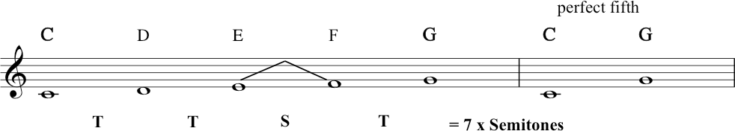
This interval is a perfect fifth, an interval that spans seven semitones. For A minor, we get the same thing between A and E:
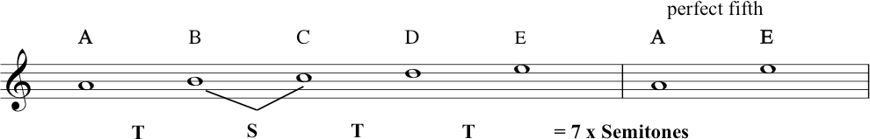
Now we need to find the interval between the ‘bottom’ and ‘middle’ note of the triad of C major: 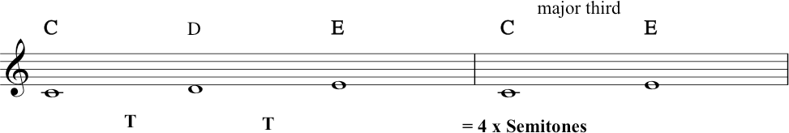
...which gives us a major third.
And for A minor:
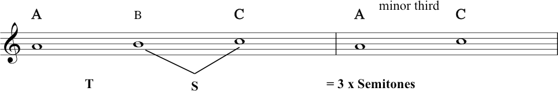
Here we have the minor third smaller by one semitone, i.e. the minor third spans only 3 semitones. It is this difference in the ‘size’ of the interval of the third that makes all the difference (perceptually) between these two chords.
Here we have all the triads as played by Zack, starting at about 5 minutes in the video:
In the next segment we are going to begin looking at how these triads relate to the C major scale, starting with the three primary chords.
Before we move on, here’s a quick note about labelling and numbering. In music theory, we need to use a lot of different systems of counting and labelling – a lot of different systems to be able to handle all the concepts. We will review these and more in Topic 5. For the time being, let’s talk about scale degrees vs intervals.
We were just counting out and labelling intervals (second, third, fourth, fifth, etc). Before that we were counting out the notes in scales: 1, 2, 3, 4, 5, 6, 7 and back to 1. (You’re learning to speak Music Theory now. This is the lingo.)
When it comes to thinking about the notes of a scale, we often refer to these as ‘degrees’ of a scale. The first degree of the scale, the second degree of the scale, the third degree, and so on. We also have a special music theory name for each degree of the scale which we will tell you later in the course. For now, you just need to know that scale degree 1 is known as the tonic, scale degree 4 is known as the subdominant, and scale degree 5 is the dominant. ‘Which scale degree is this?’ ‘It’s scale degree 5, the fifth note of the scale, the dominant.’
When we talk about intervals, we refer to them as an interval of a second, third, fourth, etc. ‘What’s this interval?’ ‘It’s a second!’

Transcript of the Video
00:00 | With our scales so far, we’ve been working sequentially. In a linear fashion, sounding one note at a time. But in fact, it’s very common for music to sound notes, at the same time. Just now when we were playing, Zack was playing, chords on the piano. So this is what we’re going to go and look at now. But, before we do, it’s going to be important to recap, the difference between our C major scale, and our A (Aeolian) mode, the natural minor, the scale that we built from six degree. So, here you have our C major scale. And then, if we start from the sixth degree of that scale and say this, play the same pool of notes, we get, which we called out natural minor or The Aeolian mode. Right. Remembering how God Rest Ye Marry Gentlemen did sound different from the major scale, let’s have a look at some important relationship ships within this. So looking at the natural minor scale, the A minor scale. Looking from A to E. That’s the note- the tonic up to note number five. I can count tone, semi tone, tone, tone. That would be three tones and one semitones. If I break that down into semi tones, that will be one, two, three, four, five, six, seven semitones. That’s the sound of the seven semitones A to E. Okay, and back to the C major. If I do the same thing and start on the tonic C and go up to note number five which is G, I get tone, tone, semitone, tone.
01:56 | The same except that the tones and semitones are in a different order. But again, I’m getting seven semitones. Let’s hear those. That one’s from C to G. And then, from A to E, right. So, A and E to, and C to G both have the seven semitones, they’re the same. That interval was called a fifth. And in fact, we can now give it a quality and say it’s a perfect fifth. And note also that the two notes sound nice together.  Now, going back to A, let’s now have a look at A to C. This is note one to three, the interval of third. Here, we get a tone and a semitone, so that adds up to three semitones however if I start on C and go from C to its third note which is E. I get two tones, which adds up to four semitones, and there is the difference. The second one, is the C major chord. And when you hear it, you’ll probably find, it’s very natural to hear the major scale. So there, looking again at our C major scale, we now isolate the three notes the C, E and G and then we stack them up vertically. Like this, and that is the C major triad.
03:51 | Now, there are other ways of writing this. If you play a lot of Rock music or Jazz, you’re used to using something called a lead sheet. Where instead of writing the chords out with notation, as you can see here. We use chord symbols. There are several different chord symbols: so for C major it could simply be shown with a capital C like this, or Cmaj, abbreviated for C major, or a capital C and a capital M. All of those could be used, in different kinds of music.
04:28 | Now, going to the A minor, the A natural minor scale, again, we’ll do the same trick. We’ll isolate the three notes of the A minor triad, so that’s A, C, and E. And again, we’ll stack them up vertically to show the A minor triad. And again, if you were using a lead sheet, this could be shown with an Amin, short for minor, or A little m, or A with a minus sign, that you’ll find in jazz.
05:05 | So if we take one, three, five starting on C and the key of C major. We’ve got C E G. Now, we know that we’ve got seven semitones between the C and the G. So it’s a Perfect fifth. And we’ve got four semitones between the C and the E, and that’s a major third.
05:24 | Now because this has got three notes, it’s a triad. It’s a simplest type of chord and what we’re going to see is that a triad that has a Perfect fifth and a major third is a major triad.  Let’s start it on D. We’ve got one three five. D F A. Now again, we’ve got seven semi-tones between the D and the A, which gives us a Perfect fifth. But this time, we’ve only got three semi-tones between the D and the F. So this gives us a Minor Third. Again, because it’s got three notes, we’re going to say that this is a triad. But this time, we have a Perfect fifth and a Minor third. So, we have a Minor triad.  Let’s move on to E. Again, we’ve got a perfect fifth between E and B, and our third this time is G, which is a minor third, so we get a minor triad. Move on to the fourth degree in this case, which is F. We’ve got F A C so we’ve got, a Perfect fifth. This time we’ve got a major third, so, this is a major triad. If we go to the sixth degree, we already know this one, this is A, C, E. So we got our Perfect fifth and then we’ve got our Minor third, so we’ve got a, Minor triad. The A minor triad.
07:00 | Now, the next one that we need to look at, starts with B, and we’ve got B, D, F. Now, some of you already, may be aware that that sounds different but what we’ve got between B and F is actually only six semitones this time. So, it’s one semitone smaller than the Perfect fifth. Now we actually call this a Diminished fifth and we’re going to talk more about this next week. But we have a Diminished fifth and we’ve got a Minor third. Now, a triad with a Diminished fifth and Minor third, is called a Diminished triad. So, it sounds different, and it has a different structure to the rest of the chords within the key because of the, Diminished fifth. So again, if you’re a keyboard player, try them for yourself now. Even if you’re not, grab your keyboard app or even have a look at a picture of a piano keyboard, just so you can work out where the notes fall, how we’re going to build the chords, and just think about the nature of the fifth and the nature of the third and the quality, as we would say in music theory terms.
08:05 | And from that, you can determine which type of triad, you would be able to play, on each degree of this scale. So, that last chord that Zack just showed us, the B Diminished, looks like this, in notation. And using lead sheet symbols, it could be written as this, a B with a little zero after it. Or B Dim, short for Diminished.
08:27 | And what Zack’s just shown us, in this last segment, are all the triads that we can derive from C major scale. And here they all are again.
08:38 | And you can also find these in your handout, print them out and look at them which you need to do, because you should sit down at a piano and play through them. Just again looking at them, we can see that there are three major chords the C major, the F major and the G major, so these three chords all have the same internal relationship between the three notes and then we have three minor chords the D minor, the E minor and the A minor. And again, they have the same internal relationship with each other. And then we found this one, other different chord, the B diminished chord, which will be important later. So, that’s three kinds of chords from one set of white notes.

1.6. Primary Chords
Video: Primary Chords
The three primary chords:
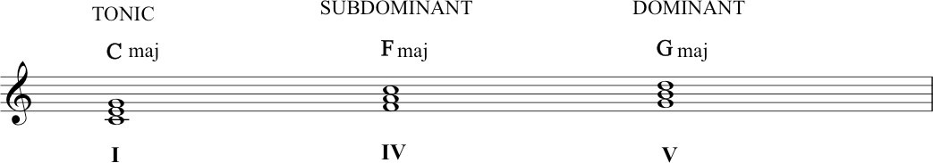
So we have the C major tonic triad, built on the tonic of the scale. A triad is a type of chord. The subdominant triad is built on the fourth note, and the dominant triad on the fifth.
The roman numerals written underneath refer to these triads: I = the tonic triad, IV = the subdominant triad, V = the dominant triad. These are important terms: memorise them.
IMPORTANT!
In C major, these three primary chords – tonic, subdominant and dominant – are the only major chords that you can get by building triads up from each scale degrees. Building triads on D, E, or A will create a minor chord. And what happens when you build a triad on B? It makes a diminished triad. We’ll tell you more about these in following sections.
At 3 minutes in the video, Richard harmonised each note of the major scale with one of these primary chords. The following notation illustrates this, also with the names of each chord in lead sheet chord symbols:
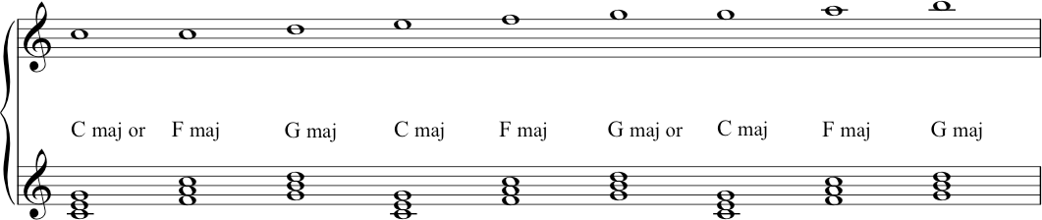

Transcript of the Video
0:00 | So, we found seven triads that we can derive from the major scale. We’re now going to focus on the three major ones. That was the C major, the F major, and the G major. These ones are important. They’ve become important through time in a ‘Common Practice’ classical music, and also in a lot of Jazz and Pop, and Rock. And, folk music as well in fact. It’s sometimes referred to as the ‘Three Chord Trick’. I’ll start off by giving them their formal name. So the C major chord, built on the tonic is the Tonic triad. The G major one, built on the fifth degree, is the Dominant. And that refers to its importance in that name. The F major is the Subdominant, one underneath the dominant. And there they are written out for you, and as lead sheet notation.
0:59 | Now, when we’re harmonizing a melody, in the kind of music that we’re talking about here, it’s normal to have the melodic note be a member of a chord that’s backing it. Okay? Not so much as we move into Jazz and 20th century classical music, or Rock in the 70s. But on the whole, we can expect to hear a strong melody note existing inside its chord. So, in other words, if I want my melody note to be a C. In the key of C major then it’s a good chance I am going to have a C major chord underneath it, or maybe the F major chord. Because that also has a C in it. And so what we are going to do now is we are going to look at the major scale and see how each note can be harmonized by one of these three chords. So again, starting with my opening example C, with a C major chord or with an F major chord. Now we move up to the note D the second note. And the only triad out of our three that has this is the G major triad. So we’re going to harmonize it with the dominant. The next one, next note is E, and that exists in the tonic triad, in the C major. The next note in the scale is F, and that exists in the F major, the sub dominant. When we get back up to the G. Again we can have a G major chord with it, the dominant, or we can have the C major called with it, when we get to the A, this lives inside the F major chord, up to the B, and the chord that has that inside it is only the G major chord, so. And then when we get back to C again, we can finish on the C tonic. We could also play the F major, but I think you’ll hear that most likely our piece of music will finish from the B. With the G to the C, with the tonic chord. Again, this is really something you just have to sit down and play through for yourself. But you’ll see that it totally works. And with those three chords, you could write a hit. Who knows, there’s been quite a few like it.  Now, just hearing these three chords in a slightly different context, I could make them sound like this. Or, they can sound like this. So you can see, and you probably recognize both of those ‘sounds’ that come from that. So that is your ‘Three Chord Trick’: your tonic, your dominant, your subdominant. And that’s going to become more important later. But for now, I just want to leave you with the fact that with the set of white notes, confining ourselves to just, white notes of the piano and C major scale, we found three different kinds of triads. We found all sorts of internal relationships which already give us the possibility of making music.

