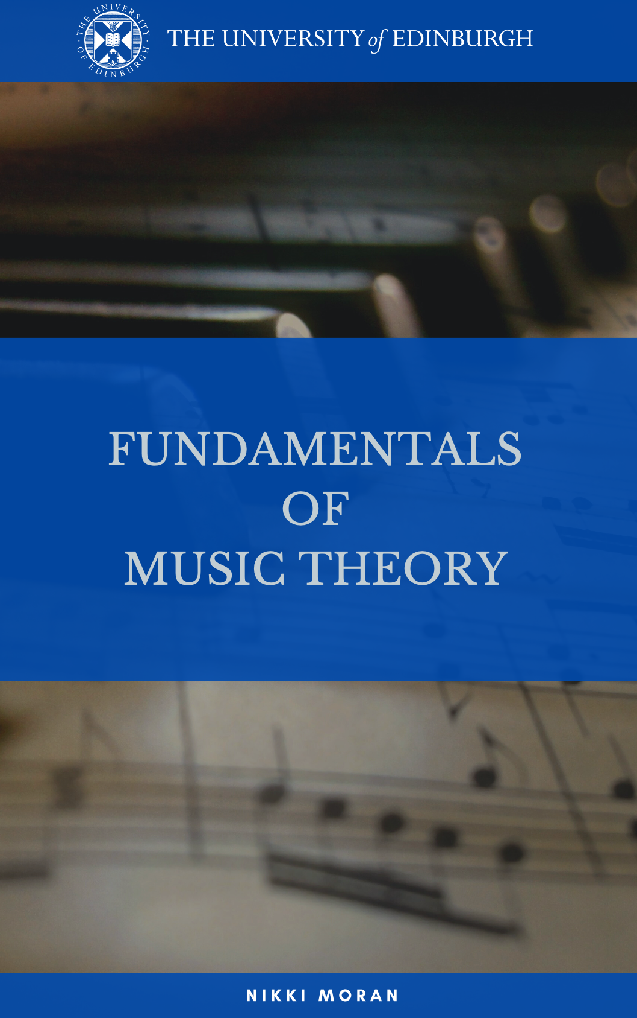

FUNDAMENTALS OF MUSIC THEORY
Michael Edwards, John Kitchen, Nikki Moran, Zack Moir, Richard Worth
The University of Edinburgh

First Edition
First published in 2021 by the University of Edinburgh, Old College, South Bridge, Edinburgh, EH8 9YL.

© Michael Edwards, John Kitchen, Nikki Moran, Zack Moir, Richard Worth, University of Edinburgh. This book is published under a Creative Commons Attribution-ShareAlike 4.0 International licence (CC BY-SA 4.0) unless otherwise indicated. Cover adapted from a free to use image by Geralt on Pixabay.

ISBN: 978-1-912669-22-6
DOI: https://doi.org/10.2218/ED.9781912669226

For further information about the University of Edinburgh’s commitment to open educational resources (OER) please visit https://open.ed.ac.uk/

Table of Contents
Table of Contents ii
Preface iv
Contributors vii
How this textbook is structured viii
Topic 0: Music theory in critical and global context 1
0.1. What we cover in this book 1
0.2 What sort of theory is this? 2
0.3. Why these ideas? Why this system? 3
0.4. What’s behind these ideas and this system? 3
0.5. Taking it from here 5
Topic 1: Musical notes, scales, and the rudiments of notation 6
1.1. Musical Notes 6
1.2. Octaves and scales 15
1.3 Rudiments: Musical duration 21
1.4. More on Scales 26
1.5 Introduction to chords 31
1.6. Primary Chords 37
Topic 2: Tonal music language - concepts and theory 40
2.1. Sharps and Flats 40
2.2. Keys and Key Signatures 44
2.3. Minor Keys and Minor Scales 54
2.4. Intervals 60
Topic 3: Musical Time and Rhythm 68
3.1. Rhythmic Duration 68
3.2. Tuplets 69
3.3. Ties and Dots 71
3.4. Metre 72
Common Time 72
3.5. Anacrusis, Phrases and Structure 75
3.6. Form 78
Topic 4: More on Chords 80
4.1. Listening to Triads 80
4.2. Elaborating Key, Triads and Scales 84
4.3. Building Triads 88
4.4. Harmonising melodies 92
4.5. Seventh chords (and summary) 97
Topic 5: Music theory code-breaking reference guide 102
5.1. General knowledge 102
5.2. Lead sheet chord symbols 103
5.3. Figured Bass 104
Topic 6: Chord functions in practice 106
Perfect and imperfect cadences 110
Interrupted/deceptive cadences 110
6.4. Common Chord Progressions 115
6.5. Modulation 122

Preface
Welcome to this resource! We are so pleased to share these open licensed educational materials, in which we deal with the building blocks of musical stave (sometimes known as staff) notation, a globally recognised language that is designed to communicate musical ideas. The particular ideas and concepts that we cover here include scale, and key, and harmonisation, and metre. The content has been devised to introduce the basic symbols and concepts the five-line stave, and to explain the ways that this notational system can be used to represent and also to analyse musical sounds. The materials cover topics such as pitches and scales, intervals, metre, proceeding to more sophisticated topics of key, time signature, harmonisation, cadence and modulation.
While the materials in this book begin from foundational principles of Western tonal music notation, what we teach here is really not all elementary. For decades and decades, these topics have been explained many times over in different media: In music lessons and lectures and conversations, in concert halls and classrooms and homes; in educational television programmes; in informal homemade teaching materials by instrumental teachers; in textbooks and workbooks that can be found in bookshops and libraries around the world, and – for the past 20 years – in a proliferation of digital content and technologies. Our contribution in this particular resource includes video lectures and their transcripts, supporting text explanations and illustrations. We expect that you have your own reasons for seeking out this resource, and that every individual’s own prior musical experiences and background will create a unique context in which to make sense out of these materials. On this assumption, we have begun from basic first principles, but we have sought to explain the concepts behind each topic in a critical and thoughtful way.
There are lots of reasons you might be interested in these resources. The open licensing means that both students and educators can make use of the audiovisual, text, and image sources that we share here. In terms of the content itself, the topics that we cover include practical skills and knowledge. Depending on your existing practice or interests, these skills could add an extra dimension or understanding to your musical life. Gaining fluency in both reading and using music notation might give you access to new repertoires or deepen your understanding or expression of familiar ones.
At The University of Edinburgh, the way in which we ask our students to approach these topics has changed significantly during the past few years. Like other institutions of higher education in the UK, and as an institution with an international student body and global outlook, we are aware that educational curricula both reflect and shape life and society. The matter of musical imagination has wide relevance not only in learning contexts, but also in our personal and social lives, and we certainly feel that this subject among all others deserves the most sensitive, critical approach. This is a fully open educational resource: we encourage you to make your own choices about your use and re-use of the contents.
Background to the project
The creation of this open textbook represents contributions from a significant number of people, over an extended period of time.
Much of the video lecture material that we share through this open textbook was originally conceived, designed and produced for The University of Edinburgh’s Coursera MOOC (Massive Open Online Course), Fundamentals of Music Theory, in 2013. MOOCs are accessible, freely available educational materials created by University academics who want to offer their expertise to a wider audience. The concept and direction of the original Fundamentals of Music Theory MOOC is attributed to Michael Edwards, at whose suggestion, Zack Moir, Richard Worth, John Kitchen and I offered to contribute. We each prepared scripts and teaching materials, which we revised together. This project was deeply rewarding. We learnt a great deal about how to reconsider the audience who might wish to access and engage with the knowledge that, as an academic team, we were accustomed to take for granted as fundamental to our discipline. It is no great surprise that this project was a precursor to considerable revision and re-assessment on our part on what these fundaments of music theory really represent, and how we should critically re-imagine them.
In 2018-19, an academic team in Music at Edinburgh devised an on-site course for entry-level University students. With support from the University’s Learning Design Service, content from the MOOC was repurposed to create a new blended learning (online and face-to-face) course for undergraduate students. The learning objectives for this course align with much of the material devised for the original MOOC, which our own students use alongside additional new lectures and contextual content which help learners to develop a critical perspective on stave notation, and to understand the topic in a contemporary, global light.
This current open textbook project is a collaboration between the University’s Open Educational Resources Service, and staff and student interns from the Reid School of Music. The project, funded by a University of Edinburgh Student Experience Grant, converted existing course content into convenient and reusable open formats suitable for use by staff and students both within and beyond the University.
Nikki Moran, 5 July 2021
Edinburgh, UK

Contributors
Open Textbooks for Access to Music Education Project (2021)
This open textbook was created by a project funded by a University of Edinburgh Student Experience Grant in 2021. The project team were Dr Nikki Moran, Reid School of Music; Kari Ding, Ifeanyichukwu Ezinmadu, and Ana Reina García, Student Interns, Reid School of Music and Information Services Group; and Lorna M. Campbell and Charlie Farley, OER Service, Information Services Group.
Fundamentals of Music Theory MOOC (2014)
The Fundamentals of Music Theory MOOC has become one of The University of Edinburgh’s most successful Coursera ventures, enrolling 90,000 learners on its first run. Since August 2016, the MOOC has been offered on a rolling basis, reaching a further 165,000 active learners across the globe. In the years since we made the original MOOC in 2014, four of the academic team have moved on to new roles. Michael is now Professor of Electronic Composition at Folkwang University of the Arts, in Essen, Germany. Richard is Lecturer in Music and Popular Music at the University of Liverpool, and Zack is now Associate Professor in Music at Edinburgh Napier University. John Kitchen has now retired but remains The University of Edinburgh’s Organist, and Director of the Edinburgh University Singers.
Information Services Group contributors (2018 - 2021)
The original Coursera MOOC was produced in 2014 by The University of Edinburgh’s MOOC team, who recorded and produced video and quiz materials for the MOOC. The Learning Design Service supported the creation of the on-campus course for entry-level University students in 2018. The Media Production team from the University’s Online Course Production Service created new media for the course during 2020 – 2021.
On-site students, associated staff and postgraduate student tutors (2019-20, 2020-21)
Working with Edinburgh University students in small groups on a weekly basis, both online and face-to-face, we use a range of teaching and learning strategies which generate new content year-on-year, through the interaction of tutors and students.

How this textbook is structured
The student intern team devised topical sections, within which materials are presented in the following order: a video lecture link; explanatory content (text and figures); suggestions for further reading. You can find transcripts from the video lecture at the end of each section. In the following figure, you can see an example of how these materials are presented.
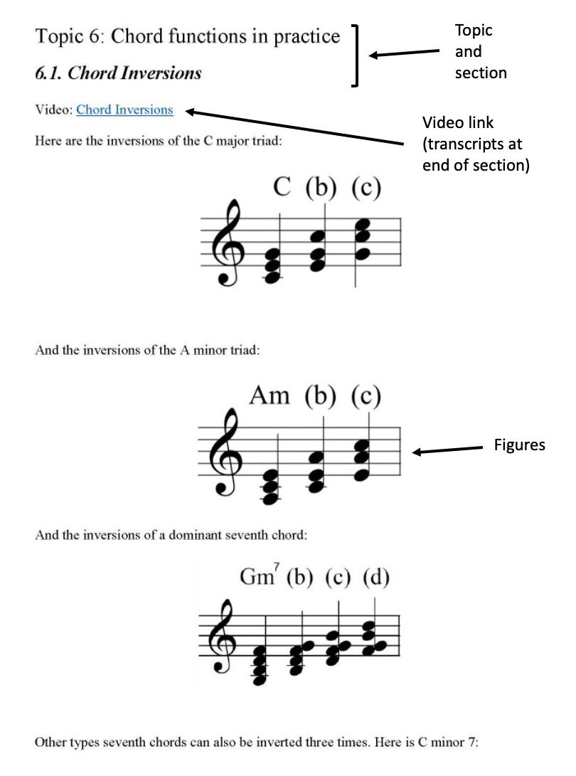
Given the origins of the videos shared openly in this resource, you will notice moments when the presenters may cross-refer lectures, topics, chapters or ‘weeks’ in the course. Where this happens, please simply return to the layout and organisation of this resource to navigate through the materials in the way that you wish to use them.

Topic 0: Music theory in critical and global context

0.1. What we cover in this book
Video: What we cover in this book
This topic is presented in a series of five micro-lectures, each one lasting 2-3 minutes. For this textbook resource, we present these here for you simply as video links and their transcripts. This topic is helpful in introducing the materials of the book, but it is delivered independently of the other topics. So, if you want to get stuck into the rudiments of music theory and notation, you can go straight to Topic 1 and come back to this when you’re ready.

Transcript of the Video
00:08 | We want you to have the best chance of learning something personal and meaningful through this course. So we have to make some things completely clear. Let’s talk about what we cover here, about what we don’t cover here, and about how that comes to be. I’ll begin with what we don’t cover.
00:27 | This course is called ‘Fundamentals of Music Theory’. That’s the title that you discovered and engaged with. But straight off: What we’re calling Music Theory here: It isn’t a scientific theory that can account for features of the natural world. No. Rather, if you’re studying the fundamentals of music theory, what that means is you’re being schooled, you’re being disciplined in an academic sense, in a particular way of knowing, connected to how you can talk and think about music. That’s not necessarily going to be simple and straightforward. So, I mentioned already in the introduction that the theory part doesn’t mean scientific, and the fundamentals part doesn’t mean elementary. There’s more. Brace yourselves.
01:13 | In this context, the music part isn’t going to give you the full picture, it’s not the whole story. The music in music theory in this context signifies an orientation to white European discourse about music. Being fluent in any sort of music language - that relies on a combination of practical and conceptual skills. It’s challenging and it requires a sophisticated type of thinking. And stave notation is a powerful tool to support this. But the scope of human musical imagination and creativity goes way past the classroom conventions of music theory. And yet, this dominant knowledge system is quite profoundly oriented to particularly European notions of music born of the past 150 colonial and post-colonial years. More of that in a minute.

0.2 What sort of theory is this?
Video: What sort of theory is this?

Transcript of the Video
00:08 | In terms of the material we teach here, the focus is mainly on that bit about ‘literacy’. A musical language you learn to write down. The apparatus of music theory more generally includes various – potentially unlimited! – languages and terminology that people can use to think about music. And beneath all languages – including music theoretic languages – we find concepts. We find ideas.
00:39 | As I’ve said in the introduction, in this course, we teach the building blocks of stave notation, as a system designed to communicate musical ideas. And we’re going to focus on the concepts of scale and key, and harmony and metre. But if we’re not talking about a scientific theory, then where do these ideas, these concepts, where do they come from? Musical concepts come from people in the world. They start off out there in the physical, human, cultural context of performance and imagination in the way that human is. And bodies perceive the physical vibrations of materials and in the ways that they make sense and patterns out of these experiences. So musical notation, in its long and varied history, is a technology. Musical concepts don’t start off as symbols on paper, but through notation we write them down, visualize them and learn them, and imagine them and create with them. Every successful human technology, it integrates with our lives and shapes our thinking and imagination. So stave notation then, as a form of literacy, it’s become a widespread, globalized, influential technology.

0.3. Why these ideas? Why this system?
Video: Why this system?

Transcript of the Video
00:08 | Here in the UK, the five-line stave is a dominant and thoroughly institutionalized language. Learning music theory generally means learning to read and write music notation. You might already take it for granted that those two things come together. That’s even more likely to be true if you’re familiar with taking formal music exams. At the heart of the majority of music exam systems is what’s known as common practice harmony. That’s a way of referring to a harmonic language that, roughly, unites European tonal music for around 2.5 centuries up to the twentieth century. And that spans an array of styles and so-called areas of European classical music – late Baroque, Classical, Romantic eras.
00:56 | The graded music examination system started in London in the later part of this common practice period in 1877. Within 25 years – so, by the start of the twentieth century - a very substantial portion of these music theory exams were taking place overseas. This exam system, it was quite an industry going on at a time when the British Empire held power over nearly a quarter of the world’s population.
01:27 | This exam system has changed somewhat in the last few years, but it’s basically continuous now for nearly 150 years. Now, the music theory that’s taught in this system, remember, we’re not describing a coherent scientific theory. Sound is real; it’s material. If you study acoustics, you’ll learn the science of sound. But study music theory, and a huge part of what you’re studying is cultural convention.

0.4. What’s behind these ideas and this system?
Video: What’s behind this system?

Transcript of the Video
0:09 | When I said earlier that this course deals with musical ‘literacy’ – well, education theory has taught us to think critically about literacy. About what we might take for granted when we prescribe certain ways of expressing knowledge in a curriculum – when we make some types of language-use legitimate. When we do that, it means – logically – that other types of knowledge, and content, and facts, are going to get skipped over. They are denied. They appear illegitimate.
0:42 | Broadly speaking, this music theory system explains – it legitimizes – some elements of musical compositions better than others. The basic principles of notation on a five-line stave, these don’t actually tie you at all to any particular musical genre or tradition or music theory. Jazz and popular musicians since the early twentieth century have been some of the strongest advocates for the artistic sophistication that music notation can enable. But the dominant musical ideology of the stave comes from association with the institutions of European classical music as it has been understood for the past 100 – 150 years - since 1877, say - for the time really that there’s been a desire to formalise, or rather, to classify, music education and its attainment.
1:39 | Well, critical and postcolonial scholarship has given us new ways to understand music education in the UK. And what’s taught in schools today is light years away from the Victorian exam system. But very recent work suggests that the institutions of classical music seems still to be strongly shaped by the collective imagination of an idealized human form. It’s white, it’s male, and it’s able bodied. The discourse of classical music education appears aspirational and beyond politics. But, of course, it intersects with social class and sex, and gender and disability. And this has consequences for the musical lives of, well, most people.
2:28 | Music theory sometimes comes with a capital M and capital T. The American music theorist, Philip Ewell, explains brilliantly how the language - the bigger academic enterprise - of music theory isn’t at all scientifically or politically neutral regarding race. Ewell uses critical race and feminist scholarship to understand and to explain in detail how this is so. And you can read about this freely on his blog posts. The link and some other reading suggestions are on the screen in case you’re interested.

0.5. Taking it from here
Video: Taking it from here

Transcript of the Video
0:09 | So, basically: the ideas we teach about in this course – remember, that’s scale, key, harmony, and metre – and five-line stave notation we instruct here, to express them – they don’t map simply onto scientific universals.
0:29 | Take a big wide view of human music-making, it’s obvious that we should expect huge variety in the core principles and theories that underpin different musical traditions. Our musical realities and our conceptualisation of them – there’s going to be huge variety between traditions, coming from geographical separation between groups of people – and also between instrumental music and song – differences due to technologies – and to do with function – and to do with social organisation, between genres and scenes of music, and so on. And even within eras of, call it Western tonal music, different musical forms and performance contexts give rise to wildly different types of harmonic conventions and opportunities.
1:23 | To sum it all up: Stave notation based on elements of this music theory system has become a very widespread system of communicating about musical ideas. It’s the system we’re teaching about on this course. It’s got some strengths, and some weaknesses. As I already explained, the ‘fundamentals’ part doesn’t mean easy or elementary; the ‘theory’ part doesn’t mean scientific – and the ‘music’ bit is partial. As a cultural system, it is not politically neutral.
2:00 | And now, I want to say: don’t let that put you off. The material that we cover here: it’s a system, like any other language. Knowing some of its context, you are better equipped to resist it, transform it, create with it.
2:17 | Whatever your reasons for choosing to learn on this course, you’re in charge of them – you’re not obliged to learn this particular system of musical thinking – and it really needn’t be your only way of thinking, musically! But whoever you are, whatever your reasons, you are entitled – and you are welcome – to choose to learn this.

Topic 1: Musical notes, scales, and the rudiments of notation

Musical Notes
Video: Musical Notes
Here is an example of some early music notation, written before the standardized five-line stave came into use:
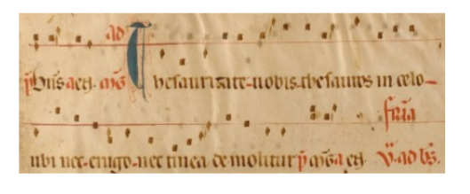
This type of early notation – known as neumes – gives some indication about how to perform this fourteenth-century chant. There are the words, there’s a reference line and there are some marks which indicate some approximate pitches (‘OK lads here’s the tune. It goes up a bit… down a bit…. Down a bit more… this bit jumps up and then it goes down again…’)

Rudiments: Naming the notes
Here are the seven alphabetical note names in ascending order. Note the ledger line for the last A, to temporarily extend the stave:
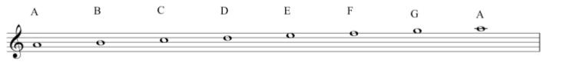
Here they are descending from A (with more ledger lines, extending the stave downwards):
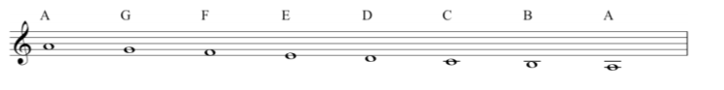
With a mnemonic for learning the position of the notes in the treble clef:
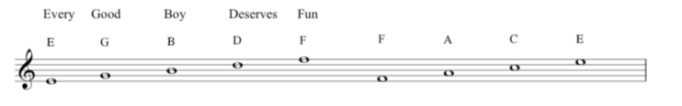
Which sounds as tired and archaic as music theory ever gets. So, please do invent your own new ones (Eating Green Beans Delivers Flatulence?).
Here are the notes on a piano keyboard:

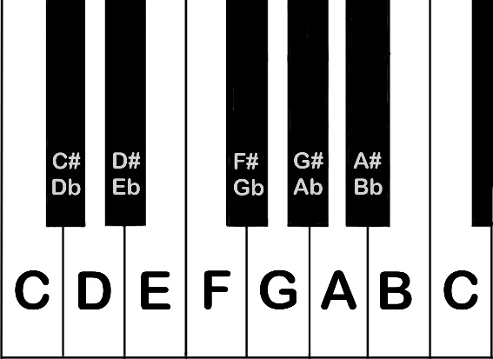

Finally, we introduced the octave. Here are the seven note names shown in adjacent octaves on the stave.
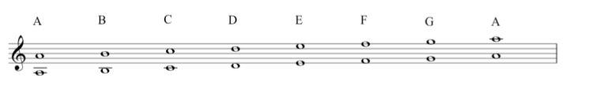
Note that when the lower note is on the line, its octave above is on a space. This lower C with one ledger line can be referred to as middle C:
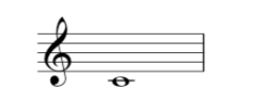
You can find it right in the middle of the keyboard. The note names are sometimes written on electronic keyboards. On an acoustic instrument, you would find it near the lock of the piano lid.

Transcript of the Video
0:00 | Before we get started, a word about pianos and keyboards. We are going to use the piano quite a lot for this music theory course. And we’re hoping that you can get access to any kind of keyboard, including one that you might download as an app. You don’t need to be a piano player; you simply need to be able to put your fingers on the keys and play along with some of the stuff as we do it. The only reason that we’re doing this is because it’s a really nice visual illustration of some of the things that we’re going to be talking about. So let’s get started. Here’s a sound. And here is another sound. You’d probably say that this one is high. Whereas this one is low. And that is the case in nearly every language in the planet. The thing is with this sound, while I can say it’s high, I can’t seem to sing it. I can’t find the note. And that’s just exactly the same as this one.
0:57 | We know it’s low, but again bom, bom, bom. There’s no, there’s no note to, to latch on to and recognize there. But compare with this, which is high, but is a note. La- sings same note. And then we’ve got a low note. That’s, again, something that we can sing, we can recognize. So those two examples have what we call Pitch. Okay? A singable musical quality to the sound, all right?  Now, we’re going to be looking at how to represent this stuff graphically. This is the written part of music. So, I could say obviously my note was high, so I’ll stick it up here. Zack’s note came afterwards with low down here, shall we, shall we say. That would imply that this axis is giving us time. My note first, Zack’s second. And this axis, this axis is giving us Pitch. High and low, okay? And that’s fine. But actually, it’s really quite difficult to know just how high that note is, or how low this note is. It’s not very good for us to able to give this to someone else, to be able to replicate what we did. You know? It’s, it’s, it’s purely a, a kind of graph of where our notes were. I can try and make a tune, like, la, la, la, la. But we don’t really know. Yeah, this is just a, a, Scatter Graph. It’s just plotting where things happened, and roughly how high or low they were.  In the seventh century, Archbishop Isidore of Seville, said, that unless sounds could be held in the memory of man, they are lost because they cannot be written down. You’ve got to imagine you’re a ninth century monk and you’ve come up with a really great piece of music for the church liturgy, okay?
02:37 | You can use this kind of system here, as a memory jogger for you and for the people you’re immediately working with. But you have no musical instrument and you have no recording devices. So if you wanted to send this to another monastery, if you wanted to submit it to the Pope for authentication, you couldn’t. There’s no way that anyone else would be able to interpret these dots. They struggled with this right through, until in the sixteenth century, they came up with this. Five lines called a stave, or if you’re American, a staff. Okay? These five lines are like a grid system that can be overlaid onto those dots. Now we have some relativity that we can work with. Right. So we got this stave, and I’m going to put a symbol here, which you’ll probably recognize.
03:31 | Now, these monks started naming the notes. Things like Do Re Mi, which we still use. But, also, particularly in English speaking countries, letters from the alphabet, and we’ll start with A. Which on the piano, sounds like. A, and I’ll put that right here, on this space. So that’s, A. Okay, so we said it was alphabetical. So the next thing obviously is B, and that sits on the line, just above that space. B. You guessed it. The next one is C, and that’s in the space above. C. And then we’ve got D on the next line. D. E on the next space. E. F on the next line. F. G compares just on top of the stave. G. And then it looks like we’ve run out of stave actually, but we can, we can write notes that are higher than this and there’s a trick for getting around that. Richard’s going to show you. It’s called a ledger line, and that gets us that note. Okay, so on that note if we were following that up alphabetically, A, B, C, D, E, F, G. Not H, what we get is another A. Okay, so we can say that our musical alphabet runs A, B, C, D, E, F, G and then the sequence starts repeating itself.
04:51 | Going down, I’m just going to come down to this stave and A goes down, of course, to G. And then if you keep going down we’ve got an F and the space, E on the line, D perched just below the stave. And again, we’ve got the same problem. But as Richard says, we can use a short line, which is temporary and it’s called a Ledger Line that represents our C. We can draw them, the line again, and write the next note in the space below, that gives us a B and we can keep going with this. So, so the next thing is two ledger lines. And all we’re doing is temporarily extending the stave when we do this and this takes us back down to our E, again.
05:31 | Now one other thing I’ll just mention. So we started on A and we came down to a G. This G is on the line and this line is where this symbol circles itself around. So this symbol can be called a G-Clef, or more commonly nowadays, a treble clef. But the really important thing we’ve got to deal with is the existence of more than one A. And in fact now we’ve seen this being a C, more than one C. What does that mean? That’s what we’re going to look at next.  Following on from this idea of having more than one of any given note represented at different points on the stave. Let’s use the guitar as an illustration.
06:08 | So on the guitar, if we play this string, we get an A. Now this instrument makes sound by having a string that vibrates. If I was to put my finger halfway along the length of that string, it now vibrates at double the frequency. This is what we call an Octave. This A is an octave higher than this A. But we can hear, although there are different notes on there’re different points on the instrument, they do sound equivalent in some way. And this is something that we’ll recognize intuitively, and we’ll be able to illustrate that with our voices. Okay, so imagine you’re at a party. Sing: Happy birthday to you, happy birthday to you. That’s quite enough of that!  But, I sang high, the part that often children or, some women would sing, and Zack sang low. We were singing the same melody. You always do this in your everyday life. We were singing in octaves. Okay? It sounded equivalent. It didn’t sound weird. It didn’t clash. This is what we mean by an octave.  So again looking at our stave, let’s see what this octaves mean. Right here’s A, and if we count these notes, A being 1, B 2, C 3, D 4, E 5, F6, G7, number 8 is when we come back to A. That’s not going to be much of a surprise to us given that we’ve called it an Octave. The 8.  So we’ve looked at these notes on the stave, but let’s just go back to the keyboard so we can look at where they are on an instrument. So the A that we’ve started with was here. We never got that A. An octave above up here. So we had A, B, C, D, E, F, G, and A. And you’ll notice that that’s just used every line and space on the stave, but we’ve only used the white notes on a piano and that’s going to become important. We’ll talk about that more in a minute. We can go down to A. A, G, F, E, B, C, B, and right down to A. So again, just to highlight this idea of the octaves. We’ve got an A here. We’ve got an A here. We’ve got an A here. We’ve even got an A up here, and this carries on both ways up and down the piano.
08:42 | Great. So we’ve seen the notes on the keyboard. We’ve been writing them down. You need a way to remember where they are on the stave, if you don’t already read music. So as Richard said, this is called the G-Clef, the treble clef and if we wanted, we could always go back to first principles and count everything from this G on the second line. G, A, B, C, D, E.  That’s going to take a long time though. So, we’ve got some nice ways to remember it. So, if I start on the bottom line, it’s an E. Then the next line is a G. The next line is a B. The next one a D. And then the line at the top is an F. E G B D F could spell Every Good Boy Deserves Fruit, football, fun, food. And, if we go to the spaces, the bottom space is F, the next space is an A, a C, then an E: F-A-C-E. So, that’s a way to remember the lines and the spaces separately, but of course we’ve always got to remember that it’s part of a spectrum. So at the bottom we’ve got E line, F on the space, G line, A on the space and so on alphabetically. These two things come together.

Rudiments: Ledger lines and clefs
Video: Ledger lines and clefs
So far in this course, we have spoken mostly about the treble clef. As we note in this video there are some other common clefs, and we’d like to just take a minute to discuss these here. The point of having different clefs is that different voices and instruments produce different ranges of pitches.

Treble clef
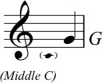
The treble clef is also known as the G clef. Why? The fat loop of the clef’s symbol encircles the second of the five lines of the stave (counting up from the bottom). This assigns the pitch G to this line. The graphic also shows the position of middle C. If you need to recap musical notes, please go and read point 1.1. on this same topic.

The bass clef
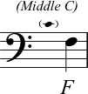
The bass clef is also known as the F clef: the two dots on the left of this symbol (see the image above) are positioned either side of the fourth line of the stave. This assigns the pitch name F to this line. Again, the position of middle C is shown in this graphic.

The alto clef
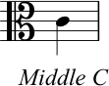
The alto clef is commonly used for music played by the viola or alto trombone, for example. The alto clef is known as a C clef; the line in the middle of the two curved loops (third line of the stave) is MIDDLE C.

The tenor clef
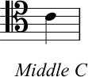
Confusingly, the tenor clef is another type of C clef. Again, the line in the middle of the two curved loops of the clef is MIDDLE C (see the graphic above).
Ledger Lines
As we are going to mention in the next section 1.1, we can extend the normal range of the stave by adding ledger lines, both above and below the stave. The following images show ledger lines being used above and below staves using each of the clefs that we have discussed so far.
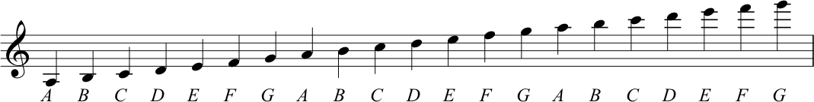
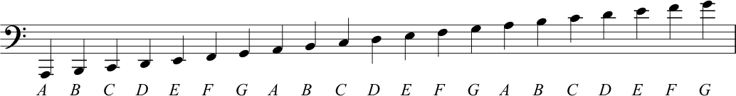
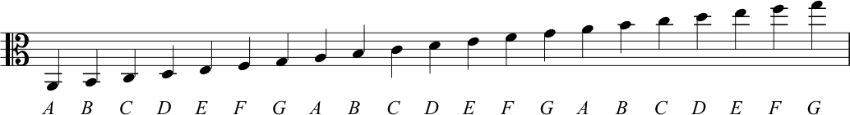
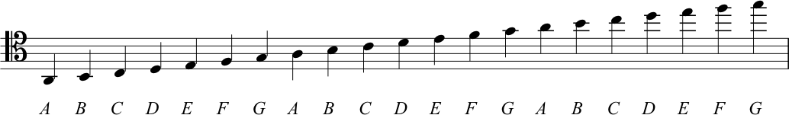

Transcript of the Video
00:00 | So up until this point, we’ve been reading and writing notes, in relation to the treble clef. And in lecture one, Richard showed us that, although this stave has five lines and four spaces, actually we can temporarily extend this. If needs be, by use of ledger lines. Now what this does, is allows us to go, a bit higher for a period of time, or a bit below the stave, a bit lower for a period of time, if we need to represent and show notes that are out width this main range. There’s a couple of problems with that. If we go on for any duration using only letter lines, that’s really quite hard to read. A musician trying to read that music, kind of loses that orientation if you stay a long way from those five lines and you’re just floating above the stave on those ledgers, or below the stave on those ledgers. You can see an example here. It gets a little disorienting to look at.
01:04 | And secondly, even using ledger lines, reasonable amounts of ledger lines above and below the stave, we still not getting, at all of the ranges of pitches that, that real instruments and real voices actually use. When they’re performing music if you think about a bass guitar and you compare it to a flute. We’ve got really low sound and we’ve got really high sounds. We need ways of covering both of those ranges of pitches. If you think about choirs and the four voice types that we might commonly have in a choir. We might have a bass voice. A tenor voice, an alto voice, a soprano voice. And kind of the point is, that in those different voice ranges, we cover different ranges of pitches. So you remember from week one, we described a clef, a cleft as really just a way to identify notes. And really to assign letter names to the series of four spaces and five lines.
02:04 | The treble clef is the one that we’ve used so far, and it’s just a system. sorry, the treble clef we’ve used is just a symbol, that we use to indicate which range of pitches we want these particular lines and spaces to represent. So, there’s actually a few different types of clefs. And all of which do exactly the same thing. They indicate the different selection of pitches that should be read from the lines, and the spaces on the stave, but we’re going to focus on the next most commonly used clef and that is the bass clef and as the name suggests this one is used to represent low-pitched notes. Now an interesting thing about this clef, is that it, quite often, forms part of a system with the treble clef. Anyone who’s ever looked at a piece of piano music, will be really familiar with the look of this.
02:53 | Now, you can see that we’ve got two staves. Each of them has got the normal five lines. And they’re connected by what we call, a brace. That’s the bracket here on the far left. So these two staves together, give us, a grand stave. So we’ve got five lines, on the top stave and we’ve got five lines on the bottom stave. Now what one is to do is imagine, an eleventh line, that runs right through the middle of these two. It’s right in between the two staves. We could say that this line gives us a meeting point between the ranges of pitches, and between the two clefs.
03:33 | So the middle line, if we think about it then, would appear as the first ledger line, below. The treble clef stave would go down, and if we are thinking about the bass stave, is the first ledger line above this stave. Now, this line whether you are thinking about it in the treble clef, or in the bass clef, actually, represents the same note, is the note that we, is the, is the line that we would draw, C on. And because it’s right in between the two, staves, with the two clefts, we actually call this, Middle C. So we can see that this note Middle C joins or it connects the two staves, and that as such, we can see that the treble and the bass staves aren’t completely separate entities but actually there are two constructs that serve to form a spectrum, of pitches from low to high. The treble and the bass clef are the two most common clefs. But there are others, as we’ve mentioned, and the additional material for this section goes into this further.

Octaves and scales
Video: Octaves

Musical intervals
Here is the interval of a second as shown in the video:
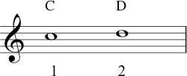
At approximately 3 minutes 20 seconds in the segment, Zack gives several examples of more intervals, and here they are in the order he played them:
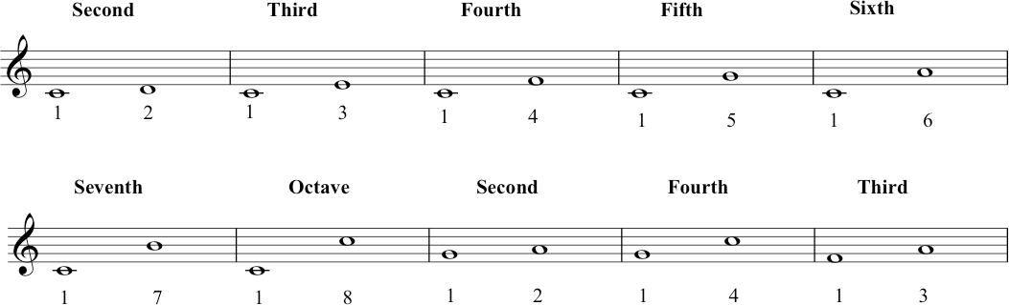

Tones and semitones
Note that – while only using white notes – we have identified two pairs of semitones. The first pair occurs between B and C:
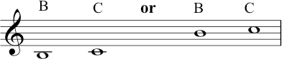
The other pair sits between the notes E and F:
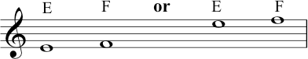
These intervals are clearly illustrated in the layout of a keyboard instrument, because there is no black key between them. If you look back at the keyboard graphic, you will see this.

The C major scale
Knowing the difference between these tones (T) and semitones (S), allows us to derive the C major scale:
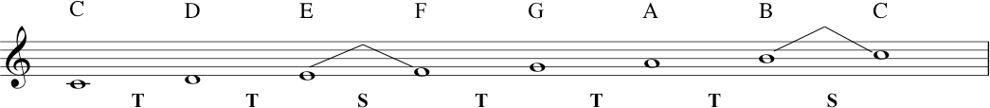
The note C is the tonic note of the C major scale. This scale is an example of a diatonic scale one that has a pattern of 2 semitones and 5 tones between the notes that take you from the tonic note in one octave, to the same (tonic) note in the next octave.
In the video we identified the octave on the guitar by halving the string. This brings up a phenomenon formally known as the harmonic series. If you keep halving a string and playing it, you don’t JUST keep getting the next octave; it becomes more interesting than that there is a mathematical relationship, which Pythagoras is often cited as the discoverer of (although others had probably figured it out before). If you are interested: Harmonic Series.
On top of semitones, smaller intervals do of course exist. The semitone as we’re talking about it today (as a fixed size of interval) comes from the technology of equal temperament – a type of tuning system – that has been dominant since the twentieth century. There are other tuning systems – e.g. just intonation, well temperament, etc. – in which some ‘semitones’ are deliberately smaller than others! If you are so inclined, you can read more about all this here… Just Intonation.
We can describe intervals smaller than a semitone as microtones.
A well-known example would be singers or guitarists ‘bending’ a note up or down in Blues, Rock and Jazz. Classical music from the mid twentieth century often used microtones as part of the compositional process, finding new ways to develop stave notation to accommodate this. And much music from other cultures around the world uses microtonal tuning as an essential element, in both imagination (theory) and performance.

Transcript of the Video
0:00 | In this section, we’re going to look more at the vertical distances between notes.  If you remember back to the graph, we originally drew and we said the vertical axis represented high pitches or low pitches. We’re now going to start quantifying those. Now, we did say that we had an octave which is a real phenomenon, a phenomenon of nature. And we said that was eight notes. Of course, it’s actually seven note names, A, B, C, D, E, F, G, back to A.
0:31 | But, of course, if you look, for instance, at Zack’s guitar here, you’ll see that there aren’t seven notes. There’s a lot more. So, we did an example where we said that the open A string is here and then if you half that string. It’s an octave above. But if we look at the, the discreet pitches available to us in between. We’ve actually got, 1, 2, 3, 4, 5, 6, 7, 8, 9, 10, 11, 12, and then things start to repeat again, actually. So what we’re saying is the octave on many musical instruments nowadays isn’t divided into eight, as you’d expect based on the prefix oct-. Actually, we have 12 distinct pitch classes. Yeah. Now, if we were to look at the piano, we will see the same thing again. So looking at what Zack did on guitar. If we look at it on the piano, instead of having frets, of course we’ve got all of these white notes. We’ve also got these black notes, which we’re now going to introduce. So, starting on A, where Zack was, 1,2, 3, 4, 5, 6, 7, 8, 9, 10, 11, 12, and then we’re back to A. And there’s the octave. Now, going back to this A, this distance here is called a semitone, where ‘semi-’ means half. If that distance is called a semitone this distance is called a Tone. Semitone, half, double it, tone. That’s the same on all instrument.
2:23 | Okay, keep that thought in mind. We’re now going to have a look at that represented back on our stave. Now, this semitone is the smallest distance that we’re going to work with at the moment. Now, if you want to find out more about that, we have additional material on it. But let’s just say for the moment, the semitone is the smallest working distance we can have between two notes. Also, at this point we’re going to stop using A and start orientating ourselves around C.
2:51 | And so, here is C on our stave. The next note up on the line is D. We can count from C to D, one, two. It’s a tone. But if we’re going to name it in a different way, we can say it’s an interval of a second. One, two, a second. There are lots more intervals for us to look at, and to do that we’re actually going to go back to the keyboard. So Richard’s just talked to you about this interval, the second, from C to D. But as he said, there’s much more than that. So let’s have another look through that, and we’ll do that within the octave. So, we’ve got C to D. There’s a second, one, two. We’ve got C to E, 1 2 3. That’s a third. C to F, a fourth. C to G, a fifth. C to A, a sixth. C to B, a seventh. And from C to C, we’re not going to call that an eighth, we’re going to use the word that we’ve already used, which is octave.
4:03 | But what we don’t want you to think is that intervals are only ever counted from C. You know, we could go from G to A, is a second. G to C is a fourth. F to A is a third. It’s all about counting the space. One, two, three. F to A is a third. Now, if we were to play B to C, for example. We can see that this is a second. One, two. But actually what we see here is that the B to C Is a second, but the C is only a semitone above B. Whereas, for instance, F to G, 1, 2, is a second. But G is actually a tone, that’s to say, two semitones above F. Now, they are both seconds, and it’s perfectly correct to describe them that way. But they do have a different quality. We’re going to talk about that more next week, so hold that thought, but at the moment let’s use that information and turn to think about scales.
5:24 | So now I’m going to turn our attention to scales. There’s one. Scales are a pathway through an octave, okay? It’s like they’re a pool of notes, a set of notes which melodies can be drawn from. And if we can have that on the piano as well. I could say if I was doing Julie Andrews. Which is that is a Do, Re, Mi, Fa, Sol, La, Ti, Do. But I can also say it is, C, D, E, F, G, A, B, C. That is why we have orientated ourselves to C, because we’ve now found the scale of C major, which I’m sure you’ve heard of. Which is very common throughout the world. Similarities exist in many cultures, and it’s what lots of music is built on, C major. And an important thing for you, looking at this, is when you’re looking at your piano, it’s all the white notes from C to C. So, Richard just said that this is an example of a major scale.
6:29 | And actually, what’s important here, is the relationship between the notes.  The relationship between all of these notes that are available to us within this pool of notes. And actually what we have to remember here is the difference between tones and semitones.
6:48 | So let’s look at them again on the last stave. C to D. That’s a tone, so I’m going to write T underneath here for tone. D to E another tone. So here is a T. E to F there is no black note in between so this is a semi tone. Which I will show with an S. F to G a tone. G to A a tone. A to B, a tone. And again, B to C, a semitone. There’s no blank note in between. So, that gives us a pattern of Tone, Tone, Semitone, Tone, Tone, Tone, Semitone.  So, this pattern of two tones and then a semi-tone and three more tones and a final semi-tone is what makes this scale sound the way it does. Now we could say that each note on its own doesn’t actually mean that much, what’s important is how they sound next to each other in the context. How they stand next to each other and build up relationships between one another. What this does is it gives us the flavour, gives us the overall sound. And if we’re going to talk about that formally in music theoretic terms, it gives us the quality of the scale.
8:06 | An important piece of terminology to remember, then, is that the letter name that the scale is named after is called the tonic. So, in the case of C major, C is the tonic. In the case of F major, F is the tonic.
8:28 | This major scale is also an example what is called a Diatonic Scale. ‘Dia-’ between two tonics. Diatonic scales are ones where we always have seven notes with some pattern of five tones and two semitones.
8:45 | Now, let’s just have a little bit of the scale again on the stave. And, remember we said C to D was a second. Zack had pointed out that B to C was also a second but one of the smaller ones: a semitone. So, I’m going to put this little dart sign here, to show that between B and C is the semitone. Now, the other place we have a semitone is between E and F. So, I’m also going to put the dart sign there. That will just help us to see, on the stave, or major scale, where the semitones are. So, there you have it, we found C major. Through our pattern of tones and semitones, we’ve found our first major scale. But of course, a scale isn’t just a scale. A scale helps to make music. C major can give us this. Well, we are in Scotland. C major can also give us this. And don’t think I’m being patronizing playing Twinkle Twinkle Little Star. It’s a good exemplifier of the major scale. It’s also a good enough tune for Mozart to write a whole set of variations on. While I’m on Mozart, that brings me to a little disclaimer. In this course, we’re dealing with musical techniques that are known as the ‘Common Practice’. And the ‘Common Practice’ era is basically Western Europe from 1600 to 1900. So, it’s very much the music of Bach, Haydn, Mozart, Beethoven, etc.
10:15 | But there are other forms of music around the world. That might use different techniques. Where possible, we will reference them, but it has to be said that the common practice is a good system to work from. It applies to quite a lot of pop and rock, a lot of jazz, quite a lot of folk music, and so that’s our main focus in this course.

1.3 Rudiments: Musical duration
Video: Rudiments of rhythm notation
The following graphics set out the forms of note-heads, stems, flags and beams which conventionally indicate musical duration. With each level (working from top to bottom), the duration of the note is halved, i.e., 4 beats, 2 beats, 1 beat, half beat...and so on. The first figure shows the symbolic forms used for musical notes. The second shows the equivalent symbols used to indicate measured rests (silences) in the music.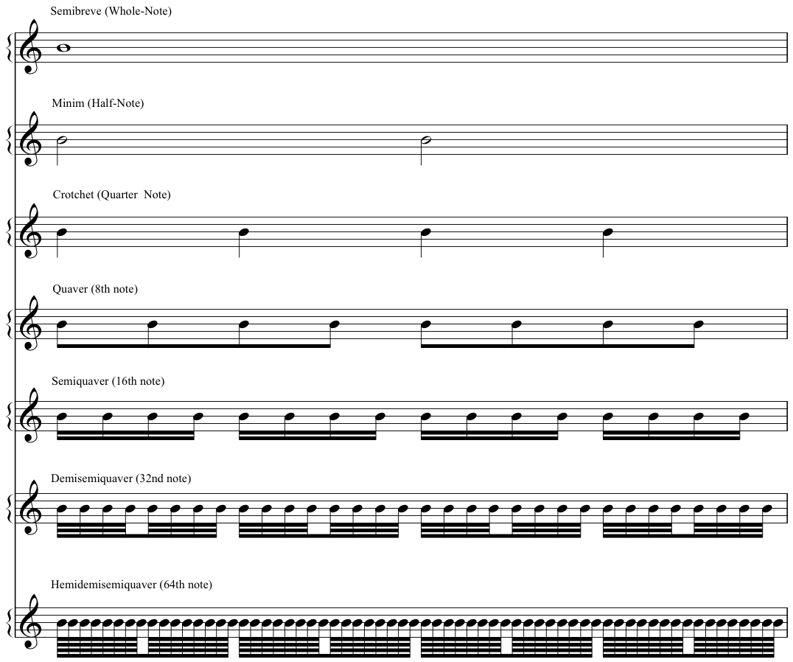
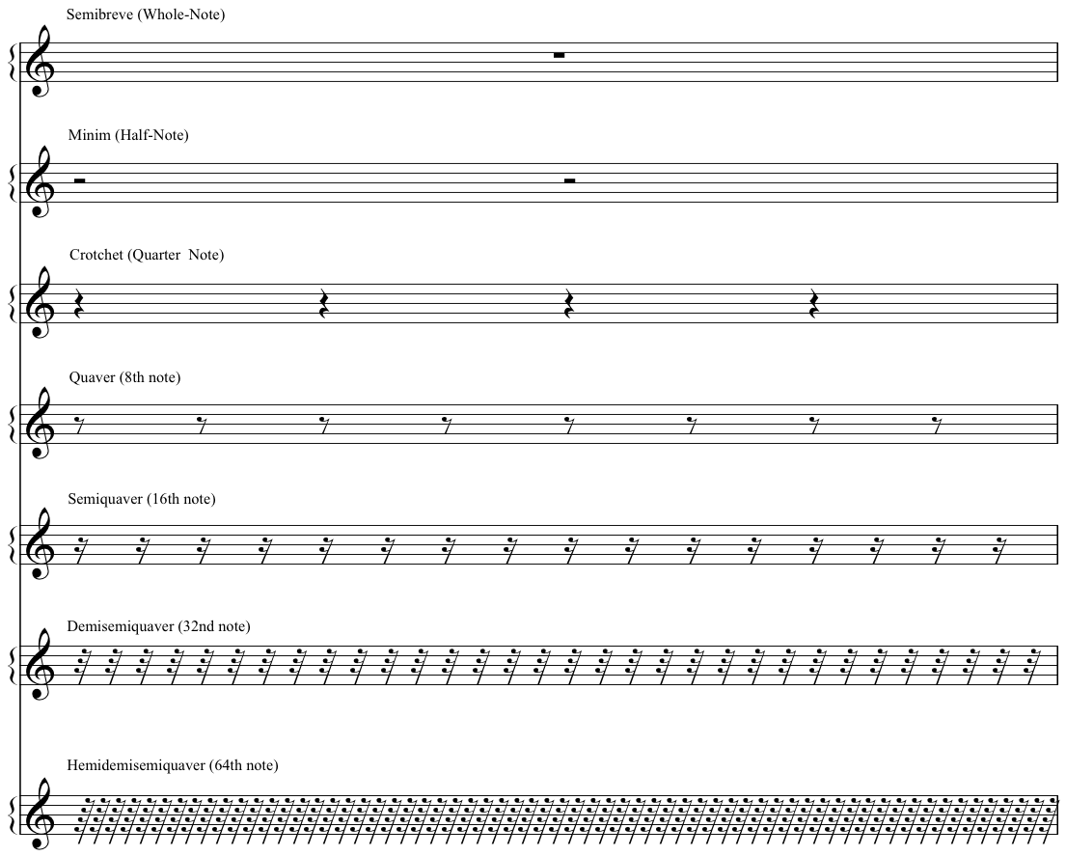

Musical example – quavers with flags, quavers with beams!
During the video, Nikki refers to an excerpt of a musical score which is freely available in the public domain. You can find it here at the sheet music repository, https://imslp.org. Nikki indicates the portion of the score in the upper half of page 33, and she highlights the stave of music marked ‘Corno Principale’. This musical example features the opening four seconds of the third movement (Rondo) of Mozart, Horn Concerto in E-flat, K.495, composed in 1786. Nikki suggests listening to the corresponding portion of a recording freely shared by the BBC Scottish Symphony Orchestra, recorded in Glasgow City Halls on 1 February 2018, available at https://www.youtube.com/watch?v=KogtLJpgHXg.

Transcript of the Video
0:00 | While we’re introducing some of the rudiments – some of the first principles - of notation, let’s talk about duration. About how long any particular note or sound should last - because not all musical notes last the same length of time. Some are long, and some short short short! And there’s everything in between.
0:23 | To communicate about this type of information, we can change the appearance of a note. We can do things like changing the appearance of the note-head, by having it filled or appearing empty. We can add stems, we can add flags and beams to those stems. So what matters here isn’t whether a note sits up high or low on the stave (whether it’s high up or low down). We’re looking at the shape of the symbol.
0:49 | And, we’ve got some names for these, of course! I’m using UK English naming conventions. So we’ve got - from top to bottom here - semibreve, minim, crotchet, quaver, semiquaver. And what do all these mean? Well this is a system. These symbols work in relation to one other. The middle level here, the crotchet, each one lasts for one count.
1:18 | So here are four crotchets. [Click - click - click - click.]  In the same time span of those four counts, we could have two minims. Or eight quavers. Or sixteen semiquavers. Or one semibreve. So each row, each level in this pyramid represents the same amount of musical time. They each represent four counts.
1:50 | And there are also symbols to indicate short versus long rests. By rests, we’re talking about gaps or silences, where there are no notes. Where there is no sound to be made. So these correspond to the same names and relative durations as the note symbols. And again, these have the same simple relationships as their counterpart notes. So in this pyramid, again, in this pyramid shape, the semibreve sits at the top - the semibreve rest is worth four counts. Two minims. Four crotchets. Eight quavers or sixteen semiquaver rests. So again, each level has a 2:1 relationship with the rows above and below it.
2:38 | Now you might notice that I’ve handwritten these graphics. And they might look a bit uneven places! This is not (totally!) an accident. I really want to keep away from the idea that there is one perfect form of musical notation. Remember that musical notation is about expressing and communicating about musical ideas. Which are human ideas! And so, for many reasons, you’ll notice a lot of variation in how notation symbols are formed across different musical scores and contexts.
3:10 | And when we’ve got them laid out like this, notation can perhaps seem like a simple code to map out musical sounds, unit by unit. But these rudiments of notation are not just about representing individual sounds. Language is more subtle than that, isn’t it?
3:28 | So even just looking at written English language, for example: notice how my ‘Q’ here is different to my ‘q’ here! They’re both Qs but they look different. And musical notation can work in similar ways to communicate about how the musical composition works, about how it hangs together.
3:51 | For example, you have seen already two different ways of writing out a quaver duration, using a flag or a beam. So we have two individual quavers here, with flags. We could also write them joined together with a beam. But the decision to do this - with a flag or a beam - it’s not only about how many quavers we’ve got together. It’s a notational convention that’s also communicating something about the bigger picture of a composition. About the way that the particular piece of music is expressing time and rhythm.
4:28 | So here’s one quick example, which will also help you to get familiar with the varied visual appearance of these rudiments of notation. You can take a look at this excerpt that I’m showing here. In the line of the score that I’ve highlighted here – the main melody line – you can see that both types of quaver notation appear. If you’d like to listen to a recording, scan the QR link – the first 4 seconds of this recording correspond to the score.
4:59 | So in this music the very first quaver, what it’s doing is it’s expressing a pick-up. Another name for this is an anacrusis. And what it means, is that the very first note that we see happening comes in just before a strong downbeat in the music. So the notation can communicate about this effect by showing that very first quaver all on its own. It’s not beamed together with the other notes that follow - even though they are all of the same duration.
5:32 | So the next time you are enjoying listening to some music, you might like to listen out for pick-ups! Now the well-known example that I gave on the previous slide is the Rondo from Mozart’s Horn Concerto in E-flat, K.495. Which was composed in 1786. But for an alternative example of an equally effective anacrusis, you could think about Dolly Parton’s hit song, Jolene, which was first released in 1974. Or you could listen out for melodies and songs that begin squarely with the downbeat and do not start with a pick-up. Two examples for you here include the 2020 global hit, Levitating by Dua Lipa. Or, the opening of ‘Morning Mood’, the first movement of Norwegian composer, Edvard Grieg’s Peer Gynt suite, which was composed in 1875.
6:24 | That is all for this segment about theory and notation of musical rhythm. We will of course come back to this significant topic in more detail elsewhere in the course.

1.4. More on Scales
Video: More on Scales
When we change the order in which the five whole-tones and two semitones occur, the scale sounds different. We could say it has a different quality.
We can change the order of tones and semitones just by choosing a different tonic note, then – starting with that new tonic – playing every white note on the keyboard for a whole octave, until our tonic note repeats.

The A natural minor scale/Aeolian mode
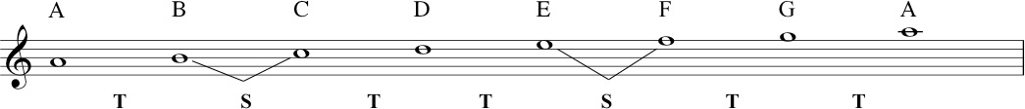
If we start on A (instead of on C), we get a different pattern. The pattern keeps five tones and two semitones, but the order in which they arise is: T S T T S T T.
This particular scale pattern and quality that we get by starting on A and using all/only the white keys on a piano keyboard is described as the ‘natural minor’ scale. It can ALSO be described as the Aeolian mode.
Here is an example of that different quality. This is God Rest Ye Merry Gentlemen, the Christmas Carol that Richard played on flute (written by an unknown composer, but probably dating back to the seventeenth century):
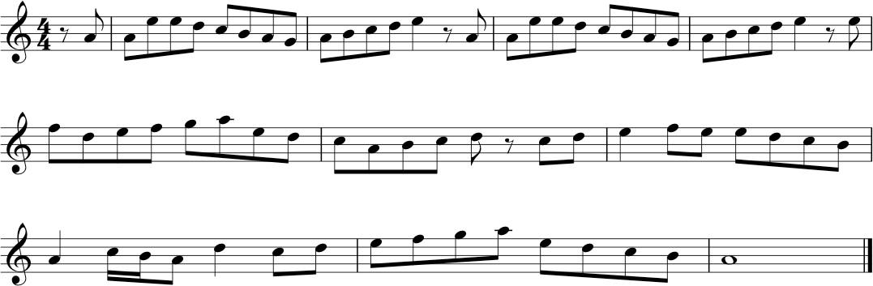
If you are new to reading notation don’t worry, you can still follow the notes of this tune as if you’re following neumes, looking at the general pattern of note-heads going up and down. Study the example, and circle all the As. Then while you’re listening to the example from the video, try to notice how the melody keeps coming back to the A.
We also named the A natural minor the Aeolian mode, we will now move on to the modes. Different modes can be discovered simply by sticking to the white keys on a keyboard and playing a scale through an octave until your starting note repeats. Each note (A, B, C, D, E, F or G) that you begin on – (by doing this, you’re designating it as the tonic) – will generate a different pattern of those five tones and two semitones.
Each of these patterns is identified as a particular mode, with a specific name.

The Seven Diatonic Modes
Today, we can refer to the seven diatonic modes as Ionian, Dorian, Phrygian, Lydian, Mixolydian, Aeolian, and Locrian.

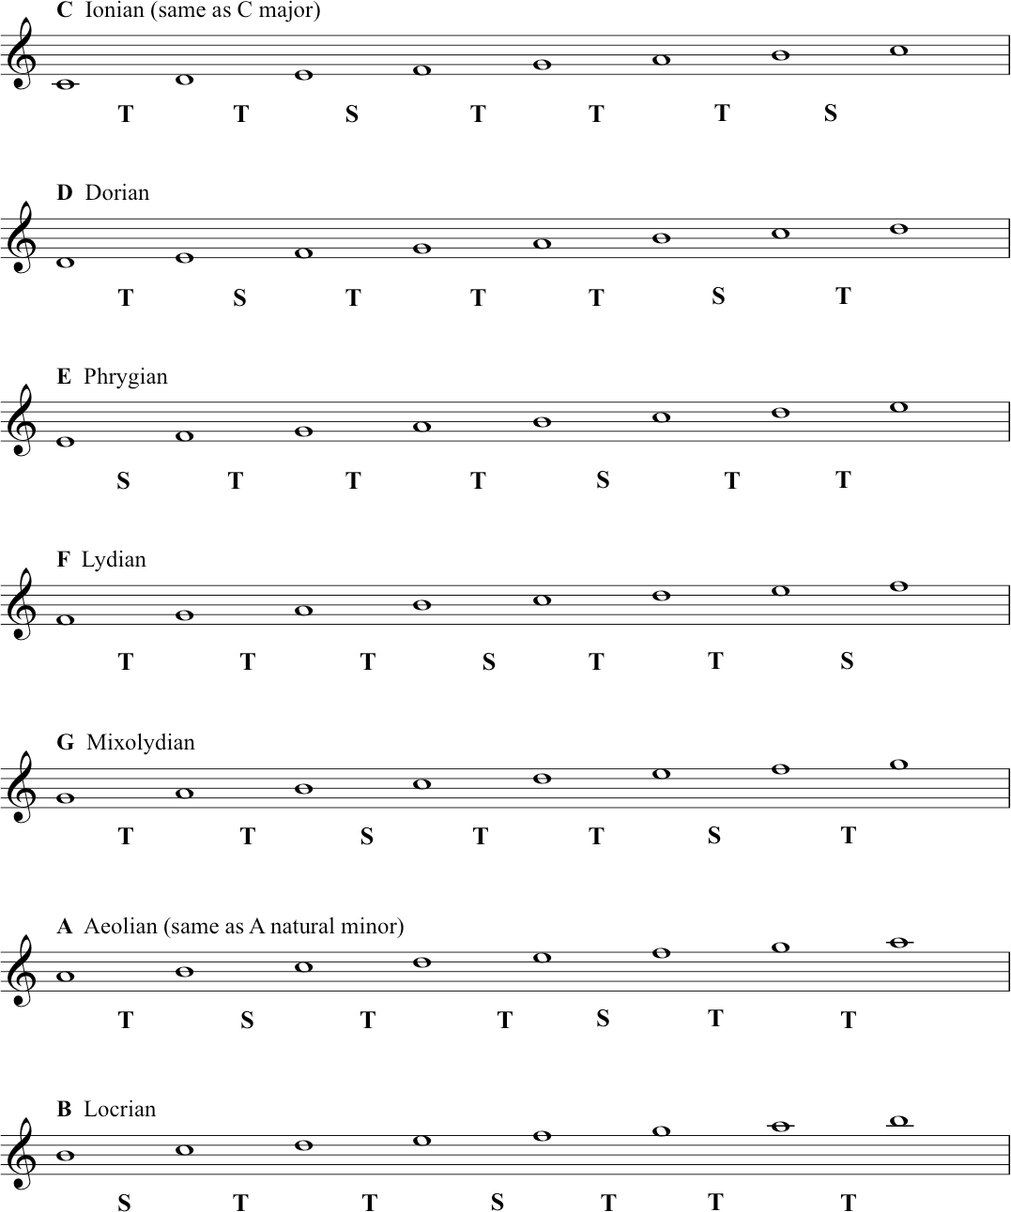

Do this:
Memorise which mode name is associated with which starting note. One mnemonic for remembering the modes is ‘I Don’t Punch Like Muhammad A-Li’.
To get a feel for the special qualities of each different mode, try playing them yourself. Notice the different sequence of tones and semitones. Also try this exercise. If you know the song Scarborough Fair, find the note D; play two Ds and then an A (the beginning of the song); keep trying to play it ‘by ear’. You will only need to use the white notes on the piano keyboard. If you manage to get through the tune, pay attention to the way that D feels like ‘home’. D is your tonic. Play all the notes through from D to D (this is the pattern known as the Dorian mode) – sing that scale back, now, while the song is in your memory.
Playing around like this will help you to experience tonality – it will give you real knowledge about the concepts and terminology that you’re learning on this course. And it will help you to develop your general musicianship. Try to play properly – by which we mean for fun! Mess around at the piano keyboard for your own discovery and satisfaction.
Another song in the Dorian mode is What Shall We do With a Drunken Sailor. To play this song with white notes you have to start on A and go down to a D - ‘What shall we do with the drun - ken ’(that’s the D on ‘ken’). Music doesn’t always start on its tonic, but it often finishes on it, and this song finishes on D – which again should feel like home. You could play along with our version of She Moved Through the Fair, and see if you can ‘feel’ the G as the tonic note. Just keep playing the note G and see how it ’fits’. Anyway, try it - improvise on a keyboard or your own instrument!
There is much more to say about modes and other kinds of scales - for instance, we haven’t even touched on pentatonic scales, which are very common in all kinds of music. For a very detailed article on the modes and their history, use Wikipedia again to start you off on that particular voyage of discovery: Modes. And for pentatonic scales here: Pentatonic Scales

Transcript of the Video
00:00 | So from this pool of notes we’re now going to look at more scales beyond just the scale of C major. So let’s take a different tonic this time. Let’s take A as our tonic instead of C. If we start now and play all the notes that we know and all the notes that we now know belong to C-major, we get A-B-C-D-E-F-G-A. So by taking A, as our new tonic what we see is that we actually still use all the same notes, but now we’ve got a different pattern of tones and semitones.
00:37 | We get A to B is a tone. B to C is a semitone. C to D is a tone. D to E is a tone. E to F is a semitone. F to G is a tone. G to A is a tone. Now this is called the Natural minor scale and we’ll talk more about this next week. Or also the Aeolian mode. It’s still a diatonic scale because it still has seven notes with five tones and two semitones, but they have a different sequence of tones and semitones now as opposed to the major scale.
01:15 | Now, many of you may have heard of modes, especially if you visit a lot of rock guitar websites. So we’ll briefly look at those now. See, one of the amazing things about music is that, simply by re-orientating ourselves around these notes in C-major, we can create different patterns and different kinds of melodies, for instance.
01:32 | This may be the wrong time of year for you, but....  So, that’s God Rest Ye Merry Gentlemen and Merry Christmas, if it is Christmas. I think you can hear that, that is different from the Auld Lang Syne, or Twinkle Twinkle Little Star, or God Save the Queen, or something else like that. That is because I was orientating that melody around the A, around that Aeolian mode that we just saw up on the stave. So the relationship of the tones and the semi-tones between the tonics changed and this is how we get a different flavour, we get a different quality.
02:27 | Well, we already know that starting on C, we have a C major scale. If we go up to D, this is the second note of C major, we get a mode called the Dorian mode. It’s made up of the notes D, E, F, G, A, B, C back to D. This gives us a different pattern and a different sound.
02:47 | Okay, again if we move up to the E, that’s the third degree of C major. So if we build a mode on the third degree. It’s called the Phrygian mode. In this case, we have E, F, G, A, B, C, D, E, and again, that obviously gives us a different pattern of tones and semitones and again, that changes the flavour, or the quality of the mode.
03:18 | Starting on F. We get F, G, A, B, C, D, E, F, which is now called the Lydian mode. Then onto G, which is the fifth degree. If we start this process on the fifth degree, we get something called the Mixolydian mode. We get G, A, B, C, D, E, F, G. This has got a very similar pattern of tones and semitones to the major scale, but it is slightly different. So again we get a different sound, a different flavour, what we’d describe as a different quality.
03:57 | We’ve already looked at A, which we know is called the Aeolian mode. Moving on to B. We get the notes B, C, D, E, F, G, A, back to B. This one is now known as the Locrian mode. That’s all seven modes. There’s a lot of information to take in, but we have given you some exercises and some additional information in the supplementary material. For this lecture.
04:25 | So there you have the modes. The names we just gave you are the 20th century names for them and they are often described as the church modes and indeed many of them were used in ancient church music. You will also find them around the world they were popular in jazz from the late 50’s onward, often used in popular music. We’ve used the kind of names that you’ll find listed for them, in things like guitar websites, or guitar player magazines, or jazz theory textbooks. But what’s really important, is, if you can find a keyboard, or you have your own instrument, or you sing. What would be really is if you could just take the major scale and start this pool of notes on each tonic, so C to C, B to B, E to E. And get used to the sound and the, the quality of these different modes.
05:10 | And we’ve heard when I did that God Rest Ye Merry Gentlemen, that was a different sound. Just to show you that it really does make a difference, we’re going to now do a little piece of modal music. This one is going to be orientated around G, which makes it the Mixoydian mode, the fifth degree.  Which is our slightly jazzy version of She Moved Through the Fair which is built on the G Mixolydian. Mixolydian is built on the first degree of the major scale.

1.5 Introduction to chords
In this section and also 1.6. Primary Chords, we introduce some material that could properly belong in Topic 2, about tonal music languages. Since this current section and 1.6 work on some important concepts that can help to prepare your understanding of that next topic, we think that the presentation can work in this sequence. But - as always - you can feel free to move back and forth across the materials we have shared here.
Video: Introduction to chords

The C major and A minor triads
A triad is a three-note chord. Deriving the C major triad from the C major scale:
Deriving the A minor triad from the A natural minor scale:
We can say here that C major is the tonic of the C major scale, and A minor is the tonic of the A minor scale.
Here are the two triads standing alone, C major and A minor:

Understanding the internal structure of the triads major and minor
Firstly, we will understand the interval between the ‘bottom’ note and the ‘top’ note, by breaking it down into semitones, and adding those up. For C major, it’s C and G:
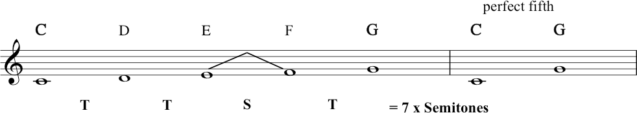
This interval is a perfect fifth, an interval that spans seven semitones. For A minor, we get the same thing between A and E:
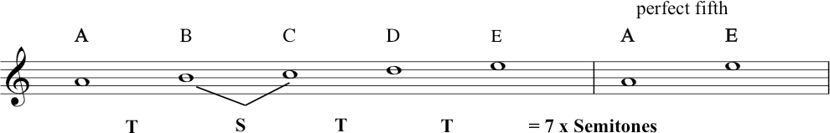
Now we need to find the interval between the ‘bottom’ and ‘middle’ note of the triad of C major: 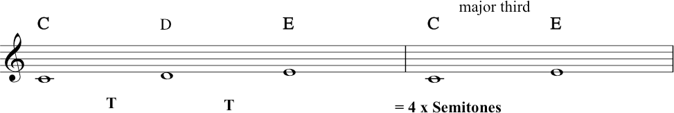
...which gives us a major third.
And for A minor:
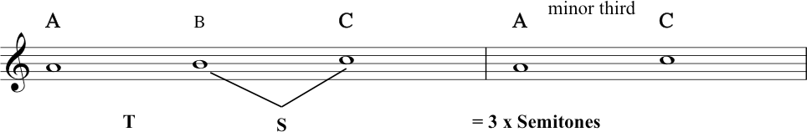
Here we have the minor third smaller by one semitone, i.e. the minor third spans only 3 semitones. It is this difference in the ‘size’ of the interval of the third that makes all the difference (perceptually) between these two chords.
Here we have all the triads as played by Zack, starting at about 5 minutes in the video:
In the next segment we are going to begin looking at how these triads relate to the C major scale, starting with the three primary chords.
Before we move on, here’s a quick note about labelling and numbering. In music theory, we need to use a lot of different systems of counting and labelling – a lot of different systems to be able to handle all the concepts. We will review these and more in Topic 5. For the time being, let’s talk about scale degrees vs intervals.
We were just counting out and labelling intervals (second, third, fourth, fifth, etc). Before that we were counting out the notes in scales: 1, 2, 3, 4, 5, 6, 7 and back to 1. (You’re learning to speak Music Theory now. This is the lingo.)
When it comes to thinking about the notes of a scale, we often refer to these as ‘degrees’ of a scale. The first degree of the scale, the second degree of the scale, the third degree, and so on. We also have a special music theory name for each degree of the scale which we will tell you later in the course. For now, you just need to know that scale degree 1 is known as the tonic, scale degree 4 is known as the subdominant, and scale degree 5 is the dominant. ‘Which scale degree is this?’ ‘It’s scale degree 5, the fifth note of the scale, the dominant.’
When we talk about intervals, we refer to them as an interval of a second, third, fourth, etc. ‘What’s this interval?’ ‘It’s a second!’

Transcript of the Video
00:00 | With our scales so far, we’ve been working sequentially. In a linear fashion, sounding one note at a time. But in fact, it’s very common for music to sound notes, at the same time. Just now when we were playing, Zack was playing, chords on the piano. So this is what we’re going to go and look at now. But, before we do, it’s going to be important to recap, the difference between our C major scale, and our A (Aeolian) mode, the natural minor, the scale that we built from six degree. So, here you have our C major scale. And then, if we start from the sixth degree of that scale and say this, play the same pool of notes, we get, which we called out natural minor or The Aeolian mode. Right. Remembering how God Rest Ye Marry Gentlemen did sound different from the major scale, let’s have a look at some important relationship ships within this. So looking at the natural minor scale, the A minor scale. Looking from A to E. That’s the note- the tonic up to note number five. I can count tone, semi tone, tone, tone. That would be three tones and one semitones. If I break that down into semi tones, that will be one, two, three, four, five, six, seven semitones. That’s the sound of the seven semitones A to E. Okay, and back to the C major. If I do the same thing and start on the tonic C and go up to note number five which is G, I get tone, tone, semitone, tone.
01:56 | The same except that the tones and semitones are in a different order. But again, I’m getting seven semitones. Let’s hear those. That one’s from C to G. And then, from A to E, right. So, A and E to, and C to G both have the seven semitones, they’re the same. That interval was called a fifth. And in fact, we can now give it a quality and say it’s a perfect fifth. And note also that the two notes sound nice together.  Now, going back to A, let’s now have a look at A to C. This is note one to three, the interval of third. Here, we get a tone and a semitone, so that adds up to three semitones however if I start on C and go from C to its third note which is E. I get two tones, which adds up to four semitones, and there is the difference. The second one, is the C major chord. And when you hear it, you’ll probably find, it’s very natural to hear the major scale. So there, looking again at our C major scale, we now isolate the three notes the C, E and G and then we stack them up vertically. Like this, and that is the C major triad.
03:51 | Now, there are other ways of writing this. If you play a lot of Rock music or Jazz, you’re used to using something called a lead sheet. Where instead of writing the chords out with notation, as you can see here. We use chord symbols. There are several different chord symbols: so for C major it could simply be shown with a capital C like this, or Cmaj, abbreviated for C major, or a capital C and a capital M. All of those could be used, in different kinds of music.
04:28 | Now, going to the A minor, the A natural minor scale, again, we’ll do the same trick. We’ll isolate the three notes of the A minor triad, so that’s A, C, and E. And again, we’ll stack them up vertically to show the A minor triad. And again, if you were using a lead sheet, this could be shown with an Amin, short for minor, or A little m, or A with a minus sign, that you’ll find in jazz.
05:05 | So if we take one, three, five starting on C and the key of C major. We’ve got C E G. Now, we know that we’ve got seven semitones between the C and the G. So it’s a Perfect fifth. And we’ve got four semitones between the C and the E, and that’s a major third.
05:24 | Now because this has got three notes, it’s a triad. It’s a simplest type of chord and what we’re going to see is that a triad that has a Perfect fifth and a major third is a major triad.  Let’s start it on D. We’ve got one three five. D F A. Now again, we’ve got seven semi-tones between the D and the A, which gives us a Perfect fifth. But this time, we’ve only got three semi-tones between the D and the F. So this gives us a Minor Third. Again, because it’s got three notes, we’re going to say that this is a triad. But this time, we have a Perfect fifth and a Minor third. So, we have a Minor triad.  Let’s move on to E. Again, we’ve got a perfect fifth between E and B, and our third this time is G, which is a minor third, so we get a minor triad. Move on to the fourth degree in this case, which is F. We’ve got F A C so we’ve got, a Perfect fifth. This time we’ve got a major third, so, this is a major triad. If we go to the sixth degree, we already know this one, this is A, C, E. So we got our Perfect fifth and then we’ve got our Minor third, so we’ve got a, Minor triad. The A minor triad.
07:00 | Now, the next one that we need to look at, starts with B, and we’ve got B, D, F. Now, some of you already, may be aware that that sounds different but what we’ve got between B and F is actually only six semitones this time. So, it’s one semitone smaller than the Perfect fifth. Now we actually call this a Diminished fifth and we’re going to talk more about this next week. But we have a Diminished fifth and we’ve got a Minor third. Now, a triad with a Diminished fifth and Minor third, is called a Diminished triad. So, it sounds different, and it has a different structure to the rest of the chords within the key because of the, Diminished fifth. So again, if you’re a keyboard player, try them for yourself now. Even if you’re not, grab your keyboard app or even have a look at a picture of a piano keyboard, just so you can work out where the notes fall, how we’re going to build the chords, and just think about the nature of the fifth and the nature of the third and the quality, as we would say in music theory terms.
08:05 | And from that, you can determine which type of triad, you would be able to play, on each degree of this scale. So, that last chord that Zack just showed us, the B Diminished, looks like this, in notation. And using lead sheet symbols, it could be written as this, a B with a little zero after it. Or B Dim, short for Diminished.
08:27 | And what Zack’s just shown us, in this last segment, are all the triads that we can derive from C major scale. And here they all are again.
08:38 | And you can also find these in your handout, print them out and look at them which you need to do, because you should sit down at a piano and play through them. Just again looking at them, we can see that there are three major chords the C major, the F major and the G major, so these three chords all have the same internal relationship between the three notes and then we have three minor chords the D minor, the E minor and the A minor. And again, they have the same internal relationship with each other. And then we found this one, other different chord, the B diminished chord, which will be important later. So, that’s three kinds of chords from one set of white notes.

1.6. Primary Chords
Video: Primary Chords
The three primary chords:
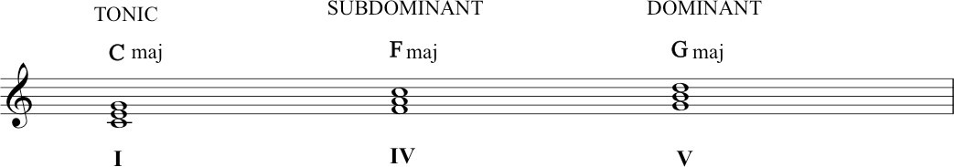
So we have the C major tonic triad, built on the tonic of the scale. A triad is a type of chord. The subdominant triad is built on the fourth note, and the dominant triad on the fifth.
The roman numerals written underneath refer to these triads: I = the tonic triad, IV = the subdominant triad, V = the dominant triad. These are important terms: memorise them.
IMPORTANT!
In C major, these three primary chords – tonic, subdominant and dominant – are the only major chords that you can get by building triads up from each scale degrees. Building triads on D, E, or A will create a minor chord. And what happens when you build a triad on B? It makes a diminished triad. We’ll tell you more about these in following sections.
At 3 minutes in the video, Richard harmonised each note of the major scale with one of these primary chords. The following notation illustrates this, also with the names of each chord in lead sheet chord symbols:
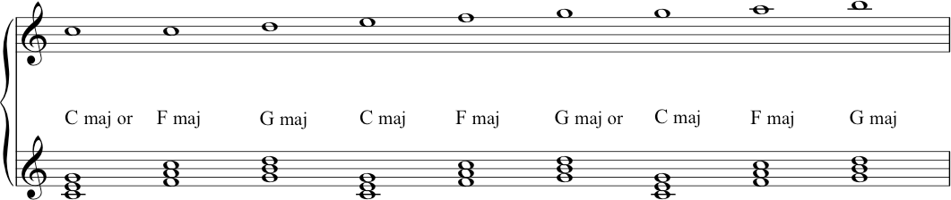

Transcript of the Video
0:00 | So, we found seven triads that we can derive from the major scale. We’re now going to focus on the three major ones. That was the C major, the F major, and the G major. These ones are important. They’ve become important through time in a ‘Common Practice’ classical music, and also in a lot of Jazz and Pop, and Rock. And, folk music as well in fact. It’s sometimes referred to as the ‘Three Chord Trick’. I’ll start off by giving them their formal name. So the C major chord, built on the tonic is the Tonic triad. The G major one, built on the fifth degree, is the Dominant. And that refers to its importance in that name. The F major is the Subdominant, one underneath the dominant. And there they are written out for you, and as lead sheet notation.
0:59 | Now, when we’re harmonizing a melody, in the kind of music that we’re talking about here, it’s normal to have the melodic note be a member of a chord that’s backing it. Okay? Not so much as we move into Jazz and 20th century classical music, or Rock in the 70s. But on the whole, we can expect to hear a strong melody note existing inside its chord. So, in other words, if I want my melody note to be a C. In the key of C major then it’s a good chance I am going to have a C major chord underneath it, or maybe the F major chord. Because that also has a C in it. And so what we are going to do now is we are going to look at the major scale and see how each note can be harmonized by one of these three chords. So again, starting with my opening example C, with a C major chord or with an F major chord. Now we move up to the note D the second note. And the only triad out of our three that has this is the G major triad. So we’re going to harmonize it with the dominant. The next one, next note is E, and that exists in the tonic triad, in the C major. The next note in the scale is F, and that exists in the F major, the sub dominant. When we get back up to the G. Again we can have a G major chord with it, the dominant, or we can have the C major called with it, when we get to the A, this lives inside the F major chord, up to the B, and the chord that has that inside it is only the G major chord, so. And then when we get back to C again, we can finish on the C tonic. We could also play the F major, but I think you’ll hear that most likely our piece of music will finish from the B. With the G to the C, with the tonic chord. Again, this is really something you just have to sit down and play through for yourself. But you’ll see that it totally works. And with those three chords, you could write a hit. Who knows, there’s been quite a few like it.  Now, just hearing these three chords in a slightly different context, I could make them sound like this. Or, they can sound like this. So you can see, and you probably recognize both of those ‘sounds’ that come from that. So that is your ‘Three Chord Trick’: your tonic, your dominant, your subdominant. And that’s going to become more important in the coming lectures, especially in the later lectures in, series four and five. But for now, I just want to leave you with the fact that with the set of white notes, confining ourselves to just, white notes of the piano and C major scale, we found three different kinds of triads. We found all sorts of internal relationships which already give us the possibility of making music.

Topic 2: Tonal music language - concepts and theory

2.1. Sharps and Flats
Video: Sharps and Flats
When thinking about sharps and flats and tones and semitones etc, it may be useful to visualise an instrument – particularly for those who already play. Below are images of piano keyboards and guitar fretboards. Look at them whenever you need them. In each case, there is a blank version, and one which has been annotated with pitch names, labelling all sharps and flats.
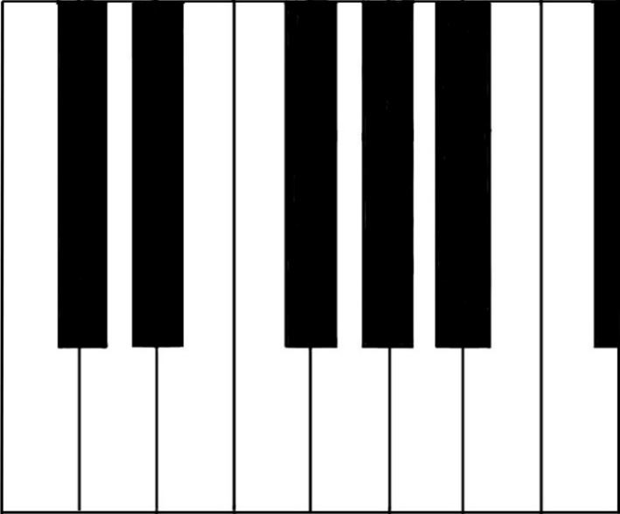
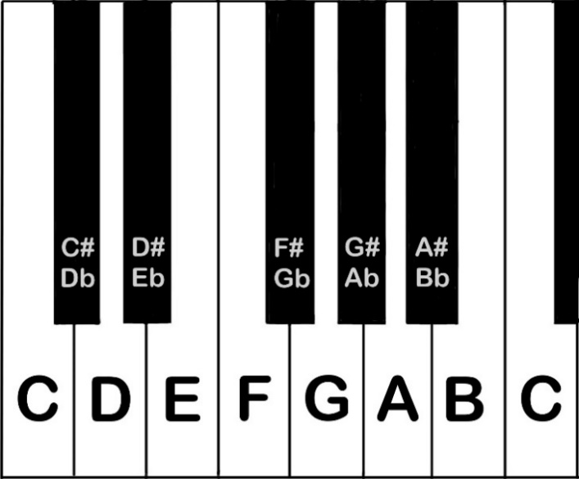
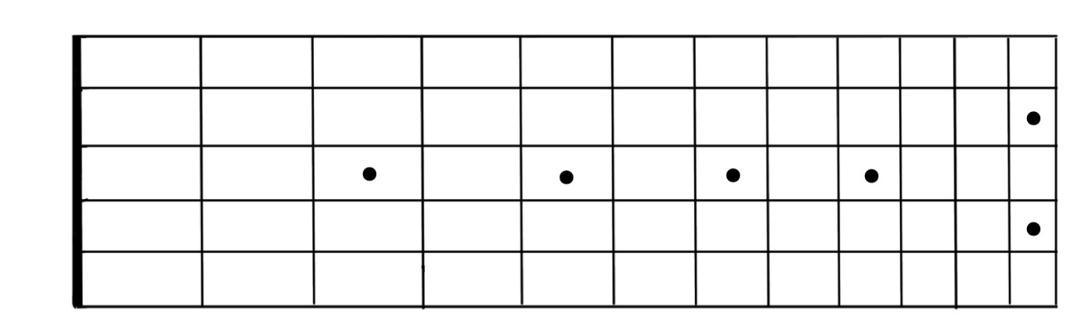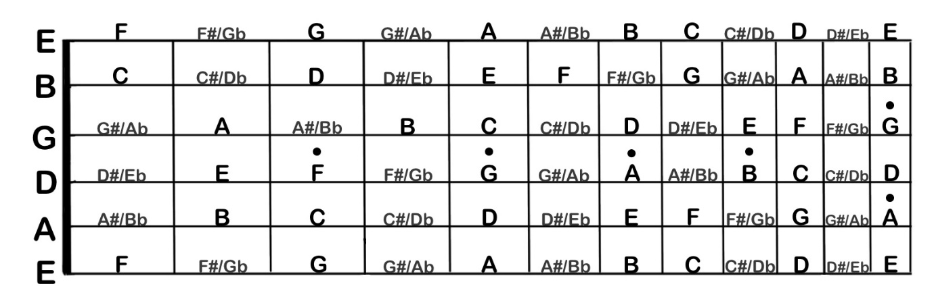
In the video, we ask you to try to build D major. So, what are the steps? First, we need to start on D and apply the pattern TTSTTTS. The image below illustrates this – and it reveals that this scale requires an F-sharp and a C-sharp: in order to make a whole Tones (rather than Semitones) between scale degrees 2 and 3, and between scale degrees 6 and 7, we have to make the interval wider than the one that we’d get if we just stuck to the white keys.
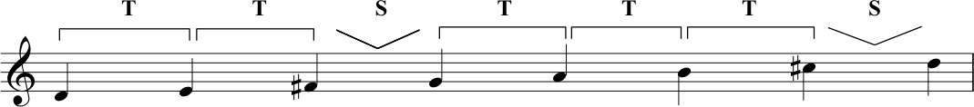D major scale example.

Transcript of the Video
0:00 | Hi. So this week, what we want to talk about follows on from what Richard and I illustrated last week, and that was the concept of tones and semitones. And what we did was we picked the note C and we applied the pattern of tone, tone, semitone, tone, tone, tone, semitone. And we called the result the major scale.
0:26 | So what we can do is we can pick any other note and apply the same pattern tone, tone, semitone, tone, tone, tone semitone, and the result is a major scale. So, what we’re going to do for the rest of this lecture is we’re going to refer to that pattern of tones and semitones as the major scale pattern. So, we’ll pick another note now I’m going to pick this note here - G. What I’m going to do is apply the major scale pattern to that so tone, tone, semitone, tone, tone, tone, semitone. Now you’ll notice actually when we played C, we only played the white notes on the piano, we didn’t touch any of the other ones, these black notes.
1:05 | When I started on G we need to play this note here. And this is called F-sharp in this context. So let’s take a closer look at it. It’s called F-sharp because it is one semitone sharper, or higher than F. But you might also notice that by the same rationale, we could say that it’s one semitone lower than G. We could then call it G-flat, which means one semitone lower than G. You’ll remember from last week that a semitone is a fixed interval. There are semitones between every note that I played just then. But you’ll also notice there are places on the piano keyboard where we have two white notes and no black notes in between them. It happens between B and C and it also happens between E and F.  Some of you that have come to this course as guitar players might already recognize this. So if you think about your E strings, for instance, if you play the first fret on your E strings, you’re more likely going to call this note F. And that’s the same if you play the first fret on the B string, you’re more likely going to call this C. And that really just serves to illustrate, just for a different instrument really, that the distance between B and C, the interval B and C is a semitone, and the interval between E and F is a semitone. And that’s why if you look back at the piano keyboard, there isn’t a black note in between these pairs of notes.  You might be thinking that it seems a bit arbitrary. That you have a black note between some pairs of white notes and there’s a semitone there, and yet, between other pairs of white notes, you get a semitone all by itself with no black notes in between.
2:53 | But actually, this unevenness, this asymmetry that we get in the spread of the note names as they repeat across the octaves. This is something that gives eyes and our ears - more importantly our ears kind of landmarks that we can latch on to.
3:11 | So, a minute ago we played G major. We started on the note G and we applied our major scale pattern. We found that we needed to use an F-sharp. Let’s pick another note this time. Let’s pick the note F, and apply this pattern. So we get tone, tone, semitone. Again we’ve touched another black note there. Tone, tone, tone, and a semitone between E and F as we’ve just discussed. Now let’s look back then at this. So we’ve got F, G. So, a tone apart. G, A, which is a tone apart. And then we’ve got this black note. As Nikki said, because this is a little bit sharper than A, it’s a semitone sharper than A. We could call this A-sharp.
3:55 | But it’s also a semitone lower than B. So we could call it B-flat. So which are we going to call it, in this case? Well, as we talked about last week, scales need one of each letter name. So, actually, when we go up from F, we’re going to go F to G, G to A, not to A-sharp, because that’s another type of A. We’re going to go to B-flat, which is a semitone above A, or a semitone below B. And then a tone onto C up to D, E, and we have another semitone to take us back to our tonic, F.
4:28 | So it’s one thing to understand it, looking at the piano keyboard. It is another thing to get it into your own practice. You can use a keyboard app, or you can use a piano if you’ve got one, or you can go into your own instrument, or you can sing. But this time, start for yourself, do it for yourself. Start on D. Figure it out. Go from D up to D, an octave higher, and then show yourself what the pattern of tones and semitones is if you’re just using the, the plain note names. And then, go back to that major scale pattern. Tone, tone semitone, tone, tone, tone, semitone. And then see for yourself what note names you have to alter in order to recreate that major scale pattern.  So we should make a little bit of an apology. Because what we’ve been doing is talking about white notes and black notes, and clearly that’s only really relevant if we’re looking at a piano keyboard. Guitar players don’t have white notes and black notes, for instance.
5:24 | The reason that we’re doing this, and the reason that for this particular lecture we’ve made it so piano-centric is just because the layer of the keyboard’s actually a really clear and really beautiful way to illustrate where semi-tones are. And from that, you can build patterns of tones and semitones. So, it is important for you understand that on your own instrument, but just be aware that you can always come back to this visual, and there there’s picture of a piano keyboard in this week’s supporting material on the website for you. And as Nikki said, you can go on the internet and find an app that will do this for you absolutely no problem as well.  So the way to learn this and to actually understand it is to get it into your eyes, into your head, and into your fingers and into your ears. So, you can practice in all these different ways. Practice hearing and playing whole tones. Practice hearing and playing semitones.

2.2. Keys and Key Signatures
Video: Keys and Key Signatures
In the video we talked about the fact that key signatures are very useful in helping with the appearance of written music. The following is the tune, Twinkle Twinkle Little Star, written in the key of B major without a key signature. Although this is a very simple melody, you can see that, since B major includes five sharps, writing these out on each occasion could make it difficult to follow, particularly if you were sight-reading this music.
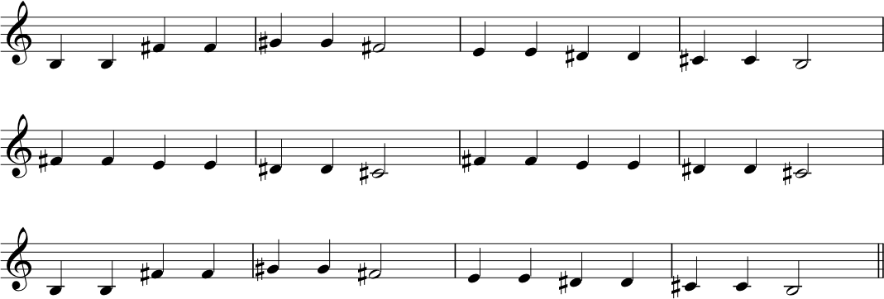

The next image shows notation for the same melody – but this time we’ve used the key signature for B major. In this case, the key signature tells us (right at the start of the line) that all Fs, Cs, Gs, Ds and As are sharpened. This makes the notation easier to read as it is not cluttered with accidentals.
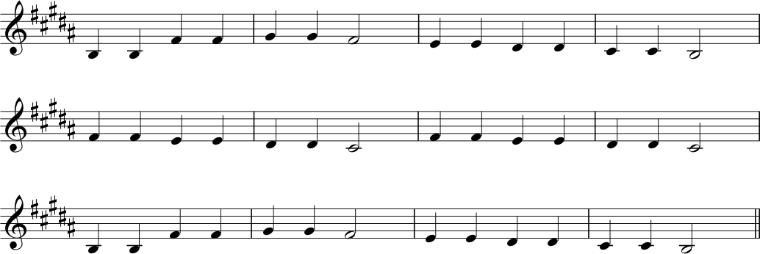

Circle of fifths
We talk about the circle of fifths in the video. It is helpful to have a more detailed look at it here. This diagram helps us to see the signatures of sharps or flats needed to construct each key and its relative minor.
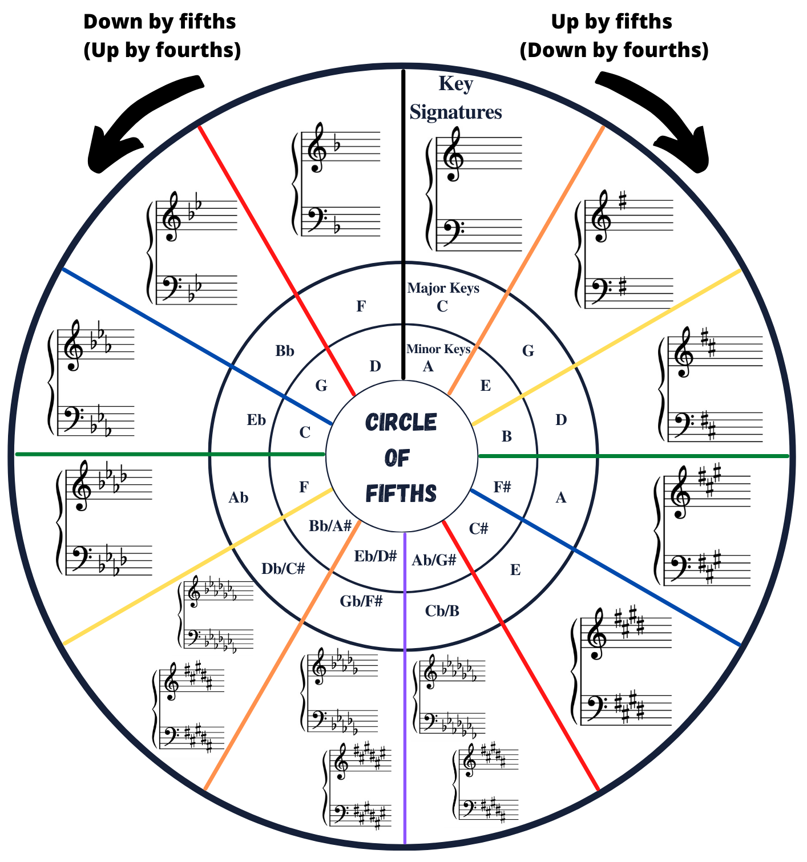
The circle of fifths is a really valuable tool and a handy way to visualise many of the things that we have been talking about in this lecture, and those that follow. Let’s highlight a few useful things at this point that will help you with key signatures, and which will also be useful for thinking about scales and harmonic progressions later in the course.

The order of sharps and flats
To reiterate the video lecture: when sharps and flats appear in a key signature, they always do so in a specific order. For sharps, the order is: F C G D A E B (clockwise round the circle of fifths). For flats, the order is: B E A D G C F (anticlockwise around the circle of fifths)

Reading Key Signatures
As we noted in the video, the circle of fifths can also be used to help us to read key signatures. It’s a matter of counting the points on the circle: count the number of sharps or flats in the signature. If it’s a signature that uses sharps, then we count clockwise from C (in the 12 o’clock position). If it uses flats, then we count anticlockwise...
So, imagine a key signature with three sharps. We know that the sharps will be F, C and G (always in that order), so we will count 3 steps from C.
1 = C → G
2 = G → D
3 = D → A.
Therefore, the key represented by three sharps is A major. Ta-daaaaahhh!
Let’s try one with flats. Imagine a key signature with six flats. Again, we are simply count steps round the circle. This time we’re going anticlockwise (because we’re dealing with flats) from C. And we need to move 6 steps. This time we get...
1 = C → F
2 = F → Bb
3 = Bb → Eb
4 = Eb → Ab
5 = Ab → Db
6 = Db → Gb
Ta –dahhhh! The key represented by six flats is G-flat major.
Try this yourself and see how you get on. Always count from C and to go clockwise for sharps and anticlockwise for flats. Remember, you will NEVER have a key signature containing a mix of sharps and flats.

Writing Key Signatures
We can use the circle of fifths to help us write key signatures too. Just reverse the process. So, if someone asks you to write the key signature for D major, then count the steps from C until you get to D:
C → G = 1
G → D = 2
Therefore, D requires two sharps.
We know the order of sharps to be F-sharp C-sharp G-sharp D-sharp A-sharp E-sharp B-sharp, so if the key signature needs two sharps, we use the first 2. So, D major needs F-sharp and C-sharp!

Appearance of Key Signatures
It is important that key signatures are written correctly. Why? Because we need to be able to glance quickly and recognise them. When we get used to looking at key signatures, we begin to see a complete visual symbol – a complete unit, like an entire word whose letters no longer need sounding out. WARNING! Key signatures do move around a bit, depending on the clef... We discuss clefs later this week. For your reference, here are all key signatures presented in four different clefs.

Key signatures with SHARPS
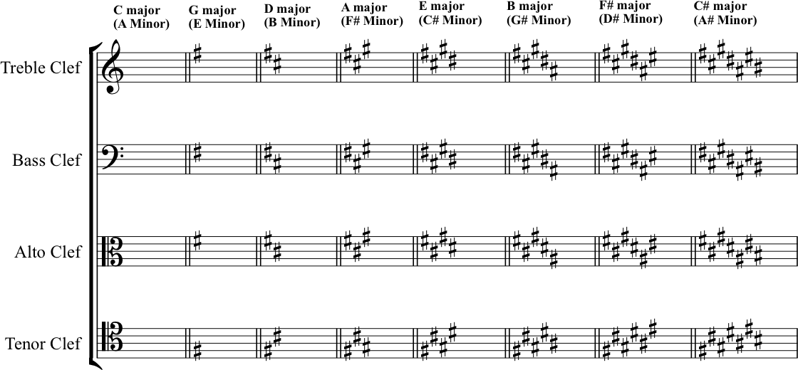

Key Signatures with FLATS
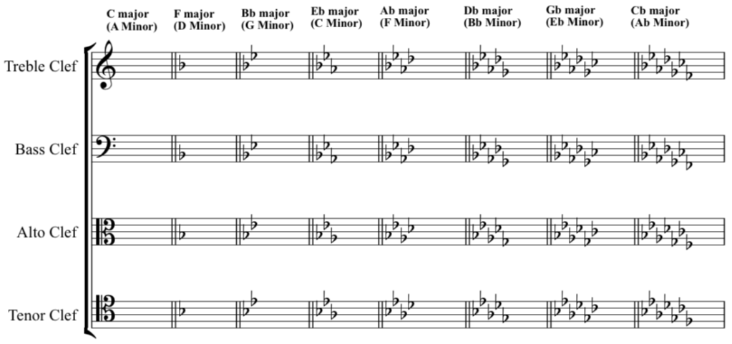

Transcript of the Video
0:05 | So in the last section we talked about scales and notes that we need to create these scales in quite an abstract theoretical way. Now it’s a good time to actually go back and relate this to music in more general terms. So if you had a piece of music that just used the notes of C major.
0:23 | That’s the notes of the C major scale. We could say that this music is in the key of C major. And if we had the notes of the G major scale; with that F-sharp, we can say that this is in the key of G major.
0:46 | So what do we actually mean by key? Well, it’s quite a complex term really, and it relates not only to the notes that are available to us, as drawn from the scale, but also to the way that we subconsciously hear the way that these notes work with each other and react with each other and the relationship that exists between each of these notes.  So, that feeling in G-major. We have a sense, that out of all these notes. G has got a kind of gravity for us. G pulls us home. G is our tonic. Yeah, we could say that when we are playing a piece of music that uses these notes; when we arrive back at G, there’s a feeling of completeness or that we’re at rest; it’s the home note if you like. So, when we are talking about scales and keys, they are sometimes confused as terms, and what we really mean when we are talking about scales is this sort of ordered. String of notes. When we’re talking about key, just to reiterate, it is this relationship and the feeling that pulls us back to the tonic when we feel at rest.  Okay, so, if you did the exercise that we used in the last section where we started on D, you’ll note that we got in D-major, we got an F-sharp and the C-sharp. So, if were looking at piece of music written down in a score, how would we know what key it’s in?
2:16 | What we might want to do is look to see whether any of the Fs are sharpened, and we say, yes, all the Fs have got a sharp next to them. And we see that, oh, also, all the Cs have got a sharp next to them. In the context of everything we’ve just said, so far in this lecture, it would make a lot of sense to say, oh, this piece of music’s probably in D major.  So given that we know in this case that we’re going to have every F-sharp and every C as a sharp, it might make sense for us to know this information up front, right at the start. And the convention that we’ve got for this, we call ‘key signatures’.
2:16 | What we might want to do is look to see whether any of the Fs are sharpened, and we say, yes, all the Fs have got a sharp next to them. And we see that, oh, also, all the Cs have got a sharp next to them. In the context of everything we’ve just said, so far in this lecture, it would make a lot of sense to say, oh, this piece of music’s probably in D major.  So given that we know in this case that we’re going to have every F and every C as a sharp, it might make sense for us to know this information up front, right at the start. And the convention that we’ve got for this, we call ‘key signatures’.
2:59 | So by announcing what we’re going to have in terms of sharps or flats right at the very start, it does a couple of things for us. So firstly from a musical point of view, what it does is it, it gives us an indication of where the tonic is, what’s going to be most important. And also the relationship that exists between the notes in this key.
3:17 | But also, just from a visual point of view, what it does is it really tidies things up. So that no longer do we have the need for every F and every C to have a sharp in front of it to say that these are going to be F- and C-sharp. Actually, we see this at the very start by means of the key signature, and we take it as read throughout unless we are signalled otherwise.  There’s additional on the website that’ll help you learn more about the conventions of notation because what we are talking about here, is the idea of graphically representing, for people to read and to write with, all of these concepts and terms that we’re, that we’re introducing to you for, for music theory.
3:57 | So key signatures are used to tell whoever’s looking at the music, what key the music’s in and to do so by signalling, which notes are going to be sharp and which notes are going to be flat; from the outset.
4:09 | There’s a really logical way for writing key signatures. And also, if we’re looking at key signature and determining what key it signifies.  We call this the circle, or sometimes the cycle of fifths. Let’s start with C. C, as we know, C major is signified by having no sharps and no flats. That’s the key signature. G, however, contains one sharp. F-sharp. F-sharp. G. And D, has got two sharps; it’s also got an F-sharp, and now it’s also got a C-sharp on top.
4:53 | So if we look at the cycle of fifths, we can see when we look at the key signature for C, there are no sharps or flats. And this makes sense because when we play C major and we’re looking at it on the piano, we only use the white notes. If we look at the next stage round clockwise, we see that we’re looking at G major, which is signified by having an F-sharp. If we look at the next stage again, clockwise. We see that we’ve got D major, and that this is an F-sharp and a C-sharp.
5:21 | So you’ll note, notice the cycle of fifth is proceeding literally stages of a fifth. C, D, E, F, G. And then we’ve got G, A, B, C, D. Each stage includes five note names forwards. And each stage includes one additional sharp as we go around the circle.
5:43 | Okay, so we’ve looked at our circle, the circle of fifths moving around clockwise where each stage takes on five notes for further forward. Okay, what happens if we look anticlockwise? The results of this is that we’re, in fact, going, moving in fourths instead of fifths. So, we’re starting at C again.
6:05 | So, let’s start with C and move around in fourths. So if we go from C, we go to the fourth note of C major. C, D, E, F. So we’re going to start on F. Now just to illustrate this really, let’s apply the major scale pattern to F. Okay, when we do that we get F, G, A, B-flat, C, D, E, F. So what we can say now is that the scale of F has a B-flat in it. One flat. One flat. One B-flat. Clockwise sharps, anti-clockwise, the first thing we notice is that we’re introducing one flat. Okay, so we might be able to guess where this is going. Starting from the F, let’s travel another fourth around the circle. So we’re going anticlockwise. F, G, A, B-flat. B-flat.
6:56 | So, we can take our B-flat as our tonic now, and we’re going to apply our major scale pattern. We’ve got B-flat, C, D, and a semitone takes us to E-flat, F, G, A and back to B- Flat. So what we’ve found now is we’ve got a B-flat and an E-flat, so we’ve added an extra flat. for an extra step, around the circle, just as we did for sharps. Therefore, B-flat has B-flat and E-flat. So it’s all fair and well, then, when we’re looking at the circle of fifths to say when we move around clockwise, we’re going to add one extra sharp. Or when we move anticlockwise, for each step, we’re going to add one extra flat. But it’s not really enough information. We need to know, which extra sharps and which extra flats we’re going to add for each step.
7:43 | So we could really go back to the keyboard and work it out from first principles, and for each new tonic, we build a major scale, and we work out which extra sharps we’ve got and which extra flats we’ve got. But that’s time consuming, it’s a bit of a pain; we need to remember lots of different information. Actually, having some sort of mnemonic device for the order that sharps and flats occur is probably going to be quite useful. And it’s really common for people to learn it in this way. So, and good pneumonic advice for the order that the sharps occur.
8:14 | Father Christmas gave Dad an Electric Blanket. So, that’s F, C, G, D, A, E, B.  You could also say, Father Charles Goes Down And Ends Battle. That’s a very common one to hear people talking about. Okay, so there’s two. You could make your own up. Now, this being the circle of fifths, with all the patterns inherent in that, when we go anticlockwise and start introducing flats, you might not be that surprised to find out that the order in which flats occur, is actually the same sequence as the sharps but in reverse. B, E, A, D, G, E, C, F. So two sentences that we could use to try and remember that sequence,.  Well, we’ve got Blanket Explodes And Dad Gets cold feet, which is the reverse of the Father Christmas one. Or Battle Ends and Down Goes Charles’ Father.
9:29 | So, we now know that if you see a key signature at the start of a piece of music, and it’s got four sharps in it; those four sharps have to be F, C, G and D. And we know that if you see a key signature with three flats in it, they’re going to have to be B, E and A.
9:51 | So we’ve been talking about sharps and flats within keys. So that’s to say that we’ve been talking about the sharps that belong to a particular key. Or the flats that belong to a particular key. But what happens if we want to use a note that’s out with the pool of not available to us in any given key? So say we were in G major. We wanted to use a B-flat for instance. We know this isn’t part of the key signature. But there’s absolutely nothing wrong with using a B-flat in the overall context of G major.
10:21 | If we do this, if we use a sharp or a flat in a place that we don’t expect that based on the key signature, we call these accidentals; let’s say it’s absolutely fine to use these. We just need to be aware of some conventions surrounding them, so we can actually use them, talk about them accurately. Have a look at the example:  We can see that in this example, the music got a key signature of one sharp, so we know it’s going to be an F-sharp, and we know that this signals G major; however, there are notes here that don’t belong to the key; there are some accidentals. As we work from left to right, looking along the example, we can see that there’s a sharp sign in front of the third note, meaning that this is a G-sharp.  And looking further along, we notice a flat in front of the B. Making it a B-flat. Now, just in front of the next B, we see a symbol that we haven’t seen before. This is another type of accidental, and we call it a natural. Its purpose is to cancel out the sharps or flats that have just previously been shown.
11:46 | One thing that we need to mention at this point is that when an accidental is used, it’s actually effective for the whole bar. We’ll discuss what bars mean more next week, but really what we mean is until we see the next vertical line across the stave. So the second bar, we see a B-flat. And this means that any other B in that bar is also a flat. The natural sign in front of the last note in this bar actually cancels out the flat, meaning that this particular note is to be played as a B-Natural. That is to say that it is no longer a B-flat. And again, although this is the last note in the bar, this instruction lasts right to the end of the bar.
12:31 | If we can look at the next bar, we see a natural in front of the F. Again, this cancels out the F-sharp in the key signature. And it means that this note is to be played as an F-Natural, not an F-sharp.
12:48 | Have a look at additional material on the website. We’ve included some practice questions to help you get to grips with this.

2.3. Minor Keys and Minor Scales
Video: Minor Keys and Minor Scales

Major/Minor Relationships
Right. Let’s get to grips with the relationship of major and minor scales.
Major and minor scales can be related in different ways. We can make a major scale starting on C, and we can also make a minor scale starting on C. Or on Bb. Or on G, etc. In music theory-speak, we would describe this major/minor relationship as a ‘parallel’, or ‘tonic’ relationship. In the video, we spoke about ‘relative majors’ and ‘relative minors’. This is a music theory shorthand, referring to major and minor scales which are related to one another because they share a KEY SIGNATURE. Let’s have a quick recap of this.
We’ll take the example of A major. Go back to the cycle of fifths diagram and find its relative minor. It is… F-sharp. The key signature of both A major and F-sharp minor feature three sharps (F-sharp, C-sharp, G-sharp).
Therefore, we say that F-sharp is the relative minor of A major. But, what does this mean...?
Well, if F-sharp minor has the same key signature as A major, it is built from the same set of notes. However, when we treat F-sharp as the tonic – the starting note – a different pattern emerges in this scale’s sequence of tones and semitones. If we play each note up and down the scale in turn, this pattern gives us a different perceptual effect than when we begin and end of the note A. Beginning and ending on A creates an overall quality of sound that we can describe as major tonality; beginning and ending on F-sharp creates a minor tonality.
While there are (at least) seven different named notes in every major or minor scale, they tend not all to occur with the same regularity. You can expect to hear plenty of the tonic note, and also the fifth, the fourth and the seventh notes of the scale. In real music, tonality emerges from the complete effect of this hierarchy (along with some other features of musical compositions and their performance).
As we noted in the video, there are several different types of minor scale. We are focussing on three different sorts of minor scale here: the natural minor, the harmonic minor and the melodic minor. Let’s have a closer look at them.

Natural Minor (AKA the Aeolian Mode)
This is the easiest of the minor scales to get to grips with. All the notes taken from the key signature, up and down, as you found from our A major – F-sharp minor example in the previous section.
Another way to discover natural minor scales is to find scale degree 6 from any major key… then begin and end from that note. In the case of our example of A major above we saw from circle of fifths that the relative minor was F-sharp minor. Alternatively, find the sixth scale degree: 1 = A 2 = B 3 = C-sharp 4 = D 5 = E 6 = F-sharp 7 = G-sharp...

Harmonic Minor
The harmonic minor is the next most straightforward of the minor scales. A harmonic minor scale refers to the same selection of notes as the natural minor, but with a raised (that’s another way of saying ‘sharpened’) 7. So, sticking with F-sharp minor at the moment, this gives us:
E is the seventh degree of the scale, so we have raised it by a semitone. This produces the harmonic minor scale.

Melodic Minor
The melodic minor is a bit more complex. That’s because its ascending form differs from its descending form – it goes up one way, and down another….
This is illustrated very clearly in the video but, just to recap, the ascending form of the melodic minor is based on the natural minor, but with both the 6 and 7 scale degrees raised up by a semitone. Then, in the descending form, these notes are lowered again back to the notes of the natural minor. So, the whole scale is:
You must play or sing these and get used to the sound of each of the scales. The differences between the minor scales only make proper sense when you consider how they sound, and how these different variations make different musical patterns to one another.

Finding the relative MAJOR
So far, we have talked about finding the relative minor of a major. If you began with a minor key, and needed to find the relative major? Well, you just need to reverse the process. Whichever note is the tonic (scale degree 1) of your minor key now needs to be thought of as scale degree 6 in a major key.
Or, yet another way to imagine major/minor key relationships is to look at the absolute pitch interval. (We deal with intervals in the next segment – so read this now, but come back to it and read it again after reading the next section.)
You can also find the relative major key by figuring out which note sits a minor 3rd above the tonic of the minor. The interval of a minor 3rd = 3 semitones = 1 ½ whole tones.
If your minor tonic is A, count up 3 semitones from A… 1 = A, 2 = B, 3 = C. C is a minor 3rd above A. Therefore, C is the relative major of A minor. Ta-dahhh!
Spend time working out for yourself the pairs of related majors and minors. Learn these associations! There’s no shortcut: just do it, through practice and repetition.

Transcript of the Video
0:00 | In the last section we were talking about key signatures, and whenever we did that, we were talking about major keys. We were saying things like, the two sharps, F-sharp, and C-sharp, so we must be in D major, or there’s three flats, B E, A flats. So we must be in E-flat major.
0:23 | Now a lot of you watching this video might have already realized, but we’ve only really given half the picture here because we’re only talking about major keys, and the thing that we’ve neglected to talk about up until now is minor keys.
0:35 | Now, when we’re looking at the circle of fifths, we noticed that there were 12 distinct tonics that we could build our major scales from. And actually for minor keys, there’s 12 distinct tonics that we can build these from as well. But, it’s the same key signature system that we’re using. So we don’t have to learn an entirely new system of building these key signatures. The key signatures that we already learnt, and the way they’re constructed from collections of sharps and collections of flats. This applies equally to the, to minor scale systems as it does to major scale systems. Every key signature actually represents not one, but two keys. It represents the major key and it represents the related, the relative minor key.  So this music we need to have a think about what we actually mean by minor keys. And how we work out what major keys they’re related to. One of the easiest ways to do that is to start thinking about minor scales, although this is slightly problematic, because when we talk about minor scales, we’re talking about something less concrete, the major scales. And this is because there’s more than one version of a minor scale. But we’ll start with the simplest.
1:46 | Now, every minor scale is related to a major scale and if we look at that major scale, it just so happens that the sixth degree, is the degree that the minor scale is built from. So if we take D major example with its F-sharp and its C-sharp, we’re going to start building up from D. D is number one. 1, 2, 3, 4, 5, 6. 6 takes us to B. B is the relative minor for D.
2:19 | So, from this degree that we’re going to build our relative minor scale. So if we take the sharps that belong to D major, F-sharp and C-sharp. We keep them, but we’re just going to start the whole sequence on B. We get B, C-sharp, D, E, F-sharp, G, A, B. What we got to produce that B minor, was all the notes of D major, but just rearranged with B as our new tonic. We call this the Natural Minor. It’s the most closely related to D. Now we mentioned that there’s a couple of different types of minor scale that are in use. The reasons that we’ve got a few different variations on that, is partly because of the transition we made from D to the relative Minor B, there in the natural form. Where, where we’re only using exactly the notes of D major but rearranged from B to B. And the results of that, is that although we can start and end on B if we want to, we could easily, just as easily, end on D and we’d be back feeling as though D was still our tonic.  So D really feels the point of which the music has come to rest that we feel comfortable with this as being the centre of the key and the whole note. And this goes back to what we talked about in the previous section, whereby it’s actually not just the notes that are available to us, but it’s the special relationship that they have, and the environment, the sonic environment that they create. And that’s inevitably going to pull us back to D. Listen to this though.  Now that minor scale had a really different feeling to the natural minor that we started with. We only changed one note, but the result of that one change was to give us a scale that showed us how B really is our new tonic. So the note that we changed was the 7th degree. So instead of an A natural, as we had when we derived the scale from D major, we have an A-sharp and actually, what we heard was that this. Really led our ears to B, being the new tonic. And actually the 7th degree of a scale is called the Leading Note. And we really had this, Raised 7th. Raised by a semitone, from an A to an A-sharp. Led our ears to B as our new tonic.  So, just to recap from previous lectures, we now know that the 1st degree of this scale is called the Tonic. The 5th degree of this scale is called the Dominant and the 7th degree of this scale is called the Leading Note. And this is one leads our ears to the Tonic. But don’t worry we’re going to cover all these note names and the others in week 4. This leads our ears back to the Tonic. So the scale that we just produced by raising that 7th degree, we call the Harmonic Minor Scale and it’s the one that has a really distinctive sound. In lecture 4, we’re going to talk about Harmony. We’re going to talk about the relationship of chords within a key and the way that the chords move and progress. And at that point, it’ll hopefully be a little clearer as to why we call this the Harmonic Minor Scale.
6:06 | So, up until now we’ve talked about the Natural Minor Scale, the Harmonic Minor Scale, and we’re going to go on to talk about the third main type, which is the Melodic Minor Scale. Now remember we were talking about the Harmonic Minor Scale. We noted how distinctive the sound was, and the reason for this distinctive sound is the big gap between the 6th degree and the 7th degree, created by raising our 6th degree, before leading back to our 7th degree.  It’s a whole tone and a half. It’s three semi tones in one leap. So, it takes us up, if we want to sing it, we have to sing. B, C-sharp, D, E, F-sharp, G, A-sharp, B. It’s a long way to travel. And it’s particularly awkward for people to sing. It’s a big, big interval to sing. So, although that distinctive sound, or the Harmonic Minor Scale is really useful in composition and it can create some really nice, interesting sounds. Actually in practice to get around the difficulty of that interval.
7:06 | The melodic shape of the scale is smoothed out. And actually when it’s smoothed out, the result is the Melodic Minor. So the Melodic Minor scale’s different.
7:19 | Actually to all the scales we’ve encountered so far, in that the ascending form when it’s going up, differs from the descending form, when it comes back down. So you can hear that we wanted to do something that would smooth out that great big tone and a half gap that, that was difficult to sing, a great big leap.
7:48 | So on the way up - that one. So on the way up, the way that the melodic minor is shaped, is it smooths out that gap. It keeps that sharp in 7th, the one that leads our ears up from the Leading note to the tonic, but to fill in that big old gap it raises the 6th degree as well. It’s easier to sing. B, C-sharp, D, E, F-sharp, G-sharp, A-sharp, B. Now when we come down our ears care less about that leading tone to tonic Interval. That when we’re going the other way, the leading note isn’t leading up to the tonic anymore. It’s kind of just the 7th. So, when we come down in the Melodic Minor Shape, both the sharpened 7th goes back, and the sharpened 6th reverts back. So we just come down in the Natural Minor Form. So, to make a nice smooth melodic musical shape coming down, we just take away that sharpened 7th and we take away that sharpened 6th and we just come back down in the same pattern as the Natural Minor, and that’s easy to sing to. B-A-G-F-sharp-E-D-C-sharp-B.  So what we can see, is that the ascendant form of the Harmonic Minor Scale, is just the Natural Minor with a raised 6th and 7th, whereas when we come back down, it’s exactly the same as a Natural Minor.

2.4. Intervals
Video: Intervals

Calculating Intervals
What do we mean when we talk about intervals? Well. By interval, we’re referring to a particular sounded (audible) quality that is generated between two tuneful notes. It’s worth being fussy about that definition. Because if you forget that we’re talking about heard experience, and start thinking about this in purely theoretic terms, you will wonder why it is that we describe intervals the way that we do.
As we said in the video, in order to calculate and fully describe the thing that mean when we say ‘interval’, we need two pieces of information:
- The numeric interval (e.g. a 3rd, or a 7th etc.)
- The quality (e.g. major, minor, diminished etc.)
The numeric interval is fairly easy to find as we simply count from the lowest note to the highest inclusive of the starting note.
So, have a look at the following interval:
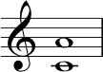
As we can see, the lower note is a C and the higher note is an A. So, in order to count this we start on C and count:
C = 1
D = 2
E = 3
F = 4
G = 5
A = 6
As such, we can say that the interval from C to A is a sixth. (NB: If you have a maths or science background, you might think of this as a bounded interval – as a set containing all points including the endpoints.)
Now, we need to find the quality... A nice way to do this is to imagine that we are in the major key of which the lower note is the tonic. So, in this case, the lowest note is C, so we imagine that we are in the key of C major. So, the question is: would we find an A natural in the key of C major...?
The answer is yes, so we can say that this is an interval of a major 6th. Let’s recap and then discuss some more complex examples.
Firstly, we imagined that the lower note of our interval is the tonic. Then we imagined that it’s the tonic of a major key. That allowed us to use our knowledge of the major scale pattern to test whether the top note of the interval belonged to the major key or not. If not, we know that it’s not a major interval.
The major scale pattern is a useful starting point because it’s constant, T T S T T T S, i.e. it doesn’t have variations or alterations, compared to minor scales.
As a consequence, we know that the scale’s internal intervals provide stable references points for us. Just to remind you, here are all the major scale interval qualities:

Quality of intervals from the tonic (1) in major scales/keys
Interval | Quality
Unison  Second  Third  Fourth  Fifth  Sixth  Seventh  Octave | Perfect  Major  Major  Perfect  Perfect  Major  Major  Perfect

How intervals change when we nudge notes up or down by a semitone
Here’s a graphic to illustrate how the quality (and corresponding description) of intervals change, when the size of the interval is increased or decreased by nudging it wider or narrower by a semitone.

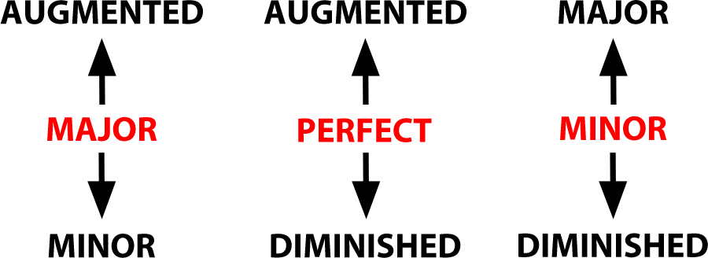

With that information in mind, let’s have a look at the following interval, which is very similar to the one that we just looked at:
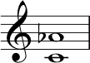
In the first example we worked out that C-to-A produces an interval of a major sixth, because A is scale degree 6 in C major. But in this example, the interval shows us C-to-Ab. We know that it must also be a sixth of some kind (C=1, D=2, E=3, F=4, G=5, A=6) – but this time, the interval is a semitone smaller than before because the upper note has been lowered/flattened by a semitone. Using this logic, we can say that a major interval made smaller by a semitone becomes a minor interval. So, this interval would be fully described as a minor 6th.
But for now, let’s keep working with the major scale as our basis. Now for a trickier example – again, using this method, for ease of calculation. Have a look at the following example:
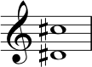
So far we have said ‘imagine you are in the key of which the lower note is the tonic...’. Whoa! D-sharp major!! When we look for it on the circle of fifths, we find ourselves off the charts... Don’t panic. Here is a method to help you identify that interval.
Cancel both accidentals. We can simply ignore both accidentals! This leaves us with the same interval, moved down by a semitone. If we ignore both sharps, we can pretend we’re looking at D to C. We can easily work out that D to C is an interval of a 7th.
Now, the key of D major = 2 sharps (F-sharp, C-sharp). Hmm. If this interval came from the major scale, it WOULD have a C-sharp in it. But we cancelled ours out. So our interval is a semitone smaller than the major seventh interval. It is thus a minor 7th.
The final step of logic: D to C is a minor 7th, therefore D-sharp to C-sharp is also a minor 7th.

Compound Intervals
How do we deal with something like the following interval?
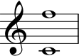
If we count from the bottom note to the top one, we see that it is more than an octave. It’s an 11th, in fact.
In jazz and popular music, musicians are happy conceptualising these big extended intervals. It’s common also, though, to re-imagine this interval as a compound interval. This is a way of describing an interval that extends beyond an octave. You can either re-imagine the top F down an octave, or take the middle C up an octave. Either way, you have a perfect 4th. So, we can describe this interval as a compound perfect 4th.

More Practice
Intervals can be tricky but the best way to get to grips with them is by doing as much practice as you can. The site musictheory.net is wonderful for this and you can use it to practice many elements of this course, including identifying intervals. You can set their interval exercise to be as challenging as you need it to be – customise it using the controls in the top right hand corner of the screen.

Transcript of the Video
0:04 | So last week we talked about intervals, and we said that this was the space between notes, but really to fully describe an interval, we need two pieces of information. We firstly need the number of the interval, but we also need the quality. So last week we looked to the distance between C and E. Everyone will tell you that this was a third, C to D to E, one, two, three.
0:28 | But, that’s only half the picture We say it is a third, but we need to know the quality, we need to know what type of a 3rd is it? Okay so Nikki what interval is this?
0:35 | One, two, three. That, that’d be a 3rd, Zack. Okay and this one? One, two, three. That, that’s also a 3rd, Zack. Okay, so these are two different intervals that we’re describing as 3rds and this is what we mean by quality.
1:01 | Take a look at this example. We’re going to use our major scale again as the reference point. We’re going to be figuring out and naming all our intervals with reference to the major scale. And this will give you a set of interval descriptions that match music theory convention.
1:18 | So we’re working from left to right. If we’ve got two notes that are exactly the same pitch, we say that they’re in perfect unison.  The distance between the 1st and 2nd, the 1st and 3rd, the 1st and 6th, and the 1st and 7th are all described as major. 2nd, 3rd, 6th, and 7ths, respectively.  The distance between the 1st and 4th, the 1st and 5th, and the 1st and the 8th are called perfect 4ths, and 5ths, and octaves, respectively.
2:00 | These intervals would all be the same in a major or a minor key. Hence, perfect. So as you can see, in each case we’ve got a description of the quality of the interval and in this case it was either major or perfect and we also have the number 1, 2, 3, 4, 5, 6, 7, or 8, but as we’ve also said, this is all based on the major scale. So, what happens if we want to work at intervals that don’t belong to the major scale? Well, firstly, we need to be aware that there are other qualities of intervals. So, we’ve already talked about major and perfect. We also have minor intervals, augmented intervals, and diminished intervals. So let’s use an example to take this forward.
2:47 | On your screen you’ve got a treble clef and a D up to a C. The lower note is D. The upper note is C. So let’s count up from D. D, E, F. G, A, B, C. One, two, three, four, five, six, seven. Seven steps. So we know we’ve got some sort of a 7th.
3:16 | Okay, so that’s only half of what we need to talk about. We’ve got the number now, we know it’s a 7th. Now we need to think about the quality. Well, a really good way to do this is to take the lowest note and imagine that you are in the major key. Imagine that’s the tonic of the major key. So in this case we’re going to imagine we’re in the case of D major, because the lowest note is a D.
3:37 | Okay, so, we know that in the key of D major we’ve got an F-sharp and a C-sharp. Therefore the 7th degree of D major, would be C-sharp. This would be a major 7th, we’ve already talked about this. Actually this is a C Natural, which is a semitone lower than the C-sharp that we would expect in this major key.  When a major interval is, it’s smaller, or lowered, we say that this is a minor interval.
4:08 | So we’ve now seen examples of major intervals, perfect intervals and, and now we’ve had our minor 7th as well. But we’ve also mentioned there’s such things as augmented intervals and diminished intervals. So, how would we get to any of those?
4:23 | Well, we’ve seen that the unison the 4th, and the 5th, and the octave, are described by the word perfect. This is because of the constancy between different types of scales. So they’re called perfect. But if we have a perfect interval and we raise it, we make that interval bigger. We call that augmented. And if we make that interval smaller, we call it diminished.  So, from a perfect interval, if you step up one semitone, you’ve made that interval augmented. From a perfect interval that you make smaller by one semitone, you’ve made that interval diminished. Now music theory convention given us, gives us even more options if what we’re starting with is, is a major interval. So if you remember the 2nd, the 3rd, the 6th, and the 7th, intervals, what all, originally started from our reference point as major. major 2nd, major 3rd, major 6th, major 7th.
5:26 | For any of those, if you were to add one semitone to the interval, so make the top note higher, sharpen it by one semitone, you would immediately get to an augmented interval so for major you’d setup one semitone to augmented. From that same major if you were to step down one semitone. So if you were to flatten the top note by one semitone, you would get to minor as we’d already seen. Now Zack, what would happen if you were to take that minor interval and flatten it by one semitone again? Well you’re making it smaller, so again we can see that, that interval has been diminished.

Topic 3: Musical Time and Rhythm

3.1. Rhythmic Duration
Video: Rhythmic Duration
In this video, Michael talks about different note durations. You may want to revisit the illustrations and introduction given in 1.3 Rudiments: Musical duration.

Transcript of the Video
0:00 | All notes have a duration in time, but in Western musical notation the duration is expressed as a fractions or multiples of a beat, rather than as a duration in seconds. Beats are related to, or even synonymous with pulse. And they’re clearly related to tempo, which is often expressed as beats per minute. Rhythm then concerns multiples, or subdivisions of beats. It can be expressed symbolically in western notation, in the form of both rests and notes. So, for instance, all our western rhythmic notations are related to the whole note, as it’s called in America, or the Semibreve, as it’s called in Britain. Semibreve represent the full duration of one bar in 4/4 meter. We’ll come to meter in a little while, but suffice it to say, 4/4 is the most common meter that we come across.
0:49 | The Semibreve can of course be subdivided, and these subdivisions have different names. In British nomenclature for example, we speak of minims, Crotchets, Quavers, etc. There are two minims per Semibreve. This is also known as the half note in American parlance. This is then subdivided into two crotchets. Crotchets are Quarter notes in the U.S., and there are four quarter notes in a Whole Note or a Semibreve, as you might imagine. Crotchets are then further divided into Quavers, Eighth Notes, and on into Semiquavers, Sixteenth Notes, and so on and so forth. So, if you use the American nomenclature, which is derived from the German by the way, it’s very easy to see how many of a particular rhythm you will have in a whole note, as all rhythms are expressed in relation to this. So, let’s just recap here and look at the actual notation of these rhythms. First of all, we’ve got the open round note symbol, which is the Semibreve or whole note. This is four beats long in common time, or four, four meter, again more on this later. Then we’ve the half note or minim, the crotchet, the quaver and the semiquaver. We also have the equivalent rhythms in rests. Rests are necessary to indicate where a musician stops playing notes. Most music consists of notes surrounded by space, of course. Otherwise, musicians would never get the change to breathe or rest, and neither would the music. So, first of all, again, the semibreve, or whole note rest. The minim, or half note rest, the crotchet, or quarter note rest. The quaver, eighth note rest, and the semiquaver, or sixteenth note rest.
2:30 | You can see that the quaver and semiquaver notes are essentially crotchets, with little flags on their stems.
2:36 | Each flag that you add divides the rhythm by two, so we could further divide semiquavers into demisemiquavers, or 32nd notes in American parlance. And these can be further subdivided into hemidemisemiquavers, or 64th Notes, etcetera, etcetera. Now those flags which we’ve seen on the quavers and lesser durations, can actually turn into what we call beams.
3:00 | We use beams so that we group notes into twos, fours, eights, et cetera, and thereby easily see a beat’s worth, or sometimes more of shorter notes. This makes it easier to orientate ourselves in the flow of the music, so we can recognize where the beat boundaries are. Here’s another example. You can see that the number of flags which we use in the individual notes, is reflected in the number of horizontal beams. And that adding one more beam is the equivalent to adding one more flag. That is, we’re subdividing the rhythm into two.

3.2. Tuplets
Video: Tuplets
We covered the basics of tuplets in this video but if you were interested in finding out more you could follow up by reading: Chapter 5 (section 5) of ‘The AB Guide to Music Theory’ by Eric Taylor or ‘The Rhythm and Meter’ section of ‘Tonal Harmony’ by S. M. Kostka, D. Payne or this Wikipedia page: Wikipedia - Tuplet. Tuplets can sometimes be confusing to start with but please remember to use the forum for this lecture to engage with your fellow learners and discuss concepts such as this.

Transcript of the Video
0:00 | We can, of course, divide our rhythms into subdivisions of three, five, seven, etc. These are generally referred to as tuplets, and could be any arbitrary division of a note. But the most common are, in fact, triplets. There are, as you might imagine, three triplet quavers or eighth notes to a quarter note. Three in the time of two or three triplet quarter notes to a half note.
0:28 | Any basic rhythm can be subdivided in this manner. So, if I’ve got a beat that goes at this speed. [SOUND] That would be quarter notes, and triplets would be one two three, one two three, one two three, one two three, one two three, one two three. As mentioned, we can have other subdivisions, for instance, quintuplets. So for example, I could divide a minim or a half note into five quintuplet eighth notes. That would go something like this: 1, 2, 3, 4, 5. 1, 2, 3, 4, 5. 1, 2, 3, 4, 5. 1, 2, 3, 4, 5.
1:08 | Tuplets are generally notated in the simplest fashion, by putting a number over a beam as in the triplet quaver, or eighth notes that we’ve already seen. The three there implicitly means three in the time of two. So whereas crotchet or a quarter note would usually be divided in two quavers or eighth notes, by putting the three above three quavers, we indicate that we want these three triplet eighths to be in the time of two.
1:34 | We can also use brackets with numbers, if we have notes that we don’t have flags or beams for. So to create triplet quarter notes, we would normally use the bracket to group the three notes we want played in the time of two. And if it’s not obvious how many short notes we want in the time of how many longer notes, we could explicitly write proportions, such as four to three.

3.3. Ties and Dots
Video: Ties and Dots
Wikipedia has a good page on dots: Dotted note. Another area related to rhythm which the video lecture didn’t mention but which might nevertheless be useful for some of you is that of grace notes.

Transcript of the Video
0:00 | Let’s turn now to ties and dots. Rhythms don’t always occupy complete beats or regular subdivisions. Sometimes, we want to extend the duration of a note. We can do this by tying one note to another, as you can see on your screen now.
0:20 | That tie or line connecting the crotchet to the quaver means that the note you are now going to play is one and a half beats long rather, than two separate notes of one beat and then half a beat. So we’re not playing this note twice now. Rather, we’re extending the duration by tying the two together.
0:41 | In this simple case of a quarter note tied to an eight note we can use a dot to indicate exactly the same duration.
0:50 | The clue is in the fact that the second tied note is half the duration of the first. If you see a note with a dot immediately to its right. then this means that the indicated duration is extended by half its duration again, so a dotted crotchet or quarter note would last one and a half crotchets. On the other hand, and you’ve got to be careful here, a dot immediately above or below a note is another matter altogether and nothing to do with rhythm. It indicates a staccato or detached type of note articulation.
1:24 | Let’s look at another example. A dotted quaver or eighth note would similarly last one and a half quavers, so that would be the equivalent of tying a quaver to a semi quaver, or an eighth note to a 16th note.
1:40 | Dotting can be further extended by adding multiple dots. Two dots would extend the duration of the indicated note by half of the duration and half of that duration again. So a double dotted crotchet or quarter note would actually be one and three quarter crotchets in length. One plus half, plus a quarter. Triple, or even quadruple dotted notes also exist, though they are a lot less common. Another notational symbol related to rhythm is the pause or fermata. When placed over any note or rhythm, this symbol indicates an out of time pause. The length of the pause is determined by the musician. Which as a general rule of thumb, it’s about twice as long as the indicated duration.
2:31 | Now, when you’re writing rhythms yourself, rather than just reading them, you might ask yourself how to space them. It would be reasonable to assume that crotchet, or quarter note, takes up the horizontal space of two quavers or eighth notes. This is sometimes the case. Some composers even prefer it that way. But most publishers tend to squash longer durations into less horizontal space, than the requisite number of shorter durations. So you could adopt this approach when writing yourselves. The thing to bear in mind, is that when you’re writing more than one part, then coincident notes have to vertically align, so that you can see which notes will actually sound together.

3.4. Metre
Video: Metre

Common Time
In the video, Michael mentions ‘Common Time’. This is another name for four-four time i.e. four crotchets (quarter notes) per bar, so called because this time is so common. In fact, it is so common that sometimes people write the following time signature instead of 4/4:
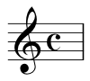
If you see this time signature written in music, don’t panic – the C stands for common time and this is exactly the same as four-four, it’s just an alternative symbol.
There is also ‘Cut-Common Time’ which is 4/4 ‘cut’ in two to make 2/2 time.
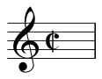

You might find this animated tutorial useful: Music theory lesson. This site does use American terminology but it is good to be familiar with this and the UK terms. The following ‘translations’ might help: ‘Staff’ = Stave, ‘Measure’ = Bar, ‘Quarter notes’ = Crotchets, ‘Eighth notes’ = Quavers, ‘Half notes’ = Minims, ‘Whole notes’ = Semibreves.

Transcript of the Video
0:00 | Now let’s move on to metre, as promised. As you might imagine, this is closely related to poetic meter or rhythmic grouping. Music is most often organized into groups of two, three, or four beats per bar. We use bar lines to indicate bar boundaries and to make reading easier.
0:23 | Less standard groupings, or meters, would be five, seven, eight, ten, or in fact, any number of beats. So any grouping is possible, but two, three and four beats per bar are the most common. These bars then represent the meter, so when we speak of duple meter, typical of marches for example, we mean two beats per bar. Triple meter, typical of waltzes, would be three beats per bar. Quadruple meter, or four beats per bar, would be the four-four that’s most common in western classical music or electronic dance music. In fact it’s so common that it’s called common time.
1:03 | Generally, we’re talking about crotchets or quarter note beats here, though it’s possible to have the beat be minims or quavers, or any basic rhythmic duration. So though four-four, four crotchets per bar, is most common, it’s possible to have quadruple meter with eighth notes or minims as the basic beat.
1:23 | The way we indicate meter is with a time signature. This consists of two numbers: a numerator on top, and the denominator on the bottom as with fractions in arithmetic. The numerator tells us how many beats there are per bar, and the denominator indicates the beat type. So four-four means four quarter notes or crotchets per bar, whereas three-eighth means three quaver or eighth notes per bar. Now, each of these bars has, or tends to have, weak or strong beats. In Western classical music, we tend to favour the down beats, or odd beats, in general.
1:24 | Let’s look at another example. A dotted quaver or eighth note would similarly last one and a half quavers, so that would be the equivalent of tying a quaver to a semi quaver, or an eighth note to a 16th note.
2:00 | If you have a four-four bar, that is a quadruple meter, the accent would generally be on beats one and three. So, for instance, if we listen to Mozart’s ‘Eine kleine Nachtmusik’, you can see quite clearly and hear these accents. Some pop and jazz music on the other hand, tends to favour the off or even beats. In a four-four bar this would be beats two and four. And this gives it the characteristic rhythmic feel we associate with this type of music, very often with a strong snare drum stroke on those off beats.
3:01 | It doesn’t stop there, I’m afraid. In Western notation, we speak of two basic types of meter: simple and compound. Simple meters are those that divide into beats of two, four, eight, etc. So when we look at a simple four-four bar, we tend to subdivide that into eighth notes, sixteenth notes, etc. That is, groups of two, four, eight, powers of two.
3:25 | Compound meters, on the other hand, use dotted rhythms as their basic beat, so it is very easy to subdivide into three. The most common compound meter would be a six-eight bar. This clearly does have six quavers or eight notes per bar. But instead of being felt as six beats per bar, it’s felt as two dotted crotchet, or dotted quarter notes per bar, each subdivided into three. This allows us in this case to avoid having to write tuplets all the time, or triplets, because essentially the equivalent would be a triplet eighth note in a two-four bar.

3.5. Anacrusis, Phrases and Structure
Video: Anacrusis, Phrases and Structure
Amendment:
In this segment, Michael mentions an example by Brahms. The example he refers to is the main theme of the 4th movement of Brahms’s 1st symphony (not the main theme of the 4th symphony as stated in the video). Sorry for any confusion!

Anacrusis
An anacrusis is also known as the ‘pickup’ or the ‘pickup notes’ as it is the note (or group of notes which happens before the first downbeat in a bar. You can think of it as a partial bar just before the down beat of the first full bar.
Have a look at the following image which is the first few bars of the popular jazz standard ‘Autumn Leaves’:
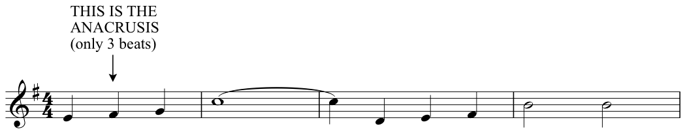
Generally, in written Western music, when a piece with an anacrusis, the same number of beats are absent from the final bar so that the number of bars in the music is a whole number.

Phrase
We covered the fundamentals of phrases and structure in this segment of the lecture but this Wikipedia page has some great information on phrases in music and some of the theory surrounding this, if you’d like to read more: Musical Phrase.

Musical Form
There are many types of musical form. The basics were covered in the lecture, but the following Wikipedia page is useful for your reference and further reading: Musical form.
The link below is a glossary compiled by Yale University that may be of interest to some of you: Music Glossary Yale.

Transcript of the Video
0:00 | Before we leave meter and move onto phrases, let’s look at something that bridges the two... anacrusis. This is both a poetic and a musical term, and in music, it indicates that the start of a piece or section begins with an under-full bar, most characteristically just the last beat. This is often called a pickup note. Some very well-known melodies are structured in this way, for instance, Happy Birthday to You, or the main theme of the final movement of Brahms’s Fourth Symphony.
1:05 | So when we have music with anacrusis, we tend to start each of the phrases in the music with the pickup note, as in the examples just noted. But what are phrases? A phrase is a part of a melody, a group of several bars, most often four. It forms a melodic unit that feels more or less complete, depending upon its harmonic context at the end. In fact, phrases are generally articulated by harmony in western music, and in particular by what we call cadences; we’ll cover these in week five.
1:39 | Not coincidentally, a phrase is often the approximate length of a singer’s or a wind player’s breath. So there might be rests at the end of a phrase, in which they can take a breath. Phrases might be indicated in notation by a curved line above the stave, much as a wind player’s slur line indicates a passage to be performed in one breath also. Phrase marks and slur lines are not equivalent, but they are related and look pretty much the same
2:06 | So what we can see now is a clear hierarchy of musical structure from rhythms grouped into beats, beats into bars, bars now into phrases and as you’ll see next, phrases into periods, or phrase groups if they’re not grouped into pairs. Periods into sections, sections into movements or songs and movements into symphonies, concertos, et cetera, or songs into albums. There are, however, a couple of other things to add in here. The first of which is the motif or motive.
2:43 | Many melodies and phrases make use of concise musical signposts or motives. These are usually short musical statements that are easily recognizable by their strong rhythmic or intervallic character. Motives are often repeated considerably and developed and varied both rhythmically and melodically during the course of a piece.
3:03 | Probably the most famous music motive in Western classical music is found at the very opening of Beethoven’s Fifth Symphony. This is fairly typical of motives, in that it is an isolated short statement. Shorter, in fact, from not, what we’d normally consider to be a phrase, but it could by itself, or in compilation with extensions of itself, form a complete phrase of music.
3:33 | Somewhere between phrases and sections, we have melodies. But the confines of these are open ended. They may or may not constitute a complete section of a piece, depending on stylistic context. It all depends on how long the melody is.  Wagner’s were famously never-ending, for instance. But in any case, melodies generally consist of several phrases. Take for instance, the old English tune Greensleeves. This displays an anacrusis or pickup note, which we’ve already discussed.
4:04 | The pickup here is on the last eight note, or last quiver of the six eight-bar. So we got a six eight melody, which we may remember is a compound duple form with two dotted crochet beats per bar.
4:17 | The Greensleeves melody consists of four four-bar phrases. These are grouped into two periods, each consisting of two phrases, the antecedent phrase, which doesn’t come home to our tonic of G and the consequent phrase which does indeed come home.

3.6. Form
Video: Form

Repeat Marks
Repeat marks are important symbols that are used to indicate a section of music that should be repeated. When reading music, if you encounter this sign then this means to repeat from the beginning, and then continue.
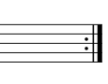
If you encounter a corresponding sign facing the opposite way, this indicates the point in the music at which the repeated section is to begin.
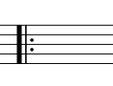
So, in the following example – all the music contained within the repeat marks should be repeated. When repeated once, the player would simply ignore the repeat mark and continue through the music in order to avoid an infinite loop.

When a repeat calls for a different ending, number brackets above the bars indicate which to play the first time (1), which to play the second time (2), etc. These are called ‘first-time bars’ and ‘second-time bars,’ or ‘first and second endings.’
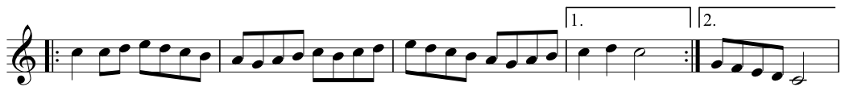
For further reading on repetition in music you can consult this Wikipedia page: Repetition.

Transcript of the Video
0:00 | The last thing we’ll cover today is musical form. We’ve already touched upon form in fact, by talking about the clear hierarchical relationship that went from bars to phrases, phrases to periods, and then periods into sections and on into movements and songs. We can only really touch on Musical Form here as it’s a complex much debated area of musical thought analysis and composition. But essentially, once you’ve built up your phrases into sections, you can then start combining these sections and their repetitions into movements. There are several basic ways of combining these sections. The most simple of which is the Binary Form.
0:44 | As you might imagine, this has two sections. Usually referred to as A and B. The B section could or would actually most likely be closely related in character to the A section. But generally it would be in a different key. Also of note in Binary Forms, is that both section A and section B are quite likely to be repeated.
1:07 | If Binary Form has sections A and B, then Ternary Form is generally notated or referred to as A B A. So what we have here is a return to our A section after changing key for the B section. The return of A might be in some modified form, in which case, we generally notate it as A, B, A’ Prime, with the apostrophe here, Prime, signifying a modification.
1:32 | This form is quite closely related to the Sonata Form, which was common during the western classical period. It’s the form of most first movements of symphonies, sonatas, concertos, etcetera. This has a basic A-B-A Prime Form of exposition, development and recapitulation. You can read more about this via the Wikipedia link on this week’s webpage. Other common forms are the Rondo Form, which has a recurring section in between contrasting sections. So, A B A C A, for instance. And the very common repeating 12 Bar Blues Form, which you can also read more about via the Wikipedia link on this week’s webpage.

Topic 4: More on Chords

4.1. Listening to Triads
Video: Listening to Triads

Triad Types
As we have noted in this video and in a couple of the previous weeks, a triad is a 3-note chord containing a root, a third and a fifth. The following are all triads:
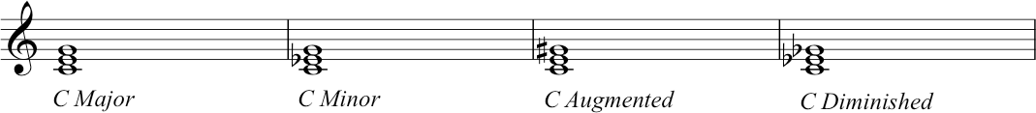
- The major triad consists of a root (C), a major third (E) and a perfect fifth (G).
- The minor triad consists of a root (C), a minor third (E-flat) and a perfect fifth (G).
- The augmented triad consists of a root (C), a major third (E) and an augmented fifth (G-sharp) - incidentally, this means the intervals are consecutive major thirds.
- The diminished triad consists of a root C, a minor third (E-flat) and a diminished fifth (G-flat) - incidentally, this means the intervals are consecutive minor thirds.

Inverting Triads
All of the triads above are in root position, that is to say that the root of the chord is the lowest pitch. However, triads do not need to be stacked root, 3rd, 5th from the bottom up, as is shown here. In fact, the notes can appear vertically in any order and still be identified as that same chord. There are conventions for understanding and communicating about this. What’s at stake is the position of the root note of the triad. We refer to this type of re-ordering as the inversion of the chord.
Look at the chords below:

As we can see, each chord contains the notes C E and G – but these notes are arranged in different ways in each of the chords. As each chord contains these notes, we can describe them all as C major triads. Actually, the fact that each of these chords differ in the way that the notes are stacked up does affect the sound of the chord and potentially also the ways in which they relate to other chords in a harmonic progression. As such, we need to be able to describe them individually.
- If a chord has the root note as the lowest pitch then we describe it as being in ROOT POSITION, e.g. C E G, as above.
- If a chord has the 3rd as the lowest sounding note then we describe it as being in first inversion, e.g. E, G C, as above
- If a chord has the 5th as the lowest sounding note then we describe it as being in second inversion, e.g. G, C, E as above

Systems for labelling chords and inversions
This is a topic that we will address again more fully in Topic 5 of this course. But meanwhile, we need some information to use for now! One system that we often use in these videos employs a combination of roman numerals and the Latin letters a, b and c. So, let’s take the example of a chord V (the dominant chord, the triad built on scale degree 5).
- If it’s in root position then we could describe it as Va (although in the case of root position chords the ‘a’ is often tacitly implied.
- In first inversion, it could be described as Vb.
- In second inversion it would be described as Vc.

For chords containing more than 3 notes, this system can be expanded. 7th chords, for example, which have four distinct notes can be in third inversion, which would be described as Vd.

ADDITIONAL MATERIAL
Visit Music theory lesson 2 for a nice, animated explanation of chord inversions from musictheory.net.

Transcript of the Video
0:00 | In lecture one we saw that it’s common to build triads. Just to remind you what a triad is, it’s three notes played together. It’s the simplest type of chord. So if we take any note. What we’re going to do in order to build a triad is, play a note, then miss a note, then play a note, then miss a note. So if we think of a chord built on F, the lowest space on the stave, we’re going to play the F, we’re going to miss the line G, play an A, miss the line B, and play the note C. So we get our three note chord, using every other note. And when we play the notes stacked up like this. It’s the bottom note, it’s the first notes there that is the one that sort of sticks out to our ears, generally. Here’s another triad. And let’s hear another one, as well. Okay now let’s just to demonstrate how we can pick out the bottom note from the triad. Zack I am going to play some chords in a row and when I finish the final triad I’d just like you to hum for me, sing the, the, the note that stands out to you, perceptually. Okay. La. Zack’s singing the key note. In this case it was G, he was singing the tonic key note G. Let’s try another one. La. He’s singing the key note B.  So although there were multiple notes being played, actually when we hear the triad, it’s still the lowest note, it’s the tonic that is the most important one perceptually. So, let’s just think of another example here, we’ve got an A-minor chord, A, C and the E. Now, because the notes repeat across the octave and that keeps going on and on, we could repeat as many of the A and the Cs and the Es as we like, and put them all into, into some sort of voicing on any instrument. So we could have something like this. La. There we go, so the note adds of all those repetitions and the various voices that we’re using. It’s the, the bottom note of the triad that should stand out the most. So, though Nikki played lots of As, and lots of Cs, and lots of Es, the important thing was that perceptually, the triad was the root of the triad was the most important. It was the strongest, and that’s what allowed me to sing the note A above the others. And that, and that’s how we identify that chord as being an A triad.  So, you’ll remember from lectures one and two, that triads don’t just have an identity. They don’t just have a note name that identifies them. They’ve also got a kind of flavour or characteristic. And we’ve already heard, just now, two different types of characteristics. We’ve heard minor triads. And we’ve just heard major triads. So just a reminder about what, what’s quite going on there. It, it’s, it’s something you’ve talked about already but it’s also good to think of it in different ways. With that triad, we’ve got the interval of a perfect fifth. On the outside, from the top to the bottom, or from the bottom to the top. And then in the middle, we can carve up that pitch space, so that it makes – A major sound. Or a minor sound.  So the important bit about that chord, and the thing that actually gives it its major sound or its minor sound. Is the third. So if we think about the first degree and the fifth degree of the triad we have got seven semitones between there and that’s like we said what we call a perfect fifth. But importantly in distinguishing major and minor is actually the third that we want to look at. So, if between the root of the triad and the third. We have three semitones. We call this a minor third, so a triad with a perfect fifth and a minor third is described as a minor triad. If we had four semitones between the root and the third, we get a major third, and a triad with a major third and a perfect fifth, is a major triad. So, so just summing up. When we have triads, we can identify them, even though they’re three notes, by one single note name, which is the root note. And we can also identify them as having a particular flavour or character, either major or minor, or diminished, or augmented. And we’ll talk about those more a bit later. So, a little aside on triads before we move on. Some people might be watching these videos wondering why we’ve always had this group of notes in the same order, appearing one, three, five. What happens if we have a different order? That order that we’ve been using, one three five, is what’s known as root position. Where the tonic note, the root occurs in the lowest position of the chord, now of course you can move around and do them in in other positions as well, so. Here we’ve got one three five, we course we could have three five one, or we could have five one three.
5:33 | Now, the interesting thing perceptually about rearranging that order, is that the note that we’re calling the root note is still the one that, that you use to identify the chord. So even when you’ve switched it round, that note, because of the relationships between the pitches when you play them together, that note is still identifiable as the root of the chord. So when we’re talking about these triads being rearranged to use a music theory term, we’re actually talking about ‘inversions’ - The notes have been inverted. We’ll talk more about that in the next lecture, but we’ve also put some supplementary material up on this week’s webpage, just so you can have a read in to, and, and become more familiar with it. From now, in this lecture however we’re always going to keep everything in root position, just because it makes it really easy to talk about the first, the third and the fifth, and know where everything is.

4.2. Elaborating Key, Triads and Scales
Video: Elaborating Key, Triads and Scales

Cadences
In this segment we introduced the idea of cadences. We’ll talk about these some more yet through the course! But let’s get started. In music, a cadence a melodic or harmonic progression that creates a sense of finality or a pause in the music. We mention two cadences in this section, one that sounds finished and one that sounds unfinished.
Let’s look at the one that sounds finished, first:
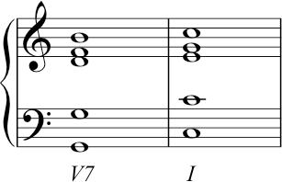
As we can see we are in the key of C major and the chords are G7 followed by a C. Numerically speaking, this is chord V7 followed by chord I. This is known as a perfect cadence.
Let’s look at the one that sounds unfinished, next:
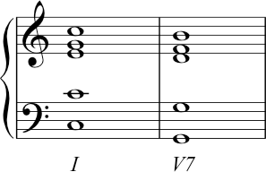
Again, we are in the key of C major but this time the chords are a C followed by G7. Numerically speaking this is chord I followed by chord V7, i.e. the reverse of the example above. This is known as an imperfect cadence. This sounds unfinished (hence, imperfect) because it finishes on the dominant. In this case, a dominant seventh chord. We know that this chord is unstable and sounds as if it requires a resolution.

Transcript of the Video
00:00 | In lecture two, Zack and I described the concept of keys and key signatures. You’ll remember that when we travel through the octave using scales, we get distinctive internal patterns of intervals that arise. And you’ll remember the major scale has that distinctive pattern of tone, tone, semitone, tone, tone, tone, semitone. And you remember us talking about key signatures and saying that they’re a way for us to signal right in the very start of a piece of music, what sharps and what flats we’re going to have in any given key. This came from the idea that some scales were built up, and we needed to use some sharps and some flats when we were using a tonic that wasn’t C. So, this then allows us to use any one of our pitch classes, and that is any one of the twelve note names as our tonic, so that we can build patterns of tones and semitones or scales, or melodies or chords in any of these given keys. Now, it’ll help you, when you’re trying to become fluent in reading and writing music, to try and get these memorized as much as possible. If you look back at week two, there are some tips and mnemonic devices for how to actually go about doing this.
01:15 | Okay so, at the start of this lecture, we were looking at triads, and we were looking at perceptual effect of those note groupings. So that one, just one of the notes that was there, was the more important one, was the one we can use to identify that triad, had that overarching label for that triad. Well, within a key, the relationships between and within those triads and how we use them can also contribute to that overarching sense of tonality, by which we mean the quality of the key.
01:55 | So we’ve been using words like harmony and harmonic structure. And these are words and phrases that you hear when we’re talking about music often. What do I actually mean by these phrases? Now is a probably a good time to actually think a bit more precisely about we’re saying. Yeah. Well, harmony describes the effect of those triads that we’ve been talking about. And the relationships and the patterns between the triads when we use them in a key. Key and harmonic structure, or key and harmony, are the two most important building blocks for music that sits in a tonal tradition. So to explain this more, I’m now going to sing you a familiar tune; you can follow the melody on the stave notation on the screen. Instead of using the words that you’ll be familiar with, I’m just going to use the scale degree numbers when I’m singing. One, one, five, five, six, six, five. Four, four, three, three, two, two, one. Five, five, four, four, three, three, two. Five, five, four, four, three, three, two. One, one, five, five, six, six, five. Four, four, three, three, two, two, one.
03:14 | You can hear a couple of things, a couple of features in that familiar song. The first one that we’re going to point out, is that you got a very strong tonal identity. I was singing in C. And C is the tonic. And it came across very clearly. Another thing we can think about relates to the structure of the music. So as the melody progresses, there are points. It comes to rest, but it doesn’t feel completely finished. There are other points where the music comes to rest but does feel finished and does feel ‘closed’. Now these points are what we know as cadences. Let’s look at a couple of those cadences from the familiar song. A cadence that comes to rest but sounds open and unfinished. We’ve got one up above the world so high, like a diamond in the sky. It rests, but it’s not finished. And we can compare that with the return at the end. Twinkle, twinkle little star, how I wonder what you are. What’s causing that effect then? Well, in order to think about, we really want to look at the scale degrees again. Before we do that, let’s just think about the key of C as a whole. So we got, one, two, three, four, five, six, seven, and back to one again for our tonic.
04:37 | We know that triads that are built on the tonic and the dominant have particularly strong structural properties, harmonically, they’re very strong. So let’s see which scale degrees feature in the dominant triad. We’ve got a five, and we’ve got a seven, and we’ve got a two. I mean, we’ve got the fifth and the seventh and the second degrees of the scale present. For the tonic triad, we’ve got the first, and the third, and the fifth degrees of the scale present.
05:08 | So let’s go back to our melody again and look at this in a bit more detail. Well, if we look at one of the points that the music came to rest but didn’t feel finished, we get. We had five, five, four, four, three, three, two, five, five, four, four, three, three, two. So the five and the two really stand out to us, and that’s what gives us that feeling - of it not feeling quite finished, the two notes that belong to the dominant chord. Especially when we compare that to the phrase that did sound finished. Four, four, three, three, two, two, one. And when we’re coming down there, we’re coming back away from the tonic chord. Sorry... we’re coming back from the DOMINANT chord back to the, the tonic chord. And this is another example of a cadence.
05:52 | So music theory, we call those cadences where we sit and hang around but at the dominant open, unfinished chord. We call that an imperfect cadence, and we contrast that with a perfect cadence. And that’s where we’ve travelled back from  a dominant. Chord back to the tonic. And we’ve come home again. There’s a lot more to say about cadences. And we’ll go a bit further in this lecture later on, but you’ll go further still in the final lecture.

4.3. Building Triads
Video: Building Triads

In the video for this segment, we talked about building triads on each degree of the major scale and minor scale. The following should be useful for reference.

Triads built on each degree of the major scale
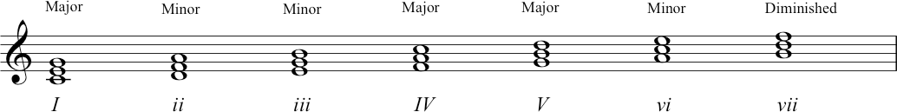This is shown in C major for ease of illustration, but the pattern is the same in any major key

Triads built on each degree of the minor scale
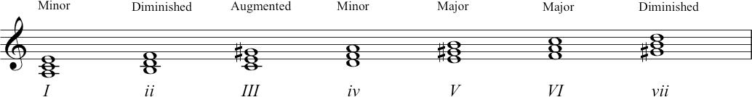This is shown in A minor (built on the harmonic minor scale) for ease of illustration, but the pattern is the same in any minor key.

Transcript of the Video
00:00 | In the last section, we talked a lot about the dominant triad and I talked a lot about the tonic triad, but actually as we talked about in week one, we can build a triad on any note within the scale and that’s exactly what we’re just going to do now. Yep, we’re going to start with chord scale degree one. going to go up through all the scale degrees one, two, three, four, five, six, seven, one and we’re going to build a triad on each scale degree. Now, just to be clear in how we’re, how we’re, we’re notating these things for, for, for, for differentiation we’re using numbers for scale degree one, two, three, four, five, six, seven. When we build triads on each of those scale degrees, that triad is also chord I (one) or chord V (five) or chord IV (four). We use Roman numerals when we, when we’re talking about chord or triad numbers instead of normal numbers.  Okay, so if we take C as our tonic in this case. We’re going to build a triad on C, it’s the first degree of the scale, and as Nikki said, we’re going to call that chord one. Now on a major key, let’s hear that again. We’ve got a major chord. Okay, let’s go in to chord two. Chord two in the major key is minor, chord three is minor. Chord four is major. Chord five is major. Chord six is minor and chord seven is the one that was different. This is a diminished triad. Just to recap, between the first and the fifth, we’ve actually got a diminished fifth, not an interval of perfect fifth as we have with the others. This would be a perfect fifth. This is slightly smaller, so we get a diminished fifth and in between we’ve got minor third from the first to the third. So, a diminished fifth and a minor third gives us a diminished triad. Chord seven is a diminished triad.
01:54 | Now, what’s important to spot here as we go up the major scale is that we’ve got yet another pattern emerging in music theory. You remember that our major scale always has the pattern of tone, tone, semitone, tone, tone, tone, semitone intervals as we ascend the scale degree numbers. When we build a triad on every single, every single scale degree, traveling up the octave, we get that pattern of major, minor, minor, major, major, minor, diminished. That pattern stays the same, whichever [major] key you’re playing in. Chord five is always major, chord two is always minor.
02:35 | So we can take any note and build a triad on it. But actually, it seems that when we look at music, and when we analyse pieces of music, there are some chords that get more use, some chords are used more often than others. We saw with Twinkle Twinkle, with our little example, it was chord one and chord five, it was the tonic and the dominant triads that were really important structurally. In common practice music theory, chords one, five, and also chord four are the three sort of, most important structural building blocks. The subdominant, that’s chord four, often appears before chord five and it sort of extends the whole structure that we’ve described with those perfect and imperfect cadences. But it’s not just in big pieces of, of work from the common practice era that we see this. In fact, any diatonic melody, we can take and harmonize it with chords one, chords four or chord five.  Since every single scale degree actually occurs in chord one, four or five, we can use these chords in conjunction with melodies built from this pool of notes. There’s a lot more to say and we will go on soon, but first we have to carry on with our triad building exercise.
03:51 | Okay. So now we’ve seen the patterns that come out through triads built in a major scale. But what happens when we do this with a minor scale? Well, as you’ve predicted, based on what you know from the major scale, we’re getting a whole new set of internal regular patterns emerging when we go through. The triads are built on each degree of a minor scale.  We’re going to use A minor this time, so, rather the c major, we’re shifting to its equivalent minor. Starting with chord one. So chord one in A minor. You’ve guessed that is a minor, so that’s a minor chord, on chord one. If we move up to chord two, we get a diminished triad. So it’s like, it’s like the seventh chord from a major scale, it’s got that same diminished quality. Okay, then if we move on to chord three, we get something interesting happening here because we’re in our minor key. Now you’ll remember from week two we talked about different types of minors. We were looking at this just now, we’re going to look at the harmonic minor, and that gives us a new chord on chord three that we’ve not discussed yet. So we’ve got a major third, but if you look at the distance between the root of the chord, and the fifth. We’ve actually got 8 semitones now, which is one semitone more than the perfect fifth that we’ve already talked about. This is called an augmented fifth. So a chord that has a major third and an augmented fifth, we’re going to call an augmented triad. And you don’t realize that this is happening because chord three has the scale degrees three and five and seven in it. And you’ll remember that what characterized the harmonic minor scale was it had a sharpened seventh. Okay, moving on to chord four. We’ve got a minor triad. And then going onto chord five, we’ve got a major triad, again encompassing the G-sharp that was important. We now have our major triad. We move onto chord six, we’ve got a major triad. And then we go to seven. We’re back to another example of a diminished triad and back to the tonic again.  Okay, so the properties that we get from the triads that we’re building in the harmonic minor scale give us a really distinctive set of distinctive set of, of patterns, of triads that emerge. We’ve got a mix of diminished; we’ve now got augmented and we’ve also got that major fifth happening on, on, on the when we build up from the, from the fifth degree of the scale because we’ve got that leading note because we’ve got that sharpened seventh. So, it’s really unambiguous. So, moving around in different keys, that pattern of triads would emerge from any key notes using a harmonic minor scale.

4.4. Harmonising melodies
Video: Harmonising melodies
In this segment we spoke about harmonising melodies. The following Wikipedia page may be of interest if you would like to do some further reading in this area: Harmonisation.
You could also recap the video of Introduction to chords in which Richard discussed the 3-chord-trick (a method for harmonising diatonic melodies). Now that we have explored more chord types, the same rules apply and you can use them to harmonise melodies using more than just the primary chords I, IV and V.
You may like to try this for yourself. Take a simple well-known melody and create a harmonisation for it (i.e. choose chords to go with the melody). This is not only good fun, it also ties your theoretical knowledge into your aural skills and helps you to understand these concepts more thoroughly.

Transcript of the Video
00:00 | Okay, so we’ve looked at a lot of different chord types now. And we’ve built triads on every degree of the major scale and every degree of the minor scale. And we’ve heard a lot of different quality of chords coming through. Now, we know that we can actually harmonize any diatonic melody just with the chords that you build on the tonic, the subdominant and the dominant. But we also now know that there’s all these other chords that we could use, so it’s, it’s a time to start perhaps playing around with that and hearing what we can do using that familiar melody again, Twinkle Twinkle Little Star.  Okay, so we’ve had this melody in week one. You know, we’ve used that a few times today. So far today, we’ve talked about harmonizing it just with chord five, the dominant, and chord one the tonic. And we had the kind of important structural impact that this has on the melody.
00:55 | Now we’re going to hear it just with chords one, four and five. And then we’re going to take some other chords and make it sound a wee bit more interesting. So, Nicky is going to play the guitar. It’s not my guitar. This is Zack’s guitar and he’s been very kind and trusting by lending it to me because I’m not really a guitarist. But we thought that probably quite a lot of you will guitars around at home. And also we’re going to sort of teach you turning around in this, in this format. Might just give you a break from where we’ve been teaching at the piano and, and give you an insight to how we learn to do things as well. Okay. So I’m going to sing the melody, Nikki is going to harmonize it using chords one, four, and five. Okay, so it’s just the first phrase but we’re using chords one, four, and five, and you hear how the, how the melodies sounds and you hear its cadential point. So, let’s try something different.  Let’s take another one of the chords we’ve learned, and this is arguably the next most important and the next most common chord. We’re going to use chord six this time. Okay dokey. In the key of G, that is the chord of E minor. That’s chord two, we’re going to have. That’s chord two. We’re going to have chord six, which is E minor. There you go... in the key of G. Thank you. Okay. So what I want you to do is just have that just as the last chord in that phrase. Mh-hm. We’re going to hear how just a subtle change in chord makes a real difference to the feel and the overall effect of the harmonization of the melody. Okay, so let’s try again.
02:35 | Okay, so again, we’ve got this, a completely different sound when we arrive at that chord. And it’s interesting because it gives the melody a different colour. And it gives us a new direction to go off in. But it kind of worked because that chord that we just used, chord six, has a scale degrees in it, six, one, three. And that overlaps a lot with the scale degrees that you get in the tonic chord one, three and five, which we were using before. Okay. Let’s try a different one. This time what we’re going to do is we’re going to extend the feeling that we get towards the end of the phrase. What I want you to do is just before the five chord, which in the key of G is D, I want you to just put an A minor chord in it. Which I already practiced. Now’s your chance to have the A minor chord in place. There it is. That’s it. A minor. Okay? So that’s chord two in the key of G. G chord one, A minor is chord two. Let’s try exactly the same thing again and see what happens. All right? Okay. So the progression we got there was two, five, one in the key of G. And this is really important. Particularly for those of you who’ve maybe come to this course from a jazz background. This is something you’ll recognize, whether or not you’re necessarily familiar with theory of it. But that’s a sound that’s really important.
04:10 | And I think that’s enough for me massacring Zack’s guitar. So, now what are we going to do is get back to the piano, and we are going to do, then looks again at some more of this typical patterns where we are using cords like two and six, to extend and elaborate the basic harmonic functions that we’ve seen. We can get with mainly chords one and five, and sometimes with chords one, four, and five. So we’ve now seen that there are some really important structural moments called cadences. And we’ve seen a few ways that we can travel. We know that we have to go from five to one. We’ve seen from the Twinkle Twinkle Little Star examples there that a common way of getting to the five to the one is to put a chord four in beforehand. And that sort of elaborates and extends that progression. So if we were in G major, then a four, five, one progression would sound like this. But there are other ways of heading back to the tonic. Yeah, and another way to do that is to change our dominant chord in some way so that it gives us greater pull back to the tonic. So let’s jump back into the key of C, just for ease of example at the moment. So if we’re in the key of C. Our fifth note is G. So if we build our triad. From there we get G, B, D. That’s a dominant triad. Dominant triad and it uses five, seven, and two.
05:36 | Now, if we add the fourth degree of the scale to that as well, again we see it’s a third up from our fifth degree there, of the, of the chord, G B D F. And this is our dominant seventh chord, we’ve altered our dominant drive in a way by adding this extra note and given it a greater sense of pull towards the tonic. >> So let’s hear how that would play out in that sort of cadential sequence, so the pattern I’m going to play now is chord five, then chord five-seven or dominant seven, and then back to one. So in C major we will have... That’s quite a strong cadence isn’t it? With the way that the five goes to the one. So, let’s just look about what, what’s working, what’s working within that cadence. We’ve got the G, the B and the D in it. Now that chord, we’re saying is a dominant triad of C major, but you might be thinking, what other chords could that be? That could be... Well, it’s just a G major triad so in theory it could be G major, chord one in the key of G major.
06:48 | Okay, if we were adding a seventh to it in, in the key of G major that would have to be this note wouldn’t it. Because we’ve got F-sharps in G major. So if we had a seventh chord built on G it would sound like this. And that’s not what we’re hearing at all. So one reason that this five, five, seven, one movement sounds quite strong is it’s really, really giving us quite emphatically our sense of ‘key’ when we get the G seven with F natural, we know we’re not in G major. So we know that that chord is probably going to take us back somewhere in C. The other important features of that dominant seventh chord is that it’s not only got the leading notes in C major, which is B, and that wants to lead us back to C. So the dominant seventh has got that leading note from C, from B to C, from seven to one. The other thing that’s going on in a dominant seventh chord is it’s got a four that also wants to move a semitone. That’s the other semitone that happens in our major scale and that wants to come from four down to three.  So, there’s two types of harmonic movement that happen in that dominant seventh that can resolve this back to the one. Let’s just listen to the five, five, seven, one again. See, it’s got two harmonic pulls in it, going in different directions. So you might have been wondering now that we just introduced four-note chords to you, why we’ve only been using three notes up till now.
08:20 | Well, there’s absolutely no reason why you should have to, we’ve been talking triads because it’s a good way to illustrate how chords work within keys. But there’s some styles of music that almost always use more extended chords. Jazz is a good example of this where you’ll have seventh chords, ninths, elevenths, thirteenths and a lot of alterations to these scale degrees. But, actually, we’ve been talking about harmonic function in a way that focuses on the, the tonic, the subdominant, and the dominant. When we’re talking about other, other styles of music that use more extended chords, this doesn’t change. It still works in the same way, but what’s important is addition of extra notes to the chords gives it a definite colour, definite flavour, and sometimes softens the way that the chords move from one to another. So we’ve just heard that progression five, five-seven, one and we’ve heard how strong a perfect cadence that is with the dominant seventh leading back to the tonic. How about instead of five, five, seven, one, we use the progression two, five, seven, one? Let’s hear how different that sounds. Here’s five, five, seven, one. And here’s two, five, seven, one. Harmonically speaking, that last cadence, two, five, seven, one, has got a lot of strong things going on.
09:46 | It’s, it stays very securely within the key. It shows us always where our tonic is, but it’s never static. It’s got major and minor chords happening in it, and it’s got that dominant movement that dominant seventh movement that gives us the leading note to the tonic, and also gives us that semitone action between, from scale degree four going down to three. It’s also got a really nice, secure, and definite movement happening in the bass. So when Nikki played it, you have the top part there, the higher sounding notes move nice and smoothly from one to the next, moving in quite, small jumps. But actually what was happening in the bass was that we had a big jump from the D up to the G, and then down to the C. So what happened was, we went from the D, up four notes to the G. And then down five notes to the C. These are big movements, if this were a physical structure then you could think of it as being really solid. We’ve got really big, wide placed pillars giving you a good foundation on the ground leading up to the supporting structures the, the highest of happening at the ceiling. So what we should do actually, is just look at what this notes actually were and then maybe draw your attention to a pattern that you remember from previous weeks. So if we look at the D to the G. This is a fourth, and then from the G to the C, this is also a fourth. So you might remember the circle of fifths when we were talking about key signatures. What we said is that if you went clockwise in the circle of fifths, each jump that you made progressed you a fifth, a perfect fifth. But we actually said if you looked anti-clockwise round the same circle, you would move in fourths. D to G, is a fourth, and G to C is a fourth. Regardless of the fact that when we actually played the piece of music we moved from a G down to a C. This again serves to show that up a fourth and down a fifth are equivalent, they take you to the same note.
11:41 | Some harmonic progressions sound more logical and flowing than others and they tend to get used more than others. And quite often it’s this root movement of the chord working with the cycle of fifths that’s actually producing this very flowing sound. Another feature of a harmonic progression that can make it sound really coherent, is where a particular pattern gets repeated within the progression. So, some of the most memorable harmonic progressions, that get most commonly used, might include both circle of fifths, and they might keep going with that some way. We’ve included an example here and you might well recognize this one. There’s some more in the supplementary material for you to follow up with.

4.5. Seventh chords (and summary)
Video: Seventh chords

Building 7th chords on each degree of the major and minor scales
In the video for this segment, we built 7th chords (i.e. four-note chords) on each degree of the major and harmonic minor scales. The following graphics will be useful for your reference.
Seventh chords built on each degree of the major scale (shown in C major for ease of illustration but the pattern is the same in any major key):

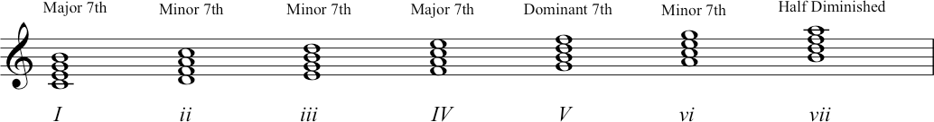
7th chords built on each degree of the minor scale (shown in A harmonic minor scale, for ease of illustration).

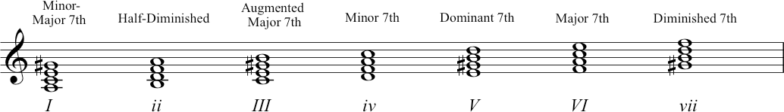

Transcript of the Video
00:00 | So we’ve had practice already, earlier on building triads on all the degrees of the major and minor scale. But now we know that we that we don’t have to build chords with just three notes in them. We now know about four-note chords, so what we wanted to do was just spend a bit of time building four-note chords up from the triad. Missing out every other note but continuing on. So we got the first on we missed out on one we’ve got another one we miss that one, we’ve got another one, we miss that one. And then put another one in as well. We’re going to do that for every scale degree and see what quality of chords emerge when we do that.
00:38 | So we start on a major key, first of all. And again, we’re going to use C, just because it’s a nice easy one to show on the piano. So as Nikki said, we’ve got the 1st degree, 3rd degree, 5th degree, and the 7th degree. And actually what we is we’ve got the major triad that we’re familiar with, but we’ve also got the interval of a major 7th from the root to the 7th. The major triad with the major 7th is a major 7th chord. Okay, the chord on, the chord built on the 2nd degree is minor triad with a minor 7th we’re going to call that a minor 7th chord that’s the same for chord C we’ve got a minor 7th chord. Chord 4, we have a major 7th chord. So we got a major triad with F to E in this case which is a major 7th on the outside. So it’s a major triad with a major 7th, so major 7th chord. Then we got a major triad, but this time we’ve got a major triad with a minor 7th. And this is called a dominant 7th chord. It goes down to the 7th chord because it’s, it’s a 4th-note chord built up from chord 5 from the dominant and it’s the one that you recognize. It’s the dominant 7th chord and it’s got important features in it. It’s got a three, a four that wants to move to a 3 and a 7 that wants to move to a 1. The reason that it’s got that going on is because that’s where the semitones fall and you’ll remember that. So, we want it wants to resolve - it wants to take us back to tonic and that’s what distinguishes it. Okay, so that’s chord five and remember we talked about that having a very important function. Moving onto six, we’ve got a minor triad, again with a minor 7th. We now know that this is a minor 7th chord. And then if we move to chord 7, we said that that was a diminished triad and it is but actually when we add the 7th on we have minor 7th between the root and the 7th.  So diminished triad with a minor 7th is what’s known as a half-diminished chord. So, let’s just reiterate that. On chord one, we’ve got major 7th. Chord two, we’ve got minor 7th. Chord three, we’ve got minor 7th. Chord four, we’ve got major 7th. Chord five, we’ve got that all important dominant 7th. Chord six, we’ve got our minor 7th. And chord seven is a half-diminished chord. We’ve included some supplementary material that not only explains this, but also shows you some chord symbols that are used particularly in pop music and jazz.
03:13 | All right, that was the major scale, that was building 7th chords on every single degree of the major scale. So now you know what we’re going to do, we’re going to do the same thing again but building 7th chords on every degree of the harmonic minor scale. We’ll use A minor. Okay, so if we look at this, we know we’ve got a minor triad. Actually, if we use a harmonic minor, we’ve got a major seven, so we’re going to call this a minor major 7th. Okay, moving on, we’ve got half diminished chord, so that a minor triad with. Sorry that’s our diminished triads with a minor 7th. That’s half diminished. Moving on, we’ve got that nice augmented sound that we got when we built the triad on chord three, but this time we got a major 7th with it. So this is an augmented major 7th. Chord four. We get our minor triad with a minor 7th, so it’s a minor 7th chord. Chord five, we’ve got a major triad with a minor 7th. We’ve spoken about this as being our dominant 7th chord. So, as in the major scale, we’ve got that same pattern of intervals which contains in it. Those two important pulls, it’s got a [scale degree] 7 that wants to move to a [scale degree] 1. And it’s got a [scale degree] 4 that wants to move to a [scale degree] 3, if we’re thinking about it in its key context. So, here I’ve got this chord chord five with a 7th on it and it wants to move to this chord one. When it does that, it’s got a pull. Or it’s got this pull. It wants to resolve in that fashion.
04:50 | This is really important. This is why dominant’s so important within the key. So it’s called five dominant 7th. moving to chord 6th. We’ve got a major triad with a major 7th, so we get a major 7th chord. And then we’ve got a diminished triad, but with a diminished 7th and this is called diminished 7th chord. Okay, so let’s just reiterate that. If we go back to chord one, we’ve got a minor major seventh. Chord two, half diminished. Chord three, augmented major seventh. Chord four, minor seventh. Chord five, dominant 7th. Chord six, major 7th. And chord seven is our diminished 7th chord.
05:32 | So, let’s sum up. Back in lecture 2, you heard how a given scale can lead our ears to hear one note after the whole scale as being the most important or defining note as being the key note. In this lecture, we’ve seen how a similar perceptual effect can happen with groups of notes with, with triads and with chords. So we started off by looking at triads and looking at how the notes work together to give us quality. So we said things like the chord was major, or minor, or augmented, or diminish. And then we took that one step further by adding another degree, we added the seventh, so it’s a four-note chord. And we looked at the qualities that we got from these chords.  So finally, what we’re seeing in this lecture is how the putting together those courts can give us a really important and very strong structural effect. How the harmonic structures that arise, from especially chords like the tonic, the dominant, and the sub dominant had these, really commonly used together. To create overall structures, that reinforce our sense of key, that reinforce our sense of, of, of tonality, of tonal centre. And we’ve seen how other chords can be used to, to elaborate and and extend that harmonic structural experience. So, just remember to have a look at the supplementary material that is on this lecture’s webpage.
06:55 | In the next lecture, what you’re going to go on to do is look more at chords within keys and how they actually work together.

Topic 5: Music theory code-breaking reference guide

5.1. General knowledge
You will have gathered by now just how many different ways there are to conceptualise the elements of musical compositions, and to communicate about these. There are different approaches to naming the component parts of various, inter-related theoretical systems - all of which might make use of stave notation. In this topic, we gather together some information to help you organise your knowledge.
Wikipedia can be a useful place to start if you want to improve your general knowledge and understanding. You could browse and read these various pages which refer to different musical notation systems.
- Roman numeral analysis
- Lead sheet
- Macro analysis
At this stage, you might also like to take some time to think about the following technical expressions. In the context of your own growing music theoretic knowledge, you will feel more familiar with the concepts to which they refer.
- Chord Voicing. The inversion in which a chord should be written out or played
- Voice leading. How individual lines (parts) sound and the way that they interact together as harmony, creating harmonic (chord) progressions
- Spell out a chord. Identify which notes – which letter names – are indicated by a particular chord, chord symbol, or notated figure.

Degrees of a scale
Use the following names to indicate a particular step of a scale:
1 = Tonic
2 = Supertonic
3 = Mediant
4 = Subdominant
5 = Dominant
6 = Submediant
7 = Leading note

Chord description as Roman numerals
- Use Roman numerals (I, II, III, IV, V, VI, VII) to indicate the triad build on a particular scale degree.
- Use CAPITALS to indicate a major triad (e.g. I, IV and V in a major key)
- Use lower-case to indicate a minor triad (e.g. ii, iii, vi and vii in a major key)

Chord voicing (inversion)
Local (UK-wide) convention is to use Latin letters (a,b,c,d) alongside Roman numerals to indicate voicing. We use this system in the video lectures.
With the example of a chord V (the dominant chord, the triad built on scale degree 5):
- If it’s in root position, then we could describe it as Va.
- In first inversion, it could be described as Vb
- In second inversion it would be described as Vc
For chords containing more than three notes, this system can be expanded. Seventh chords, for example (which contain four notes) can also be in third inversion, which would be described as Vd.

5.2. Lead sheet chord symbols

Quick Reference Table for Chord Spellings
CHORD TYPE | ALSO WRITTEN AS  (INCLUDES ALTERNATIVES) | CHORD SPELLING | E.G.  (CHORD LABEL) | E.G.  (SPELLING)
MAJOR |  | 1, 3, 5 | C | C E G
MINOR | m | 1, b3, 5 | Cm | C Eb G
DIMINISHED | dim, º , mb5 | 1, b3, b5 | C o | C Eb Gb
DIMINISHED 7TH | dim7, º 7, dim | 1, b3, b5, bb7 | C º7 | C Eb Gb Bbb
HALF DIMINISHED | m7b5, ^{ø} | 1, b3, b5, b7 | C ^{ø}7 | C Eb Gb Bb
AUGMENTED | aug, + | 1, 3, #5 | C+ | C E G#
DOMINANT 7TH | 7 | 1, 3, 5, b7 | C7 | C E G Bb
MINOR 7TH | m7 | 1, b3, 5, b7 | Cm7 | C Eb G Bb
MAJOR 7TH | maj7, M7 | 1, 3, 5, 7 | CM7 | C E G B
SUSPENDED 4TH | sus4 | 1, 4, 5 | Csus4 | C F G
SUSPENDED 2ND | sus2 | 1, 2, 5 | Csus2 | C D G
7TH SUSPENDED 4TH | 7sus4 | 1, 4, 5, b7 | C7sus4 | C F G Bb
7TH SUSPENDED 2ND | 7sus2 | 1, 2, 5, b7 | C7sus2 | C D G Bb
ADDED 9TH | add9 | 1, 3, 5, 9 | C add9 | C E G D
6TH | 6 | 1, 3, 5, 6 | C6 | C E (G) A
MINOR 6TH | m6 | 1, b3, 5, 6 | Cm6 | C Eb (G) A

How to indicate voicings
If you see a chord label using a slash (/), this tells you which note to use in the bass. E.g. C7 / G means: play the notes of a dominant seventh on C, with a G in the bass. (I.e. second inversion.)

5.3. Figured Bass
Please visit Figured bass notation to learn more detail about this system, including conventions for abbreviations, and for including accidentals.
Figured bass – also known as thoroughbass – tells performers how and (roughly) when to voice the chords to accompany the melodic line. It arose to support musical compositions and performances featuring a basso continuo, an improvised form of accompaniment. The numerical figures appear below the stave, aligned vertically to show the metrical position of the chord changes (i.e. on which beat of the bar the harmony should change).
Written and printed (or copied) as part of a musical score, figured bass tells us how the bass line should sound and what the chord progression should be. A figured bass would be provided in addition to the musical notation for the upper part(s) of a composition or song. This system for notation uses the five-line stave. But it does not include complete, detailed voicing or pitch information. Rather, it provides the specific notes/pitches for a bass-line PLUS numerical annotations that tell performers how to harmonize those notes.
The single line notation shows which pitch should be played: how the bass line should sound. The numbers indicate which chord should be played.

Topic 6: Chord functions in practice
6.1. Chord Inversions
Video: Chord Inversions
Here are the inversions of the C major triad:
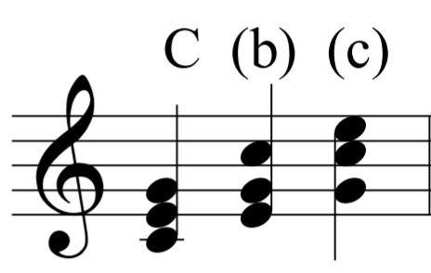

And the inversions of the A minor triad:
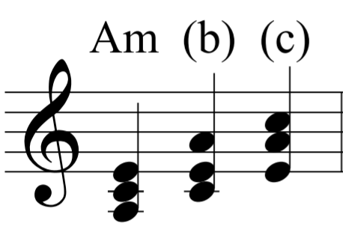
And the inversions of a dominant seventh chord:
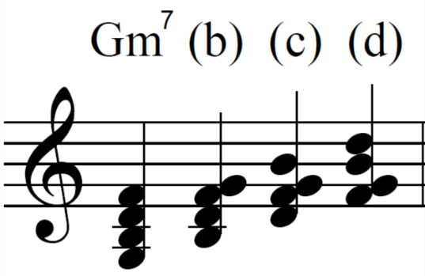

Other types seventh chords can also be inverted three times. Here is C minor 7:
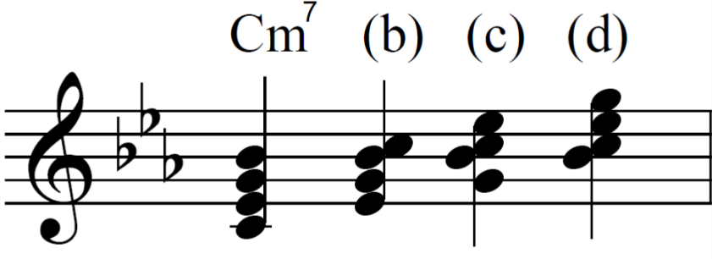
DO THIS:
Practice inverting triads and seventh chords on the keyboard. Practice writing them down.

Using the Root Position for a Final Chord
It’s common to end on a root position chord, for the sake of finality and stability that comes with this. Here is Twinkle Twinkle Little Star, ending on the root position tonic triad:
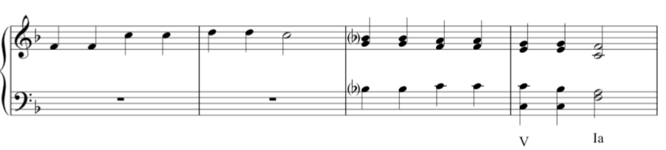
(Played at approximately 04:15 in the video)

Chord Progression Ic V7 I in F Major
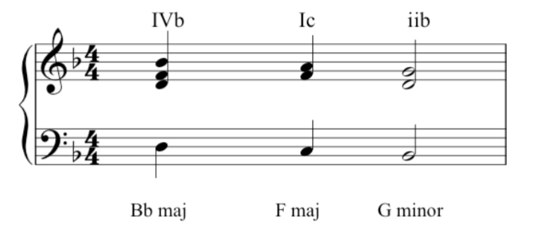

Passing Second Inversion
At 05:50 in the video, John played this example where the second inversion is again used. We are still in F major:
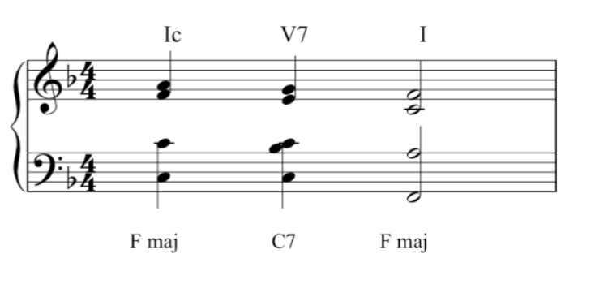

Transcript of the Video
00:05 | Hi there. We’ve already considered the most important chords, but so far we’ve used them only in root position. As you heard then, we use a single note name to identify chords, such as a triad of C-major. Here we are. And now’s the time to consider their inversions. If you take a triad of C-major, obviously it has three possible positions. What we call root position, first inversion, and second inversion. So we’re using the same three notes, but we’re stacking them up differently. We’re switching around the order of the, the same notes. And the, these chords have a slightly different feel to them. The root position feels firm and definite. The first inversion perhaps less so and needs to move on. And the second inversion demands to move on somewhere else. We’ll be considering second inversions in more detail later. But for the meantime, let’s consider a few more chords and their inversions. Let’s take A-minor, because of course this applies to minor triads as well as major. A minor, root position, A minor, first inversion, and A minor, second inversion. Let’s take G major root, first and second, and finally C minor root, first and second. You’ve also heard about some chords which have four notes one of the main ones being the dominant seventh, which has four notes. And obviously a chord with four notes will have three inversions, as well as the root position. So let’s consider a dominant seventh in the key of C major. Here’s C major. And it’s dominant seventh will sound like this in root position. And then in first inversion, second inversion, but also third inversion. Three inversions. And here is another one, key of E-flat. Dominant seventh in root, in first inversion, in second inversion, and in third inversion. Variety in music can be obtained by using the same chord in its various inversions, because each has its own feel.
03:16 | For example, the finality of a root position means that you nearly always find a root position at the end of a piece. And you feel the music has come to rest. Let’s have an example. If you take simple song like Twinkle Twinkle Little Star, and end it on a first inversion, it wouldn’t sound quite right. It’s the correct chord, but it’s the wrong inversion. If we ended the piece on the second inversion, it would sound even more peculiar. And we certainly feel we had not arrived home. If, however, you play it the correct way with root position at the end, it sounds like this. With a feeling of finality. So it’s important to get the right inversion, not just at the end of a piece as we’ve heard there, but throughout the music, throughout any piece of music. So that we call the progression of the harmony sounds pleasing and sounds smooth.
04:39 | There are many progressions we could consider, but one very common one that you find again towards the end of a piece, or the end of a section of a piece, is what we call Ic V I. Let’s stick to F major at the moment. Ic is the second inversion of the tonic, followed by the dominant, followed by root position of the tonic. So that’s Ic V I in F. Now here the second inversion really wants to move on. And this helps the harmony to progress strongly towards the final chord of the piece. Second inversion is a chord which has to be used very carefully. There are only really two main situations when you find it, one being the cadences just described, and the other is what we call a passing second inversion, where three chords move very smoothly with the base in conjunct motion. So the baseline was going to move by step, like this. So the middle of these three chords is a passing second inversion. I’ll play it again. So the chord is, as it were, protected by the ones on either side. So that is a correct way to use the second inversion, and the other one, to repeat, is the Ic V I cadence.

6.2. Cadences
Video: Cadences

Perfect and imperfect cadences
Here is the perfect/authentic cadence again in D major:
And here is the imperfect/half cadence example played by John:
Note that the actual imperfect cadence, from D major to A major, features only in the final two chords.

Interrupted/deceptive cadences
Here we are in D major, with a phrase that finishes on chord vi, B minor.
Compare this to the perfect/authentic cadence example:
Note again that the first chord is played for context – the actual cadence is the movement from V – vi.
The minor key example in G minor:
Compared to the minor key perfect/authentic cadence:

Plagal cadence / mixolydian mode
Here’s something to think about: this plagal chord progression could be called a mixolydian cadence. Why? Remember the discussion of modes from 1.4. More on Scales? Playing notes through the octave from G to G, using only the white notes of a keyboard, produces a particular set of tones and semitones which we can call the mixolydian mode. It’s characterized as sounding major in modality, but with a flattened seventh. As John showed, we can transpose modes (in the same way we have been transposing major and minor keys). The melody to the famous song shown in this example follows the mixolydian mode. For more on this progression, which is common in rock and funk, you might enjoy this YouTube link: Mixolydian Mini-Montage.

Transcript of the Video
00:05 | In week four we heard about certain cadences, we heard about perfect cadences, which occur at the end of a piece, and which sound very final. And we also heard about imperfect cadences, sometimes called half cadences which are a temporary stopping point for the music, before the music moves on somewhere else. For example, if we’re a key of D major, we might hear a passage something like this. Which obviously is not the end of a piece. Ending there with an imperfect cadence. But there are two other important cadences to be considered. First of all is the one we call interrupted or sometimes called deceptive.
00:55 | Now, if we recall our Ic-V-I cadence but change just one chord. If we change the final chord to chord six, which is the submediant, it sounds like this. Sounds very different. Let’s compare again. And I think you’ll agree that both the words ‘interrupted’ and ‘deceptive’ describe the effect here very well. The music obviously must continue.
01:36 | I’ll play you another example. That one was in D major, but let’s have one in G minor. Here’s a ic-V-i in G minor. And here’s an interruptive cadence in G minor. Moving to chord six, where the music demands it, that it continues.
02:05 | The other cadence we need to know about is called the plagal cadence, sometimes called a hymn or church cadence because it’s the one you often hear in a ‘Amen’ at the end of a hymn. And it’s chord four to chord one. The subdominant to the tonic, in F major here. This is a cadence that we used a great deal in church music in medieval and renaissance period but subsequently too and interestingly, we find it pops up quite often in newer music, in blues and rock and pop. And, a number of examples can be found in Beatles’ songs. For example, ‘With a Little Help from My Friends’, the last three chords of which are.... The last two of these making up the plagal cadence, IV - I.  And interestingly here, there’s an extra flavour added because of the influence of the third-to-last chord. Which is based on the flattened leading note. Here is a scale of E major. Leading note, this time with the flattened leading note, which gives us what we call the Mixolydian mode. And if you base a chord on that D, It gives you the third last chord of that song. And interestingly it’s also used in ‘Hey Jude’. Here’s the final chords of Hey Jude. With the plagal cadence says the last two, and the Mixolydian chord, the third last.

6.3. Chord Names
Video: Chord Names
We have already looked at all the diatonic triads but let’s be sure that we’ve identified (and learned) all the formal music theoretic names. These names can be used to describe both the scale degree (note) and the triad or extended chord built on that scale degree.
The diatonic triads in F major:
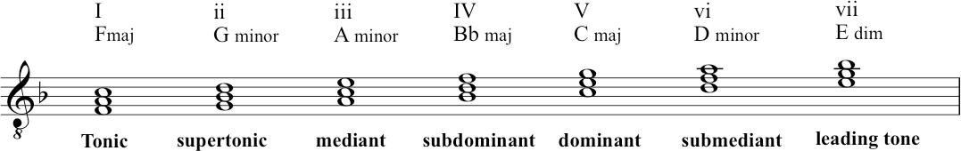
Also here in C major:
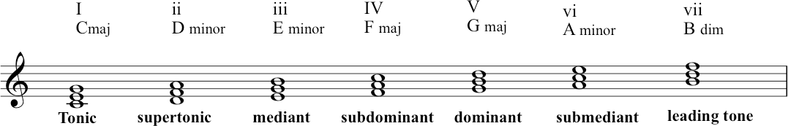

Of course all these triads can be extended to seventh chords, as you saw before. Here they are again in C:

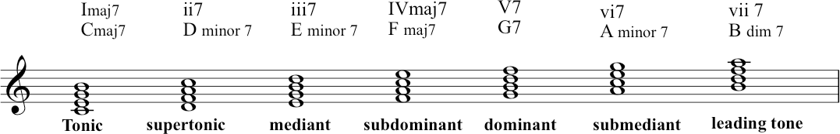

DO THIS:
Play through these triads and seventh chords on the keyboard.

Transcript of the Video
00:00 | You’ve already heard some of the chord names. That is what we call the triads, which are built up on different degrees of the scale. Let’s take the scale of F major. Where we’ve encountered the tonic, which is chord one. A dominant, which is chord five. And the sub-dominant, which is chord four. As we hear these are all major triads. And they’re the three most common, in fact, some music is harmonized entirely by these three chords.
00:58 | But as briefly mentioned before, the diatonic scale of course, contains seven notes. Back to the beginning, and a triad can be built on all of them. Not all the triads we find, will be major. But let’s go up and investigate them.
01:19 | First of all, sticking to the key of F, we’ve had the tonic, on the first degree of the scale. And then above the tonic. Chord two is called the supertonic, because it’s one step above the tonic. And as you’ll hear, the triad is minor, with the notes G, B-flat, and D. We have to remember that the triads have to be made up of notes, which are part of the scale. So it has to be one of those notes. So in this supertonic we have the G, B-flat, and D. Going up another step, the third degree of the scale is called the mediant, what we call chord iii, and its notes are A, C, and E. The sub-dominant we know. The dominant we know. And submediant, chord six is another minor triad. In this case consisting of D, F, and A. The submediant you remember is what we hear in the interrupted cadence that we talked about. And then finally, in the context of F we have, the final triad, which is built on seventh degree of the scale. And which is a diminished triad as you’ll hear, the notes are E, G and B-flat, and that’s chord seven. So to go up through all of these in F major, here we go chord one, two, three, four, five, six, seven, and back to one.
03:20 | Let’s just try them in another key, here’s C major. One, two, three, four, five, six, seven, and back to one.

6.4. Common Chord Progressions
Video link: Common Chord Progression

The Ic V7 I progression
Recapping again – here is Ic V7 I:
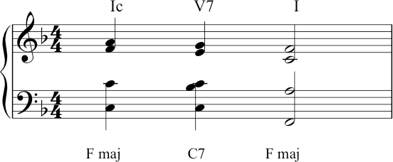

Here is that progression, still in F, in the context of the Christmas song ‘Hark the Herald Angels Sing’:
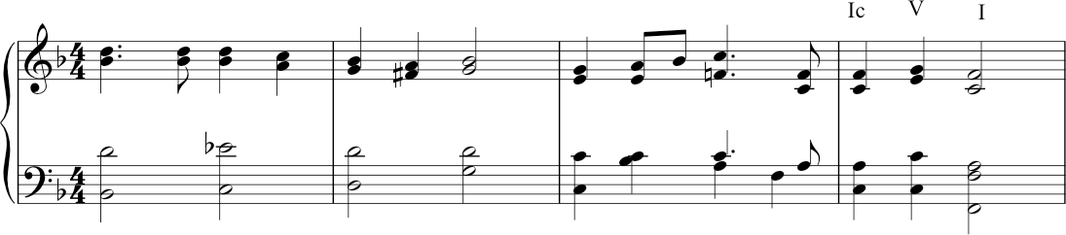

The iib V7 I progression
Firstly, John played A minor 7. In the key of G major, this is the supertonic- ii, but as a seventh chord it is ii7. John then puts it into first inversion:

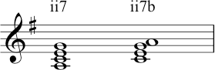

Here is that chord in context for the ii7b V I chord progression (very common in jazz also):

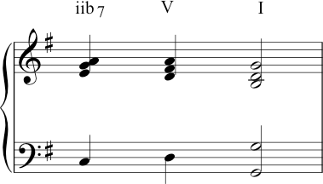

Circle of Fifths (in C major)
Here is the first example of the chord progression using the circle of fifths:
(Note this shows the chord names and the Roman Numerals: lower case Roman Numerals denote a minor chord except for viio, which denotes the diminished chord). Here is the example played in G major:
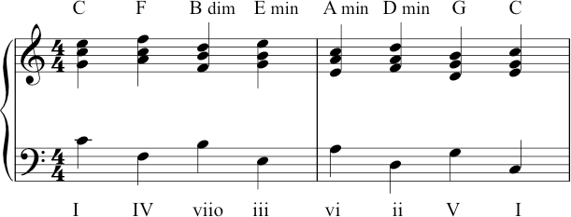

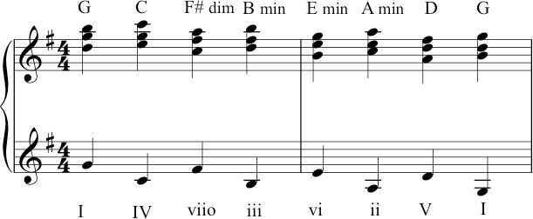

Two things to note here. Firstly, John played this in quite a high register, so please note the lower clef is also notated using the treble clef, rather than the usual bass clef. Secondly, this example (which was prepared originally by Richard) features all the chord names again. These are now in the key of G, but of course the Roman Numerals remain the same – which is of course the advantage of that system: it is not key specific, which makes it more flexible for analysis.

Vivaldi example (at 03:55 in the video)
This excerpt is in A minor and each bass notes is played twice (repeated an octave lower). The sequence of bass notes is: D, G, C, F, B, E, A.

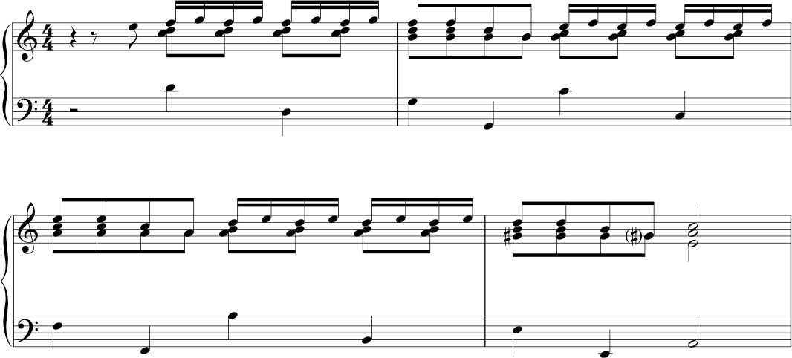

Autumn leaves (played at 04:33)
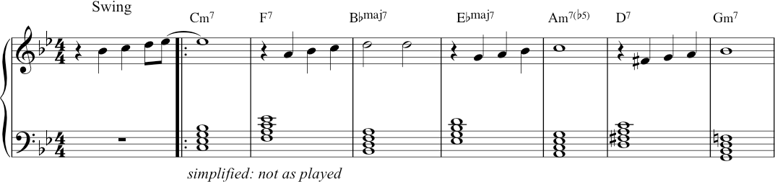

The chords are written out here as semibreves, stacked in thirds in order to make it easy to see them. But this is not how John performed (‘realised’) them in the video.
As you know, a lot of performance – especially that which is based on lead-sheet symbols rather than fully composed voicings – will require the performer to extemporise the rhythms and inversions as they go.

Circle of fifths with inversions
Here the second, fourth and sixth chords are in first inversion. Note how this makes the bass line smoother.
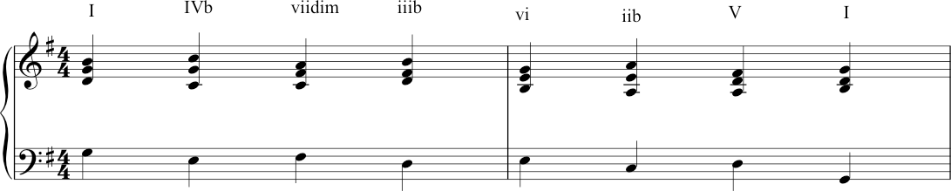

Using the circle of fifths to modulate to the relative minor (key of C major)

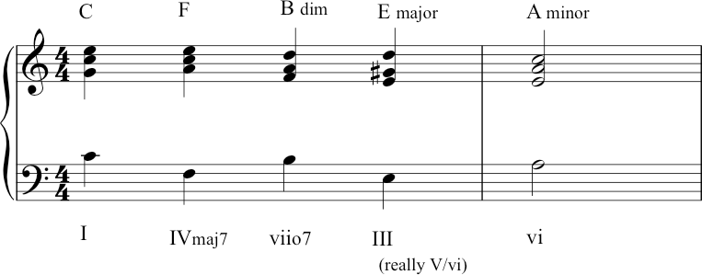
Here the circle of fifths stops at A on the relative minor. The difference from the earlier example is that instead of the fourth chord being iii (E minor), it’s been changed into III (E major), by moving the G natural to a G-sharp.
This E major is the dominant (chord V) of A minor – this helps to give a sense of modulation, rather than just carrying on through the circle back to C.

Using circle of fifths to modulate to another key
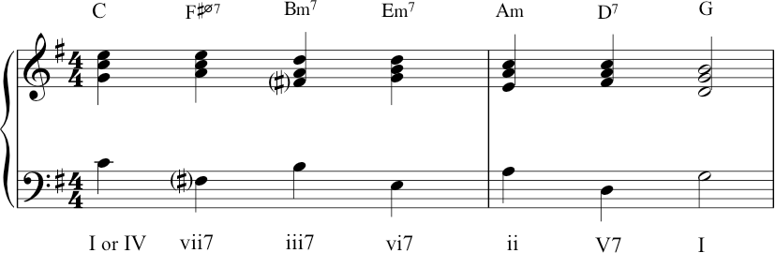
In this case John travelled from C major to G major. Imagine that the performance was (still) in C major – in that case, C was our tonic, our chord I. But now that we want to move to G, let’s re-imagine that C. Imagine we’re now thinking in G major. That makes the C major triad a chord IV in our new key of G major – it becomes the subdominant.

Pivot chord
This is sometimes called a pivot chord: C is the pivot chord, acting as a tonic in the old key and becoming the subdominant in our new key. The next chord is F-sharp half-diminished. (In a previous lecture, recall that Zack and Nikki demonstrated the difference between the (fully) diminished seventh and half- diminished seventh.) Importantly, that F-sharp chord is moving us into the tonality of G major. Why? Because the note of F-sharp is foreign to the key of C major, but it has a very strong identity in G major, as the leading note which leads our ear to a new tonic. From there, it’s just iii7 vi7 ii V7 I. (Another very popular sequence in jazz and Tin Pan Alley songs.)

Transcript of the Video
00:00 | In music, we find that certain patterns of chords, what we call chord progressions, recur frequently particularly at cadences. And we remind ourselves, of course, of the commonest cadence, Ic V I, which sometimes is enhanced by a dominant seventh on the second last chord. So we hear this. So a seventh is added to the dominant chord, which serves to pull the music strongly towards the tonic. So it’s a very strong progression and gives a pleasing finality to the cadence. You find it in lots of music, for example the well known carol, ‘Hark the Herald Angel Sing’ goes like this. Or ‘Happy Birthday To You’, it goes like this. And that’s possibly the commonest of the chords progressions and cadences.  Another cadential progression which we often find in, involves a different chord in the third to last position instead of the one C, we find two B and often with a seventh added chord. Let’s stick to G major. There G major, chord two. The supertonic sounds like that. We add a seventh to it, and then we put that in first inversion. So, we rearrange the notes in this order, and that’s our third to last chord. I’ll just play that one once again. In addition to these and other cadential progressions, are recurrent patterns of chords. We find chord sequences.
02:22 | The most common of these sequences is called the Circle of Fifths, which I think has already been mentioned. And this is a very important particular pattern. And it’s found in 18th century music, by composers like Vivaldi, writing in early 18th century Venice, but also in later music of all sorts. The circle of fifths is so called because of the pattern of notes in the bass going like this from C to F, B to E, A to D, G to C, so you’re going down fifths. And if you put root position chords on top of that in the context of the key of C, it would sound like this. I’ll play that again. Here we are in, the same thing in G, circle of fifths in G, all root position chords. Now let’s hear it with some real music. I mentioned the composer Vivaldi. Well, here’s an example of a short piece by Vivaldi from his Concerto Grosso, Opus 3. And he uses a circle of fifths, and it sounds like this. And here’s the music again. You find exactly the same pattern of chords in the popular song, ‘Autumn Leaves’. Again, all the chords are in root position. This time, we’re in G minor. And it goes like this. Here’s the circle.
05:03 | So far the circle of fifths we’ve had have been with chords in the root position. But the circle of fifths also works with some of the cords in first inversion. Here’s G major. G major again. You don’t see the pattern of fifths in the bass because some of the chords are in the different inversion because the second fourth and sixth chords are all first inversion. But it’s the same chords so instead of, [MUSIC] We have [MUSIC]. And again, I’ll play the whole thing.  And finally, the circle of fifths is sometimes used to modulate to a different key. Depending on how you arrange things, you can actually use the circle of fifths to change key. So for example, if we’re in C major. And we want to go to A minor, we might do this. The all-important G-sharp, which is the leading note of A minor, pulls us towards A minor but we have the circle there in the bass, once again C major to A minor Or, we might want to go to G major. So, if we start again in C. The important thing there, is that the first fifth is not perfect. It doesn’t go F, it doesn’t go C, F. It goes C, F-sharp, and that pulls around to G. So, here we are, again. C major to G major.

6.5. Modulation
Video: Modulation

Here are two possibilities for modulation, in the hymn, ‘While shepherds watched their flocks by night’.
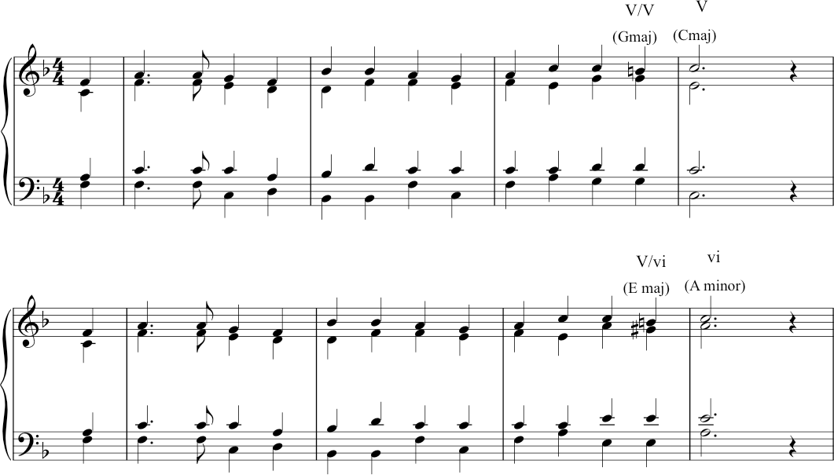

Secondary dominant chords
Both of these use ‘secondary dominant’ chords. This choice of harmonization creates an effect such that we can have something of the experience of a perfect cadence (chord movement from V to I) – and yet this happens in a new key. By introducing accidentals – chromatic notes – to harmonize a note, we can tilt the direction of harmonic travel towards a new key.
So, both of these options above take us towards a new key, away from the original F major. The first one hints at a modulation to C major from the original F major. The second one moves towards A minor instead. So, instead of:

V/V Secondary dominant
The following example is as used by Bach in a cantata, ‘Wie schon leuchtet der Morgenstern’ (BWV 1). 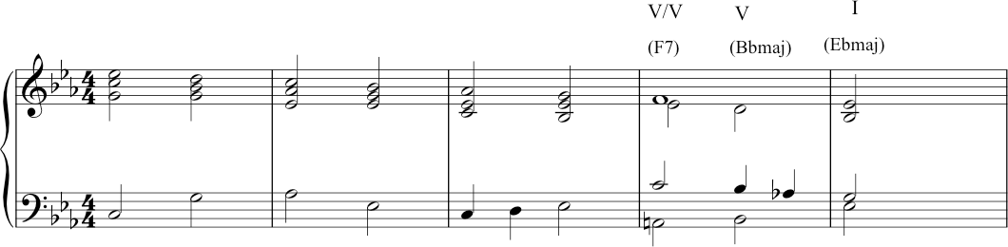

Transcript of the Video
00:00 | When talking about circles of fifths, we consider those that could help you to modulate, i.e. to move the music to another key, and I’d like to think a little but more about this, modulation is a very important concept in music, means going from one key to another. Music would be very boring, boring and dull. If pieces remained in the same key all the time. So we find that modulations occur a lot in music, and sometimes a great deal. And this keeps the music interesting, and gives us a feeling, that we’re moving on somewhere.
00:41 | The commonest modulation, that you often hear, quite near the beginning of a piece is to the dominant. So for example, a piece in F major might move to C major quite soon in the, its course. So for example, the well-known Christmas  Carol, ‘While shepherds watch their flocks by night’ goes like this. And we’re now in the dominant of C major. If you really wanted, you could even modulate that to A minor, it would sound like this. Now it sounds slightly more forced, perhaps not quite so natural. But anyway, the, that illustrates the concept of modulation; going to a different key.
01:41 | These are quite definite modulations, where the new key is established quite firmly. But we also find many instances of. Keys simply being hinted at. Rather than a true modulation taking place. We find that a key is suggested. And again, this gives the music interest. And means that we feel we’re moving somewhere. And one of the commonest of these involves a chord, which we usually call the secondary dominant, which means a dominant 7th of dominant generally. And you find this towards the end of a piece, as I said gives greater colour, greater variety to the chord progression. And can again, make the cadence sound more final, and more satisfying.
02:31 | If, for example, we return to the progression already mentioned, iib7, V, I, that sounded like this. That’s iib7, V, I in G major. If we make one alteration in the bass. Rather than C natural, if we change that to a C-sharp, it sounds like this. What we’ve created there is actually the dominant 7th in the key of D major. But in this case, it doesn’t go to D major, it just suggests D major and goes-immediately to G. But you get that extra colour. And so it’s hinting at a new key but not actually modulating to it.
03:32 | Many composers have used this, Bach is an example. For example the choral ‘Wie schon leuchter der morgenstern’ ends like this. He could have ended (this). And that would sound perfectly good, but this added secondly dominant, makes it just a bit more interesting. Where we’ve hinted at another key, without actually modulating. Another example of the secondary dominant, and can be found in the tune ‘Blackbird’ which ends. There we’re in g major and the third last chord is the secondary dominant, which suggests, again, D major. But actually immediately comes back to G. So here it is again.
04:55 | A move to the sub-dominant key often occurs later in the piece, because it helps emphasize the feeling of coming home. Sometimes composers actually modulate to the subdominant, other times they simply hint at it. If we’re in the key of C, the subdominant chord is F. The subdominant scale involves the note B-flat. And if we want to give the feeling of having moved to the sub-dominant that B-flat is an important note to introduce. So for example, if you were towards the end of a piece in C, you might hear this. By introducing that B-flat, which is one of the notes of the scale of F, the subdominant. And doesn’t enter into the scale of C. That B-flat helps you to think you’re, that B-flat gives you the flavour of the subdominant. So here’s the progression again. And you find this quite frequently towards the end of pieces. Either of a hint of the subdominant, or something slightly stronger. A famous example of it can be heard towards the end of the Prelude by Bach, the ‘Prelude in C’ from Book one of the 48 Preludes and Fugues. And he introduces the B-flat just towards the end, to give the feeling of, hinting at F major, not actually going to F major; but hinting at it. And thus giving a ‘subdominant leaning’ as we sometimes call it. So the chords at the end of this piece sound like this, once again. And we’ll finish by hearing the complete ‘Prelude in C’, played on harpsichord, as it would have been in Bach’s own day.

