Birds of Midlothian

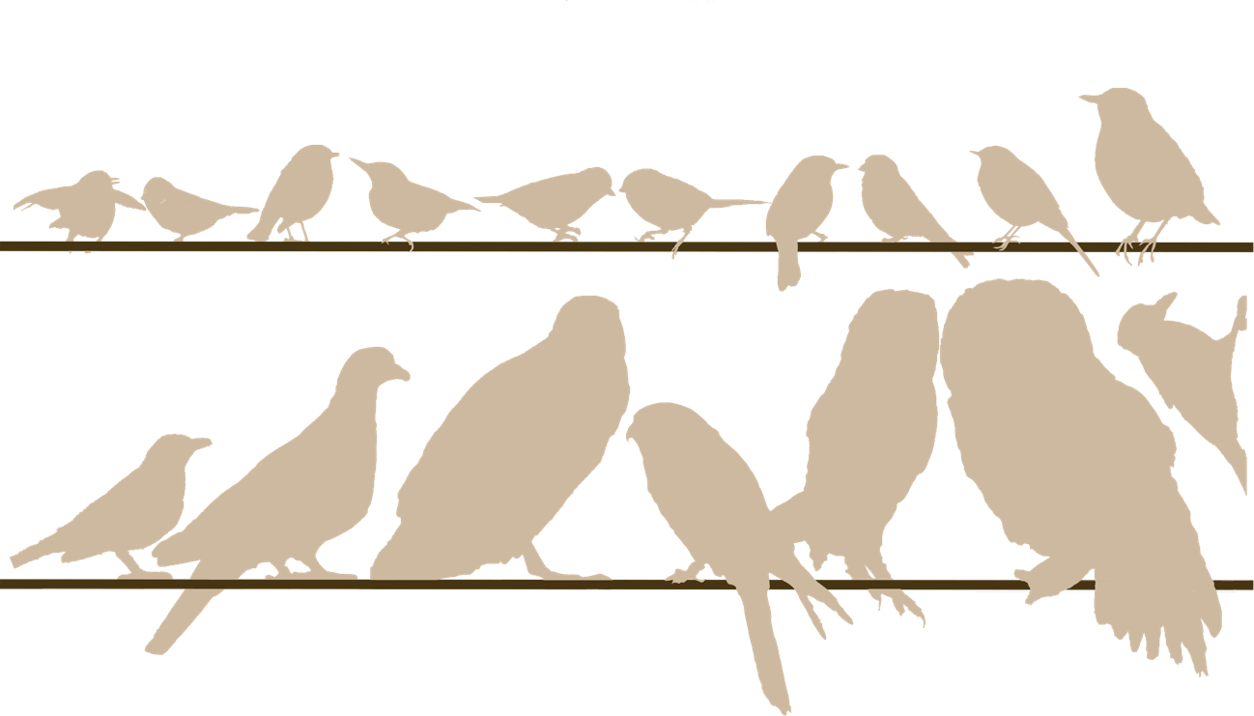

Radina Atanasova and Mayu Ishimoto, University of Edinburgh

Contents

3 How to Use This Booklet
4 Other Facts about Birds
5 Wren
6 Robin
7 Nuthatch
8 Great Tit
9 Blue Tit
10 Long-tailed Tit
12 Dunnock
14 House Sparrow
16 Pied Wagtail
17 Dipper
18 Blackbird
19 Great Spotted Woodpecker
20 Wood Pigeon
21 Sparrowhawk
23 Kestrel
25 Barn Owl
27 Tawny Owl

29 Advice When You Are Doing Your Observations
30 Ways You Can Learn More about Birds

31 References

First published in 2023 by the University of Edinburgh, Old College, South Bridge, Edinburgh, EH8 9YL.
© Radina Atanasova, Mayu Ishimoto, University of Edinburgh. This book is published under a Creative Commons Attribution-ShareAlike 4.0 International licence (CC BY-SA 4.0) unless otherwise indicated. The cover image: Mayu Ishimoto, Birds’ Relative Sizes, 2023, CC BY-SA 4.0 International.
ISBN: 978-1-912669-60-8
DOI: https://doi.org/10.2218/ED.9781912669608
For further information about the University of Edinburgh’s commitment to open educational resources (OER) please visit https://open.ed.ac.uk/

How to Use This Booklet
Please note that this is not a comprehensive bird identification guidebook. It can help you identify birds that are most seen in Midlothian, but there can be similar looking, less common species. Also, birds tend to change their appearance through seasons or ages which can make it confusing to recognise their species. However, learning bird identification is easy. It just needs practice. lf you wish to learn more about how to identify birds, please refer to the 'Ways You Can Learn More about Birds' section in this booklet.

The idea of this booklet is to inform the reader about the food and habitat requirements of the most common bird species in the Midlothian area. When you read through the bird profiles in this booklet, think about the habitat requirements each bird has and the food it needs. Those are two important factors that will define whether a bird can survive in the area where you live.

If you want to build a nest box for birds in order to ensure that the right bird uses the nest, or that any birds use the nest, rather than a colony of wasps (as they also like bird boxes), you’ll need to build it with the right dimensions for the specific bird species and should place it in the birds’ preferred habitat and height. There is a link to a website in the 'Ways You Can Learn More about Birds' section in this booklet if you’d like to learn more about this.

This booklet was originally produced by Radina Atanasova as part of Geosciences Outreach course, which provides the opportunity for students at the University to develop their own science communication and engagement project. The resource was then adapted into an Open Educational Resource (OER) by Mayu Ishimoto of the OER Service at the Information services Group (ISG), the University of Edinburgh. For further information, please visit Geoscience Outreach (https://geoscienceoutreach.wordpress.com) and Open.Ed (https://open.ed.ac.uk) websites. This book is published under a Creative Commons Attribution-ShareAlike 4.0 International licence (CC BY-SA 4.0) unless otherwise indicated.

Other Facts about Birds
Sexual dimorphism - the male and female have different feather colourations - is common but not always met among birds. The male is the often more colourful in order to attracts females. The male is also the one that usually sings, again in order to attract females.

Abbreviations Key
Migrant/Resident | Habitat
R: Resident | O: Open Space with Bushes Present
S: Summer Visitor | F: Forest Area
W: Winter Visitor | B: Burns, Streams, Rivers
♀: Female Bird
♂: Male Bird

Wren (R, F)
Troglodytes troglodytes
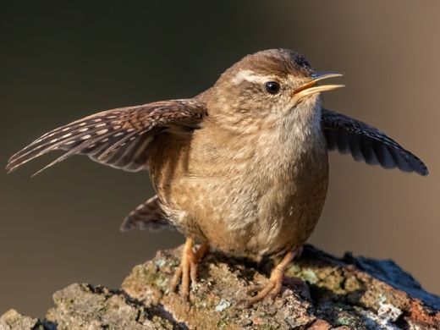
Size: Length - 9-11 cm. A plump body with a short tail.

Song – Wren: For its small body size, the wren’s song is very loud and complex.

Habitat: Everywhere the bush cover is dense - woodland, farmland, heathland, moorland and gardens.

Breeding period: From late-April. In gardens the Wren makes its nest in dense vegetation such as ivy or other creeping plants. Otherwise, they build their nests in nooks and crannies.

Food: Mainly insects, such as spiders, mayflies, midges, aphids, insect larvae hidden in the leaves, and occasionally berries and smaII seeds.

Interesting facts: All other Wren species are found in the Americas, but this is the only Wren species that is found in Europe, Africa, or Asia. Its Latin name, troglodytes, means a cave dweller.

Image: Eurasian wren Franconville 04.jpg, by Alexis Lours, from Wikimedia Commons, CC BY 4.0 International.
Audio: Lee Alder, XC814301. Accessible at www.xeno-canto.org/814301, CC BY-NC-SA 4.0.

Robin (R, F)
Erithacus rubecula
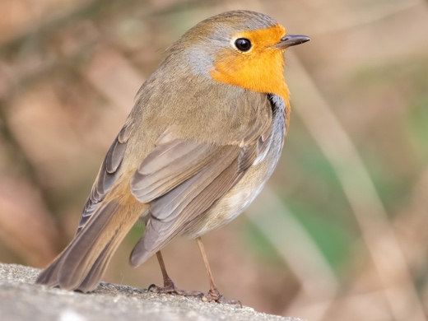
Size: Length - 12-14 cm. Round body.

Song - Robin: The Robin sings all year round as a way of protecting territories, often from hidden on a perch in the low bushes. Despite its cute look and small size, it is an aggressive and territorial bird. Both female and male sing. The Robin has distinctive autumn (more melancholic) and spring songs (more vivid, to attract mate and defend territory). They stop singing during their moulting period in August.
As the Robin is adapted to live at a low light level among the bushes, they’re comfortable with singing at dawn and dusk or during the night near streetlights.

Habitat: Likes bushy places, such as woodlands, hedgerows, parks and your garden.

Breeding period: Courtship - January. Breeding - March onwards. Robins can have up to three clutches of young. They like their nest to be in a hidden and sheltered place. Nests have been found in various places - wall crevices, between tree logs, tree roots and human items left unused (boots, pots, clothes pockets etc.). They build their nests with fine grass and line it with hairs and feathers.

Food: Mostly insects, but in the cold seasons they will eat berries and small seeds. If a decent amount of street or moon light is present in summer, Robins will hunt insects during the night despite being diurnal birds.

Interesting facts: Young Robins do not have red breasts but actually start life with all brown feathers. As they grow, they start to develop feathers with red colouring. So, you can use the number of red feathers to tell how old the bird is.
Image: European robin on a rock.jpg, by Alexis Lours, from Wikimedia Commons, CC BY 4.0 International.
Audio: Paul Driver, XC811310. Accessible at www.xeno-canto.org/811310, CC BY-NC-SA 4.0.
Nuthatch (R, F)
Sitta europaea
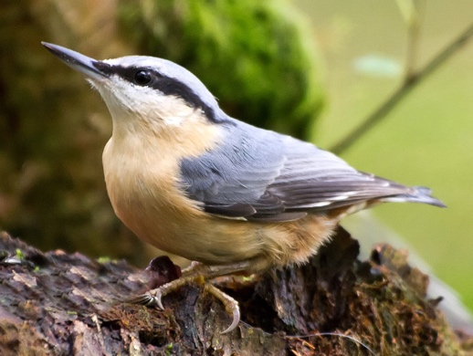
Size: Length - 12-15 cm. Short tail.

Song - Nuthatch:

Habitat: Mature woods. The Nuthatch creeps on tree bark like the Woodpecker and can be seen on the underside of branches and on the sides of the tree trunks. Nests in holes of trees or nest boxes.

Breeding period: Late-ApriI. Nests in a tree hole or a hole in a wall. The nest hole is lined with bark chips and dead leaves. If the hole entrance is too big, the nuthatch will shrink it by plastering mud around the entrance – just Iike builders use cement to join bricks.

Food: Nuts and seeds are their main winter food, which is diversified with insects (spiders and beetles) during the warm seasons.

Interesting facts: The interesting habit that earned the Nuthatch its name is that it will usually put nuts in a stone crack or between the rough peeling bark of a tree and then peck at the nutshell until it is open.

Image: Nuthatch - geograph.org.uk - 2751058.jpg, by David Baird, from Wikimedia Commons, CC BY-SA 2.0 Generic.
Audio: Paul Driver, XC811351. Accessible at www.xeno-canto.org/811351, CC BY-NC-SA 4.0.

Great Tit (R, F)
Parus major
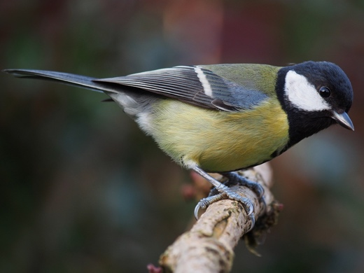
Size: Length - 13-15 cm.

Song – Great Tit: Sings mostly during the breeding period.

Habitat: Prefers woodlands, hedges and gardens.

Breeding period: Courtship starts in January. Breeding - March. The Great Tit sets its nest in tree holes, rocks or wall crevices. They also like nest boxes. Their nest is made of fine grass and moss and is lined with hairs and feathers. The female builds the nest.

Food: Mainly seeds, but when they have young, they will take caterpillars and other insects for food.

Interesting facts: Insectivorous (mainly caterpillars) during the warm seasons, but they will also take seeds, nuts and fruits. During harsh winters, Great Tits have been seen to kill birds of their size, like finches, and feed on them. When Great Tits deal with larger food items like a hazelnut, they will hold it with their foot and peck at it if the item is loose rather than, for example, attached to a branch. The laying of the eggs is perfectly timed with the hatching of the green caterpillars that they eat. It has been found that Great Tits sing louder in urban areas compared to in rural areas where there’s less noise and fewer buildings for sound to travel through.

Image: Parus major poised.jpg, by Francis Franklin, from Wikimedia Commons, CC BY-SA 4.0 International.
Audio: Stuart Fisher, XC804548. Accessible at www.xeno-canto.org/804548, CC BY-NC-SA 4.0.

Blue Tit (R, F)
Cyanistes caeruleus
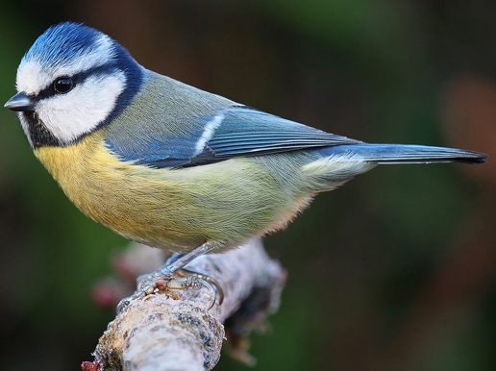
Size: 10-12 cm.

Song – Blue Tit: Sings mostly during the breeding period.

Habitat: Woodland and places with hedges present.

Breeding period: Courtship starts in January. Breeding – mid-April to May. The Blue Tit sets its nest in tree holes, rocks, wall crevices, pipes, or letter boxes. They also like nest boxes. Their nest is made of fine grass, leaves, spider webs and moss, and is lined with hairs and feathers. The female builds the nest. Blue Tits synchronise their breeding to coincide with the time when caterpillars are most abundant.

Food: Insectivorous during the warm seasons (mainly eating caterpillars) but they also eat seeds, nuts and fruits. Blue Tits can be seen searching for insects along the tree branches, sometimes hanging upside down to do so.

Interesting facts: Blue Tits can sometimes destroy tree buds in their search for insects, but they are still considered as one of the most valuable pest controllers as they eat many plant pests such as coccids, aphids, leaf miner grubs and green tortrix moths (Tortricidae) to feed their large hungry clutch.

Image: Eurasian blue tit Lancashire.jpg, by Francis Franklin, from Wikimedia Commons, CC BY-SA 3.0.
Audio: Paul Driver, XC811689. Accessible at www.xeno-canto.org/811689, CC BY-NC-SA 4.0.

Long-tailed Tit (E, F)
Aegithalos caudatus
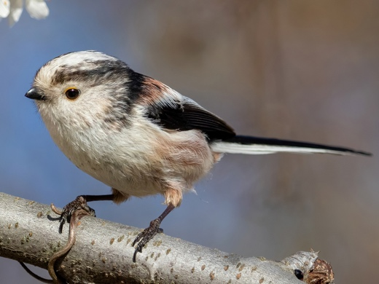
Size: Length - 13-15 cm. Very long tail of 7-9 cm.

Song - Long-tailed Tit: Being highly social, the Long-tailed Tit constantly uses sounds to locate, warn and generally communicate with others of its kind.

Habitat: Woodland (deciduous or mixed), farmland, hedgerows, scrubland, parkland, and gardens - somewhere with trees or bushes for building nests and hiding.

Breeding period: The Long-tailed Tit builds its nest with lichen, feathers, and spider webs. The webs hold together all building materials on place and stretch so the nest expands when the chicks grow. They will often use tree barks, moss, and lichen for the outer part of the nest to camouflage it.

Food: Mainly insects, but the Long-tailed Tit prefers spiders and caterpillars. They can also eat small seeds and vegetation when insects are not available in the cold seasons.

Interesting facts: The Long-tailed Tit is closely related to the Tit family but not actually in the family. They’re placed in a separate bird family, called Aegithalidae, a group of bird species with long tails. Scientists think that these birds have evolved to have long tails because they use them for communication.

The mortality rate of young is high for Long-tailed Tits due to predation. This has led to more developed social skills which are not as common among birds. If the clutch of a Long-tailed Tit pair fails, they will go and help another related pair to raise their young. ln this way, the chicks are well-fed, and the parents not so tired (as one clutch can have more than eight chicks). If the helpers are unexperienced parents, they will learn how to raise chicks. After the young fledge, the whole extended family stays together and takes care of each other, usually splitting during the next breeding period.

Image: Long-tailed tit Gennevilliers 2022 02 25 3.jpg, by Alexis Lours, from Wikimedia Commons, CC BY-SA 4.0 International.
Audio: Paul Driver, XC811513. Accessible at www.xeno-canto.org/811513, CC BY-NC-SA 4.0.

Dunnock (R, FO)
Prunella modularis
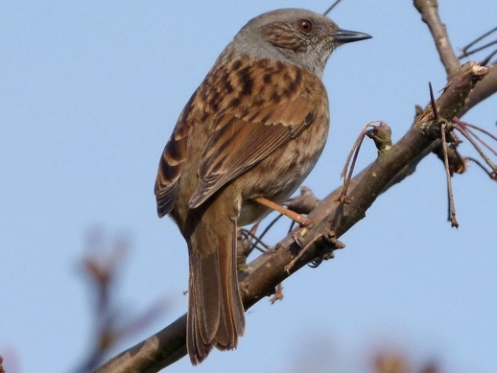
Size: Length - 13-15 cm. Can be confused with a sparrow due to the colour of its back.

Song – Dunnock: Very loud. Sounds similar to the call of a Robin or Wren. Dunnocks sing from a hidden place.

Habitat: Dense bushy areas - scrub, brambles, hedges and hedge rows, parks, and private gardens. When away from its nest, the Dunnock still keeps close to the hedge where it can quickly take cover if necessary.

Breeding period: Starts in ApriI. Nests are buiIt by the female in dense shrubs. Building materiaIs consist of twigs and moss, and nests are often Iined with moss and hairs.

Food: Feeds mainly on the ground. During the warm seasons they eat mainly insects, such as spiders, ants, beetles and insect larvae, and in the cold seasons this is supplemented with berries and seeds. Dunnocks and Robins have similar food requirements, which is why Dunnocks often will go into a Robin's territory from which they will be chased away.

Interesting facts: Some people call the Dunnock a Hedge Sparrow as the colouring of their back is quite similar. Cuckoos are known to lay their eggs in a Dunnock's nest. This behaviour is called brood parasitism. Dunnocks, unlike Wagtails, will not reject the Cuckoo egg and will not abandon their eggs. The Dunnock can have different mating habits depending on the size and conditions of the habitat and food availability. One male can mate with one or many females as well as one female can mate with one or many males. The more mates, the more broods - this indicates a good environment and a lot of food.

Image: Dunnock. Prunella modularis - Flickr - gailhampshire.jpg, by gailhampshire, from Wikimedia Commons, CC BY 2.0 Generic.
Audio: Xavier Riera, XC792453. Accessible at www.xeno-canto.org/792453, CC BY-NC-SA 4.0.
House Sparrow (R, FO)
Passer domesticus
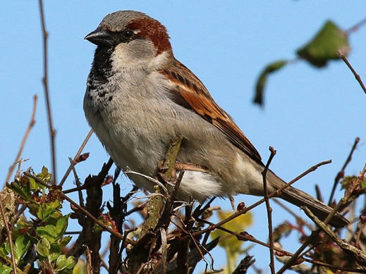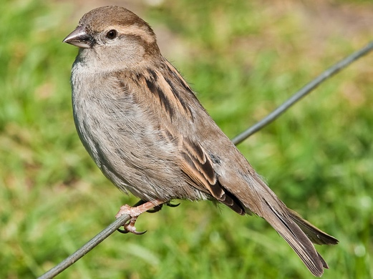
Left: ♂, Right: ♀
Size: Length - 14-16 cm. It can be confused with tree sparrow.

Song - House Sparrow:

Habitat: Easily adapt to manmade structures, so nowadays they can be often seen under house roofs.

Breeding period: April to August, in building crevices, holes, and pipes under roof tiles. They also like nest boxes. Nests have been found in thick hedges and creeping plants. They are made of straw and are lined with feathers and hairs.

Food: Mainly seeds but when they have young ones, they also hunt caterpillars and other insects for food.

Interesting facts: As the House Sparrow breeds close to humans and gathers in large flocks, they are often perceived as the most common bird, but this is not the case. House sparrows are rare in the UK (United Kingdom) and are on the Red List (a list of birds in the UK, Channel Islands, and the Isle of Man in most urgent need of our help). As they are a very social bird, they often gather in large flocks to feed on the field or 'chat' in a bush. They can form breeding colonies under the roof of houses. Pairs stay together for life and return to the same nest every year. Unlike most birds, if you give a sunflower seed to a House Sparrow, it will peel it and then eat it.

They are bold birds and are known to approach Pigeons and pluck a feather or two from them for nest lining.
Tree Sparrow (R, FO) for comparison. The male and female of Tree Sparrows look the same.
Images: House Sparrow Left: House Sparrow, England - May 09.jpg, by DAVID ILIFF, from Wikimedia Commons, CC BY-SA 3.0; House Sparrow Right: House Sparrow, England - May 09.jpg, by Charlesjsharp, from Wikimedia Commons, CC BY-SA 3.0 Unported; Tree Sparrow: Eurasian Tree Sparrow (Passer montanus) (49178252811).jpg, by Imran Shah, from Wikimedia Commons, CC BY-SA 2.0.
Audio: Paul Driver, XC811634. Accessible at www.xeno-canto.org/811634, CC BY-NC-SA 4.0.

Pied Wagtail (R, FO)
Motacilla alba
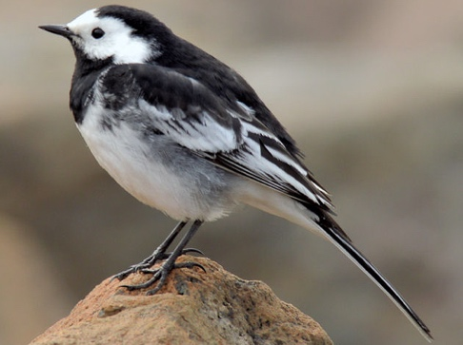
Size: Length - 16-19 cm. Has a very long tail.

Song - Pied Wagtail: Can be best heard when they gather in large groups at dusk when they call to locate their flock.

Habitat: Along fast-flowing streams and rivers where they usually search for food. The Pied Wagtails like open areas where they can fly after and catch food. This includes open and flat spaces in cities where they are often seen on rooftops, roads (made of asphalt or tiles), car parks, golf courses, mowed lawns and other surfaces with low vegetation. In cities and other populated areas at dusk, they can be seen flocking with others of their kind. They can also be seen along the seashore.

Breeding period: April to August. The Pied Wagtail likes to build its nest in crevices in stone walls, under roof tiles, under large boulders, ventilation shafts, on the sides of a riverbank and many others.

Food: Insects, such as dragonflies, mayflies, mosquitoes, small snails, spiders, worms, flies, and maggots. They catch food in the air or pluck it from the ground or shallow water.

Interesting facts: All birds from these species have the habit of wagging their tail when sitting in one place or walking on the ground. They’re also a fast-running bird for their size. It has been observed that Cuckoos may sometimes lay their eggs in a Wagtail's nest, in which case the Wagtail will leave its nest even if it has its own eggs inside.

Image: Pied wagtail, Holywood (March 2015) - geograph.org.uk - 4402371.jpg, by Albert Bridge, from Wikimedia Commons, CC BY 2.0 Generic.
Audio: Paul Driver, XC812095. Accessible at www.xeno-canto.org/812095, CC BY-NC-SA 4.0.

Dipper (R, FB)
Cinclus cinclus

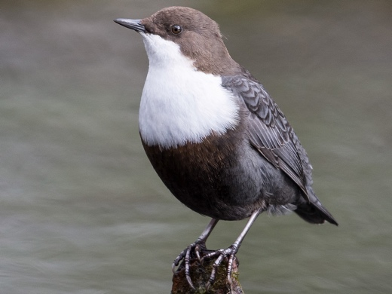
Size: Length - 17-20 cm. Plump bird with very short tail.

Song - Dipper: Usually perches on a rock in the river while singing.

Habitat: Builds a dime nest from moss, grass and leaves in the crevices from which they have access to a fast-flowing river where they hunt for prey – under bridges or banks, for example.

Breeding period: March to May.

Food: Usually, insects and insect larvae are picked from the river bottom, for example, mayfly nymphs, caddisfly larvae and small fish such as minnows. They can be found foraging for food in the leaves and turning stones along riverbanks.

Interesting facts: Although the Dipper doesn’t have webbed feet, this little bird has its name because it dives into streams to pick insects from its bottom. They will either walk on the bottom of the river, gripping rocks to hold themselves under, or will swim using their wings.

Image: Cinclus cinclus 2018.jpg, by Dirk-Jan van Roest, from Wikimedia Commons, CC BY 2.0 Generic.
Audio: Sven Jägbrant, XC709606. Accessible at www.xeno-canto.org/709606, CC BY-NC-SA 4.0.

Blackbird (R, F)
Turdus merula
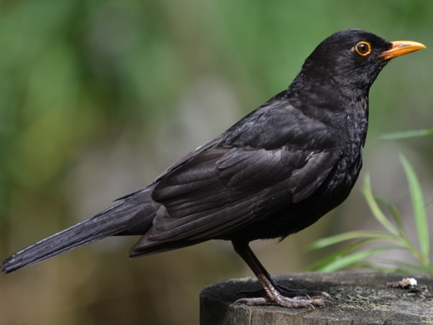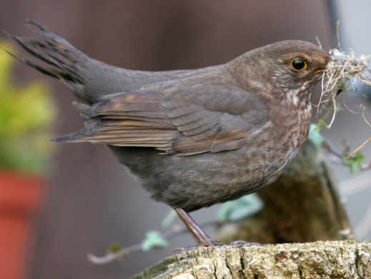
Left: ♂, Right: ♀
Size: Length - 23-29 cm.

Song – Blackbird: It is usually the youngest male Blackbirds that start singing in January, followed by adult males singing in March.

Habitat: Prefers deciduous forests and areas that have trees and bushes.

Breeding period: March to July. The nest is built by the female from grass, small twigs and other materials. The materials are stuck together with mud and the nest is lined with fine grass.

Food: Likes fruits, seeds, insects and can often be seen listening for earth worms before they hop and pluck them off the ground.

Interesting facts: Highly territorial, like the Robin. The male will find a territory in their first year and hold it for life. It will most aggressively defend its territory against other male Blackbirds with orange beaks, less aggressively against those with yellow beaks and is least aggressive to those with brown beaks (1st year males). Protection of the established territory stops during the moulting period - late summer and through autumn. The male will often care for their young in their last days before they learn to fly completely and find food by themselves. At the same time, the female will prepare the nest for a second brood to be laid. Albinism (or having white feathers) is often observed in male Blackbirds.

Images: Left, Stuutje1979 Common Blackbird 1.JPG, by Stuutje1979, from Wikimedia Commons, CC BY-SA 3.0. Right, Female black bird with nesting material, by Armin Kübelbeck, from Wikimedia Commons, CC BY-SA 3.0.
Audio: Lee Alder, XC814307. Accessible at www.xeno-canto.org/814307, CC BY-NC-SA 4.0.
Great Spotted Woodpecker (R, F)
Dendrocopos major
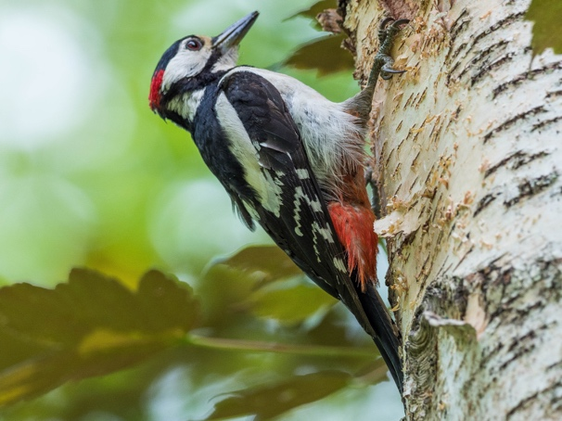
Size: Length - 23-26 cm, wingspan - 38-44 cm.

Song - Great Spotted Woodpecker: Known for their spring drumming display, which can also be used to state territory. This Woodpecker does not usually sing but can give out alarming calls.

Habitat: Prefers mature broad-leaved trees. However, mature conifers can also provide the necessary food and living conditions. Needs mature or dead trees because they are more likely to have a hollow where a nest can be set in and to have rotten parts where grubs can be found.

Breeding period: March to May, after getting ready for setting a nest in a cavity of a dead tree.

Food: Insects, seeds, nuts.

Interesting facts: Woodpeckers have a very unique tongue. It has evolved to protect the head from traumas that can be caused by hammering. The tongue can also be shot out like a spear. Its tip is hard and has hard bristles to stab the insects (like you would use a fork) to take them out of their hole. Opposite to beliefs that Woodpeckers use their tongue, not their beak, to take insects out of the holes that the bird makes to reach the insect.

Image: Dendrocopos major EM1B2679 (35219263071).jpg, by Bengt Nyman, from Wikimedia Commons, CC BY 2.0 Generic.
Audio: Paul Driver, XC811286. Accessible at www.xeno-canto.org/811286, CC BY-NC-SA 4.0.
Wood Pigeon (R, F)
Columba palumbus
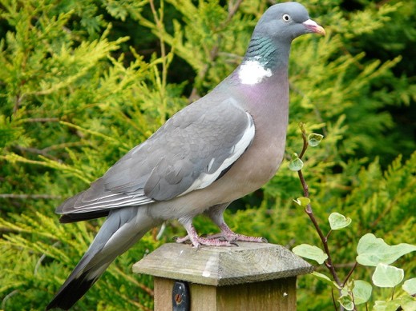
Size: Length - 38-45 cm. Wing span - 68-77 cm. It can be confused with a stock dove, which is smaller and looks less plump.

Song - Wood Pigeon:

Habitat: Wooded areas - forests, parks, gardens, and also in town centres.

Breeding period: Builds its nest high on a tree. Their nest is more like a platform rather than dome-shaped and is made from twigs. Both male and female participate in building their nests.

Food: Mainly berries, but they also eat fresh leaves and tree buds, grass, grains, crops and breadcrumbs.

Interesting facts: Wood Pigeons drink a lot of water as they don’t get enough moisture from their food. If you pay attention to how Wood Pigeons and other birds drink water, you’ll notice a difference. Most birds scoop water in their beaks and then throw their head back so that the water can flow down the throat, while a Wood Pigeon uses its beak like a straw, so it does not need to lift its head every time it takes a sip.
Both female and male Pigeons and Doves feed their chicks (also called squabs) with milky-white liquid produced in their throats by an organ called crop. This liquid provides the proteins that the young need to grow.

Image: Columba palumbus -garden post-8.jpg, by Tristan Ferne, from Wikimedia Commons, CC BY 2.0 Generic.
Audio: Craig Brookes, XC742189. Accessible at www.xeno-canto.org/742189, CC BY-NC-SA 4.0.
Sparrowhawk (R, F)
Accipiter nisus
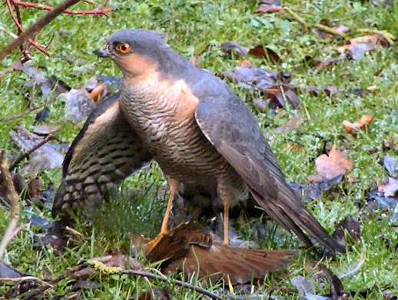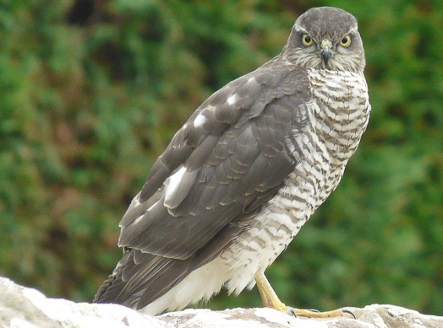
Left: ♂, Right: ♀
Size: Length - 29-41 cm. Wingspan - 58-80 cm. The female is larger than male.

Song – Sparrowhawk:

Habitat: As they make their nests in trees, woodland is their preferred place. However, if the cities have parks with large trees, they can be seen nesting there, too. The botanical garden of Edinburgh has a pair nesting there. Sparrowhawks can be seen hunting in open land or gardens. In the UK, they are only absent from the Scottish Highlands, the Western Isles and Shetland.

Breeding period: May. The nest is made of twigs and is lined with bark flakes. Several weeks are necessary to build the large nest. The chicks need help of the female to break out of the eggshells. The young are not able to control their body temperature, so in the first week the female constantly broods them.

As Sparrowhawks lay their eggs once every 2-3 days, the chicks do not hatch simultaneously. This successive hatching helps the brood to cope with low amounts of food, in which case the youngest chick dies. Another adaptation to low food supplies is their perfectly timed hatching. The chicks hatch when there are a lot of unexperienced fledgling birds around that their parents can easily catch.

Food: Mainly small birds. As the female is bigger than the male, she can catch large pigeons. Sparrowhawks have been seen catching bats.

Sparrowhawks are maneuverable birds but are large, making them slow, clumsy and easy to be spotted by their prey. When small birds see them, they give out alarm calls and soon everyone disappears. That is why only one out of ten hunts are successful. ln order to be successful, Sparrowhawks must approach closely and stay unnoticed. They prefer hunting in places where prey is abundant (like your garden) because they have a larger chance of catching something.

Interesting facts: As Sparrowhawks like to feed on pigeons, they tend to move into cities where Pigeons are bountiful.

Images: Left: Sparrowhawk-Male.JPG, by Darkeyedboy, from Wikimedia Commons, in the Public Domain; Right: female sparrowhawk - geograph.org.uk - 937444.jpg, by sylvia duckworth, from Wikimedia Commons, CC BY-SA 2.0.
Audio: Grégoire Chauvot, XC742074. Accessible at www.xeno-canto.org/742074, CC BY-NC-SA 4.0.

Kestrel (R, F)
Falco tinnunculus
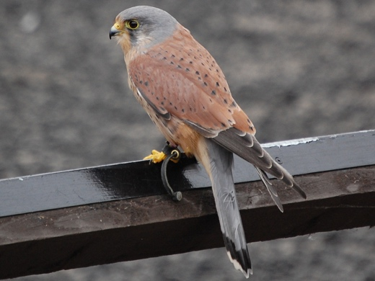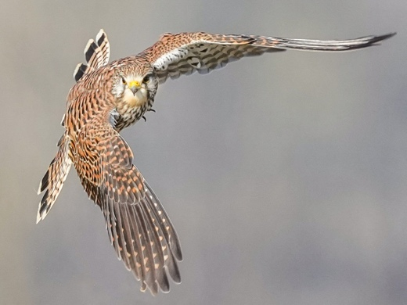
Size: Length - 31-37 cm. Wingspan - 68-78 cm.

Song - Kestrel:

Habitat: Easily adapts to a wide range of habitats. Can be seen in moors, heathlands, farmlands and urban areas. Kestrels don’t like dense forests, vast treeless areas or high mountains. This is because they like to have a high nest or perch site from which they can observe for prey and then in which they have space to swoop and grab their meal.

Breeding period: Courtship - February. They mature when they are one year old, but it often takes them one more year to find a partner and establish territory. Breeding – April to May.

Food: Kestrels have such keen eyesight that they can see a beetle 50 m away. Voles are the main food of Kestrels (which is why the kestrel population is directly dependent on the population of voles), but they also eat small mammals, birds, insects, and earthworms. In towns, Kestrels eat more small birds because small mammals aren’t as easily found. Kestrels often catch food and store it to eat just before dusk to make sure they're not hungry overnight.
They are masters of hover-hunting. You can sometimes spot them hovering 10-20 m above ground for some time before they swoop down to attack.

Interesting facts: Kestrels do not build their nest sites. They use old crow's nests or other stick nests. They can be found nesting on ledges of buildings or cliffs. Kestrels also like to nest in holes and will nest in nest boxes too.
Aggression is not typical for sibling birds of prey. Siblings will usually fly, perch and roost together for a period of time after fledging.
The reason many birds of prey have an angry look on their face is because the bone just above their eye is convex. This facial structure helps them see long distances.

Images: Left: Kestrel - geograph.org.uk - 2402721.jpg, by John Jennings, from Wikimedia Commons, CC BY-SA 2.0 Generic; Right: 077 Wild Common kestrel in flight at Pfyn-Finges Photo by Giles Laurent.jpg, by Giles Laurent, from Wikimedia Commons, CC BY-SA 4.0 International.
Audio: Clive Davies, XC738405. Accessible at www.xeno-canto.org/738405, CC BY-NC-SA 4.0.

Barn Owl (R, F)
Tyto alba
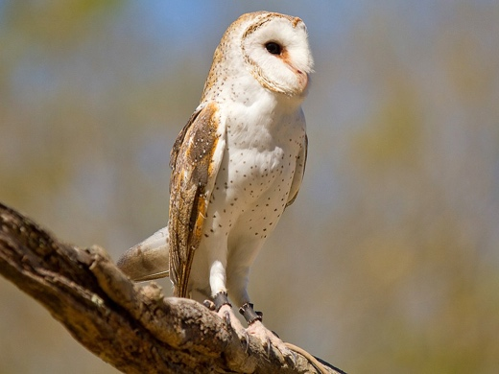
Size: Length - 33-39 cm. Wingspan - 80-95 cm.

Song - Barn Owl: Usually heard overnight.

Habitat: Barn Owls prefer open country with few lone trees, and field edges or watercourses framed with trees or bushes. This suits their hunting strategy.

Breeding period: They nest in holes in trees, and undisturbed buildings - barns, outbuildings, ruins, mines, cliffs, and quarries.
The size of the clutch, as of the sparrowhawk, depends on the availability of their main prey species – the voles. Their young also hatch in 2-3 days intervals.
The death rate among young Barn Owls is high. Around 75% of the young die before they reach their first year. Those who survive their first year normally live for another 1-2 years. ln Europe, the oldest Barn Owl has reached 21 years, with several occasional records of owls reaching the ages of 12-17 years.

Food: Barn Owls have exceptional hearing and can carry out their hunting activity solely on hearing. They are nocturnal birds but hunt during the day in winter. They may hunt before dusk and at dawn when they feed the young. In Britain and Ireland, 90% of a Barn Owl's meal consists of rodents like short-tailed voles, woodmice and brown rats. However, their diet has regional and seasonal variations.
Barn Owls usually swallow their prey whole. Indigestible parts, such as fur, bones, teeth, and feathers, are regurgitated in pellets which can be found at nesting and roosting sites. Barn Owls will often perch motionless on a fencepost, pretending to be part of it, until they spot something and swoop in for the kill. Another hunting technique they use is catching prey while flying close to ground.
Interesting facts: The reason birds of prey fly silently hides in the structure of their feathers - the wing feathers and all other feathers covering the body have fluffy and split edges that do not stop the air flowing through them but rather let it flow gently.
If nocturnal birds are out during the day, they get mobbed by other smaller birds.

Image: Barn Owl - AndrewMercer IMG06862.jpg, by Andrew Mercer (www.baldwhiteguy.co.nz), from Wikimedia Commons, CC BY-SA 4.0 International.
Audio: James P, XC653076. Accessible at www.xeno-canto.org/653076, CC BY-NC-SA 4.0.

Tawny Owl (R, F)
Strix aluco
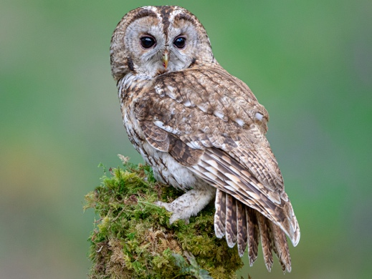
Size: Length - 37-46 cm, similar size as a pigeon. Wingspan - 81-105 cm wingspan.

Song - Tawny owl: You will not usually hear the call of a Tawny Owl during the day as it is a night bird which spends the day sleeping.

Habitat: Tawny Owls prefer old deciduous or mixed forests where they can find a hole to nest or sleep (roost) during the day as they are nocturnal. If there is no hole, they will usually stay on a thick branch close to the place where it joins with the tree trunk. People have spotted Tawny Owls in ivy too.
The way to find Tawny Owls is by looking out for pellets, which they use to mark their roosting sites. And only if you do not disturb it from its sleep by being noisy during the day.

Breeding period: Nests in a tree hole. They find a partner when they are one year old, and they are monogamous. Nesting happens in February. During their breeding period, they can be aggressive protectors, so it’s best to avoid bothering them and keep your face protected as they like to attack it. Tawny Owls are so aggressive that they can displace Barn Owls from their nesting sites and the smaller, long-eared little owls avoid it.

Food: Hunts at night. Usually stays at a perch and then swoops or glides silently low over open areas, such as grassland, before they spot something and catches it with their feet.
They eat small rodents and birds, earthworms, and beetles. ln urban areas, birds are more commonly eaten compared to mammals. They swallow their prey whole, and the undigested material is regurgitated as pellets.

Interesting facts: Has asymmetrically placed ears, which help them hear exceptionally well and locate prey. Also, their retina (the innermost, light-sensitive layer of tissue of the eye) is as sensitive to darkness as humans. Below is a figure showing how birds with their eyes on the front of their face (like humans) see compared to those with each eye situated on either side of the head.
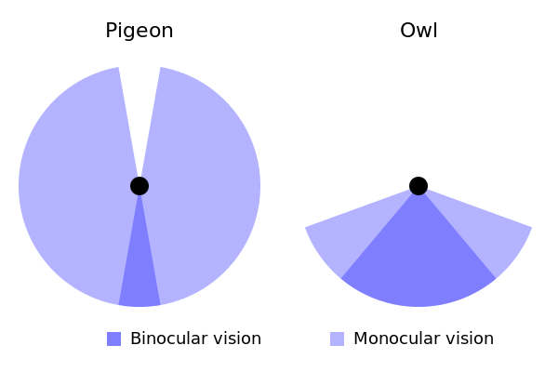

Image: Tawny Owl in Fife, Scotland.jpg, by Barry Forbes, from Wikimedia Commons, CC BY 2.0 Generic; The field of view of a pigeon compared to that of an owl, by Jimfbleak and McSush, from Wikimedia Commons, in the Public Domain.
Audio: Craig Brookes, XC666090. Accessible at www.xeno-canto.org/666090, CC BY-NC-SA 4.0.

Advice When You Are Doing Your Observations
For those you may need more than just this booklet.

1. Think about which part of the world you are situated in and at what altitude.
2. Take a note of the time of year (date), the time of day (morning, noon, afternoon), and current conditions (sunny, dry, overcast, raining).
3. Think about the birds that are associated with the season. Are there any migrants?
4. Take a note of the habitat. Is it forest, field, or mountainous, hilly, or coastal? Does it have any bodies of water such as rivers, ponds, lakes, or swamps?
5. Think about the birds that are associated with the habitat.
6. What plant species can you see around? E.g., if it is woodland, we focus on trees, if it’s a field, we focus on grasses.
7. Think about the birds that would nest in those plants or feed on them.
8. Do you notice any other animals present, and if so what kind of insects, rodents, reptiles, or amphibians etc.?
9. Think about the birds that would feed on those animals.
10. Now do your observations to see if they match your expectations.
11. What if you cannot see the bird? There are other signs to help you find out what birds are present in your area, such as feathers, pellets, and acorns or nuts eaten by animals or birds.
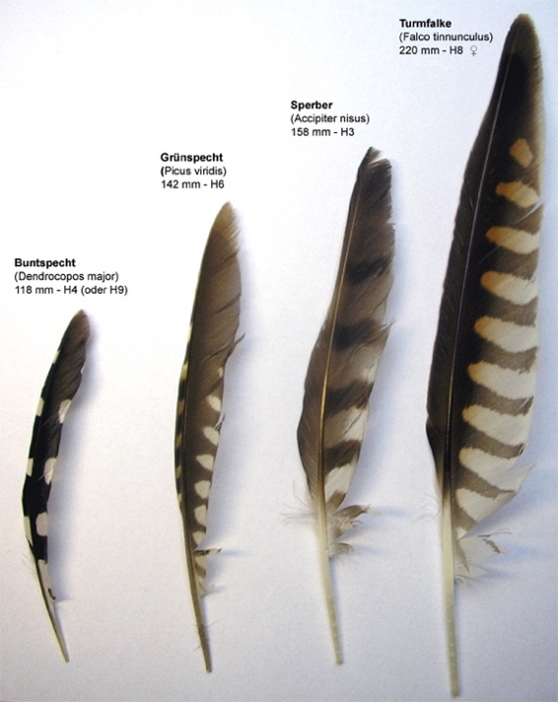
From Left to Right: feathers of Great Spotted Woodpecker, Green Woodpecker (not mentioned in this booklet), Sparrowhawk and Kestrel.
Collection of primaries: Great Spotted Woodpecker (Dendrocopos major), Green Woodpecker (Picus viridis), Sparrowhawk (Accipiter nisus), Kestrel (Falco tinnunculus), by S. Serfert, from Wikimedia Commons, CC BY-SA 3.0.
Ways You Can Learn More about Birds

Learn more about birds:
Understanding birds, British Trust for Ornithology https://www.bto.org/understanding-birds
British Garden Birds http://www.garden-birds.co.uk/

Quickly identify birds around you from their look and songs:
Merlin, Cornell University https://merlin.allaboutbirds.org – the Sound ID function of the app is especially helpful when you hear songs of birds. You can record the birds and it suggests which birds might be around you.

Learn more about songs of birds:
Xeno-canto https://xeno-canto.org/

Become a bird ringer:
Training courses, British Trust for Ornithology http://www.bto.org/news-events/training/training-programme

Get involved in various Scottish Ornithologists Club activities:
The Scottish Ornithologists' Club https://www.the-soc.org.uk/

Join the local (Edinburgh) RSPB birdwatching group for hands on experience:
Edinburgh Area Local Group, The Royal Society for the Protection of Birds http://www.rspb.org.uk/groups/edinburgh/

Become a member of the local RSPB group:
Join our local groups, The Royal Society for the Protection of Birds https://www.rspb.org.uk/get-involved/community-and-advice/local-groups/

Putting up nest boxes according to species:
Putting up nest boxes for birds, How you can help, British Trust for Ornithology https://www.bto.org/how-you-can-help/providing-birds/putting-nest-boxes-birds

Bird identification guides, such as Collins Bird Guide, is helpful If you wish to become a more competent bird identifier. Some of them are accompanied by audio recordings of birds singing, and you can learn more about their meanings, such as courtship, warning, territory defence, or locating others of its kind.
References
Books and Articles:
Pätzold, R. (1995) Das Rotkehlchen Erithacus rubecula. 3. überarbeitete und erweiterte Aufl. (in German). Magdeburg/Heidelberg: Westarp Wissenschaften/Spektrum.

Peterson, R.T. et al. (1993) Collins Field Guide Birds of Britain & Europe. 5th ed. London: HarperCollinsPublishers.

Slabbekoorn, H. & Peet, M. (2003) ‘Ecology: Birds sing at a higher pitch in urban noise’. Nature, 424(6946), p.267.

Svensson, L. et al. (1999) Collins Bird Guide: The Most Complete Field Guide to the Birds of Britain and Europe. London: HarperCollins.

Taylor, I. (2004) Barn Owls: Predator-Prey Relationships and Conservation. Cambridge University Press, Cambridge.

Thom, V. (2000) Collins Scottish birds. 2nd ed. Glasgow: HarperCollinsPublishers.

Van Noordwijk, A.J., McCleery, R.H. and Perrins, C.M. (1995) ‘Selection for the Timing of Great Tit Breeding in Relation to Caterpillar Growth and Temperature’, Journal of Animal Ecology, 64(4), pp. 451–458. Available at: https://doi.org/10.2307/5648.

Websites:
Gains, D. (1999) British Garden Birds. Available at: https://www.garden-birds.co.uk.

British Trust for Ornithology (2023) Alphabetical list of bird species, BirdFacts, British Trust for Ornithology. Available at: https://www.bto.org/understanding-birds/birdfacts/about-birdfacts/alphabetical-list-bird-species (Accessed: 9 August 2023).

Royal Society for the Protection of Birds (2015) Birds by Name, Royal Society for the Protection of Birds. Available at: http://www.rspb.org.uk/discoverandenjoynature/discoverandlearn/birdguide/name/ (Accessed: 27 April 2015).

The Woodland Trust (no date) Birds, Woodland Trust. Available at: https://www.woodlandtrust.org.uk/trees-woods-and-wildlife/animals/birds/ (Accessed: 22 August 2023).

Xeno-canto Foundation and Naturalis Biodiversity Center (2005) Xeno-canto. Available at: https://xeno-canto.org/ (Accessed: 8 August 2023).

